**SINGER/SONGWRITER & CELEBRATED GUITARIST PATRICK DRONEY RELEASES NEW EP *STATE OF THE HEART***

**“RIGHT WITH YOU” VIDEO OUT TODAY – WATCH** [**HERE**](https://PatrickDroney.lnk.to/RightWithYou_mv)

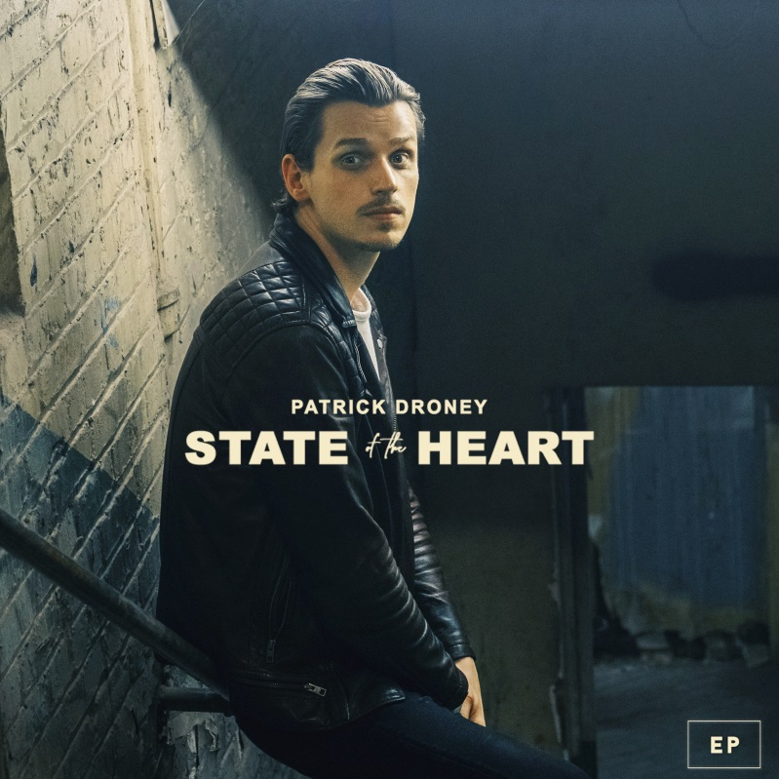

*Download hi-res artwork* [*here*](https://press.warnerrecords.com/patrickdroney/)

**October 9, 2020 (Los Angeles, CA) –** Singer, songwriter, and celebrated guitarist Patrick Droney releases his new EP, [*State of the Heart*](https://PatrickDroney.lnk.to/StateoftheHeartEP) today on Warner Records. With soulful, 21st-century pop melodies and guitar prowess that nods to past masters, Patrick dives into the various states of heart – as he puts it – *"the reckoning of what's behind you, finding meaning in loss, the essence of time, and the pursuit of self "* on the new six track EP, which features recently-released tracks [“The Wire”](https://www.youtube.com/watch?v=xA5vVhdBsC0), [“Passerby”](https://youtu.be/EUnfV73qN0w), and [“Glitter.”](https://patrickdroney.lnk.to/glitter_mv) An official video for new track “Right With You” is also out today. Listen to *State of the Heart* [HERE](https://PatrickDroney.lnk.to/StateoftheHeartEP)

For *State of the Heart*, Droney crafted future classics that feel timeless and new all at once, songs were born all over the world – London, Los Angeles, and his homebase of Nashville – and realized in the midst of a year where the only constant was change. The Pennsylvania-born artist picked up a six-string before he started grade school, and received the Robert Johnson Foundation's Next Generation Award by the tender age of 12. Since then, he's secured cosigns from legends like James Brown, B.B. King, The Roots, and Macy Gray, become a Fender ambassador, and signed with Warner Records. After following music from the Clive Davis Institute at NYU to sunny L.A. to Nashville, Droney dropped a self-titled debut EP in 2018, establishing himself as a master of both incendiary R&B grooves (["Stand and Deliver"](https://nam04.safelinks.protection.outlook.com/?url=https%3A%2F%2Fwww.youtube.com%2Fwatch%3Fv%3DWJj8PTi_Fm8&data=02%7C01%7CPatrice.Compere%40warnerrecords.com%7C14d4b031a5a445b0d75f08d86a23f874%7C8367939002ec4ba1ad3d69da3fdd637e%7C0%7C0%7C637376050003759158&sdata=jNa4cIzX1O4nSBE%2FEsNKJKD94mrjNjBESfsDj7MMDoo%3D&reserved=0)) and dreamy pop songs (["High Hope"](https://nam04.safelinks.protection.outlook.com/?url=https%3A%2F%2Fwww.youtube.com%2Fwatch%3Fv%3DTqtEGt6wuJk&data=02%7C01%7CPatrice.Compere%40warnerrecords.com%7C14d4b031a5a445b0d75f08d86a23f874%7C8367939002ec4ba1ad3d69da3fdd637e%7C0%7C0%7C637376050003769153&sdata=4bN%2BoAeD9pDHDiZ5t2Ck8GVY1UcvLX%2F6UOYBsDy0EBM%3D&reserved=0)) that soar with transcendent guitar. Now with more than 40 million streams to date, that success landed him at a sold-out Barclays Center for Tidal X and on *Late Night with Seth Meyers*. Most recently, Patrick teamed up with Kygo earlier this year on [“Say You Will,”](https://www.youtube.com/watch?v=RokWANL8Fu8) off Kygo’s acclaimed new album, *Golden Hour*.

*State of the Heart* builds on these successes toward a bigger, brighter, and bolder version of Droney's visionary sound-something powerful enough to reach across the great distances 2020 has imposed on us. The set is a culmination of sorts, with Droney gazing toward his past as he moves into the future.

***State of the Heart* Tracklisting**

1. Right With You
2. Chasing You
3. The Wire
4. Where You Are
5. Glitter
6. Passerby



*Photo by Cameron Powell. Hi-res photos available* [*here*](https://press.warnerrecords.com/patrickdroney/)

# # #

**For further information contact Warner Records Publicity**

Jaime Rosenberg / [Jaime.Rosenberg@warnerrecords.com](mailto:Jaime.Rosenberg@warnerrecords.com)

Rick Gershon / [Rick.Gershon@warnerrecords.com](mailto:Rick.Gershon@warnerrecords.com)

**Follow Patrick Droney:**

[Instagram](https://www.instagram.com/patrickdroney/?hl=en) | [YouTube](https://www.youtube.com/user/patrickdroney/featured) | [Twitter](https://twitter.com/patrickdroney) | [Facebook](https://www.facebook.com/patrickdroney/) | [Website](https://www.patrickdroneymusic.com/)

**Press materials:**

[press.warnerrecords.com/patrickdroney](http://press.warnerrecords.com/patrickdroney/)

**cid:image001.png@01D5204D.CFB194F0**