RETURNS WITH THE BRAND NEW TRACK “TROUBLE’S COMING”
LISTEN HERE

THE FIRST TASTE OF THEIR EAGERLY ANTICIPATED NEW ALBUM WHICH WILL FOLLOW IN SPRING 2021

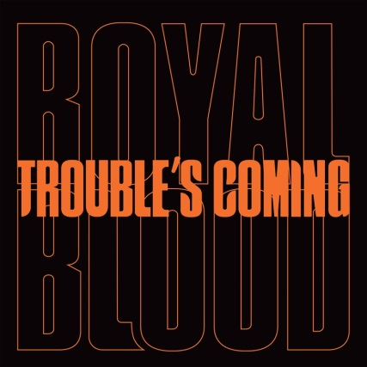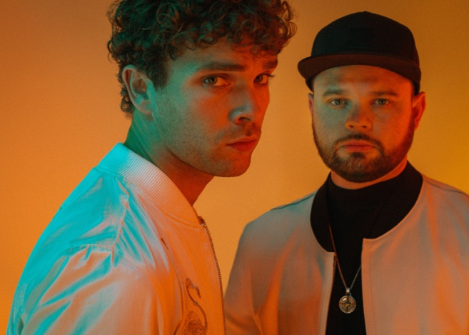
(Click here for hi-res artwork - Photo Credit: Dean Martindale)

September 24, 2020 (Los Angeles, CA) - In the space of just two albums, Royal Blood have ascended to become one of the world’s biggest and most vital rock bands. The Brighton duo have scored two UK #1 albums - their self-titled double-Platinum debut from 2014 and 2017’s How Did We Get So Dark? – in the process selling 2 million albums worldwide. Their acclaim has included the BRIT Award for Best British Group plus further accolades at the NME and Kerrang! Awards as well as a Mercury Prize nomination. What’s more, they’ve made a major international impact, hitting the Top 10 in a further seven territories and peaking at #2 on the US Alternative Album chart. Further US success has included three #1 hits at Rock Radio and four Top 20 hits at Alternative Radio. Pitchfork raved about their album debut and proclaimed, “This Brighton bass and drums duo have swiftly become the most universally deified emergent UK rock band in years. Royal Blood are, for many Britons, not just The Only Band That Matters, but The Only Band, period.”

All of which positions their upcoming third album, due next spring, to be one of 2021 most essential releases. Royal Blood now add to the anticipation for the record by sharing its first single “Trouble’s Coming.” If you think you know what to expect from Royal Blood, think again. Their patented, granite-heavy bass and drums attack is now flavored by fresh influences: Daft Punk, Justice and the late Phillipe Zdar (one- half of Cassius and producer for the likes of Sébastien Tellier and Hot Chip). As a result, “Trouble’s Coming” infuses Royal Blood’s bombastic up-tempo energy with beats.

“Trouble’s Coming” concisely tees up what to expect from Royal Blood’s third album: a very organic infusion of their visceral hard rock sting with a disco-tinged rhythm that grooves rather than pummels and as the duo started work on the project, which they largely produced themselves at The Church and Sleeper Sounds in London, the song proved to be the turning point in the creative process.

As vocalist/bassist Mike Kerr explains: “It was the moment something started to click - where we started playing over those much more rigid dance beats. The breakthrough was realizing that there was real common ground between that and what we’d done before. It’s that AC/DC aspect: where the quality that makes the riffs seem so cutting is because of that beat. Although on the surface we were stepping outside what we’d done before, it didn’t feel at all unnatural; it felt like we were returning to music we’d loved from the very beginning: Daft Punk, Justice, things that were really groove-orientated. It was all about the beat. It felt like familiar territory, but something we’d censored in ourselves.”

Drummer Ben Thatcher adds, “When we first broke out, there were only two elements to the band. I didn’t just have to carry the beat, I’d have to color in the changes. We were both bearing a lot of freight, sonically. But this was a different challenge; less varied, maybe, but so satisfying as a drummer.”

Lyrically, “Trouble’s Coming” is about looking inwards to recognize the warning signs before a situation erupts into chaos. It could also be seen as an allegory for Royal Blood’s own experience. Success is more complicated than it first seems, and the demands it brings makes finding the time to regain perspective ever more elusive.

A huge draw in the live arena, Royal Blood’s most recent full-scale UK and Ireland headline tour saw them perform in front of 100,000 people, including 30,000 over three sold-out nights at London’s Alexandra Palace. Key festivals have included Glastonbury (where they famously discovered, mid-set, that their second album had debuted at #1), Radio 1’s Big Weekend, Reading and Leeds. Highlights of their extensive international touring include a huge North American tour with Queens of the Stone Age and Foo Fighters, plus headline shows as far afield as Los Angeles, Tokyo and Sydney.

Royal Blood:
Mike Kerr (vocals, bass, keys, piano) and Ben Thatcher (drums)

For all Royal Blood inquiries, please contact Rick Gershon at Warner Records Publicity rick.gershon@warnerrecords.com

Follow Royal Blood:
Website | Facebook | YouTube | Twitter | Instagram | Spotify | Press Materials

