Grammy-Winning RÜFÜS DU SOL Reveal Second Leg of 2022 North American ‘Surrender’ Tour

Featuring Support From Paraleven, WhoMadeWho and Bora Uzer on Select Dates

Presale Sign-Up Available at https://www.rufusdusol.com/tour

General On-sale Starts Friday, April 8 at 10AM Local

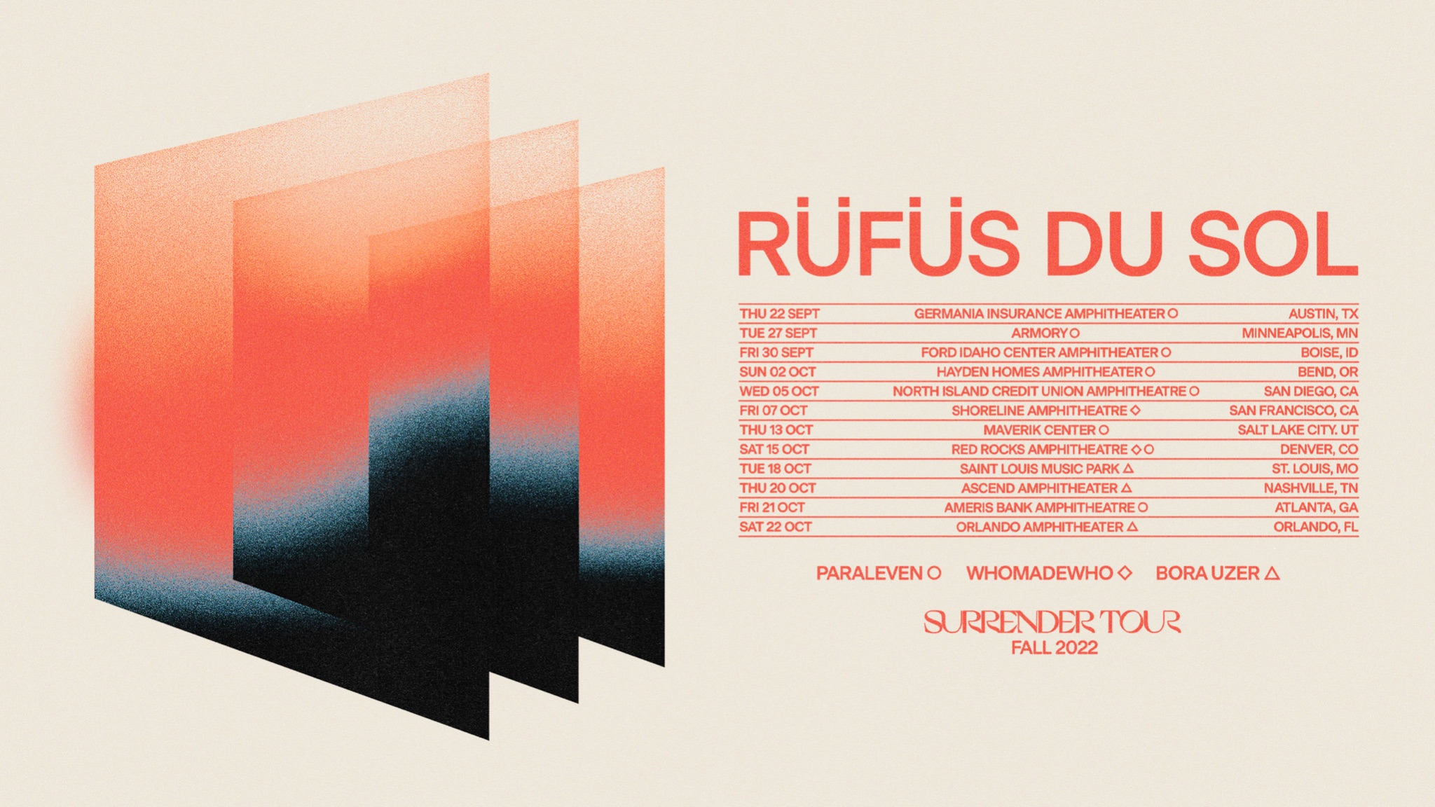

Grammy-winning live electronic trio RÜFÜS DU SOL today announced the second leg of their highly anticipated North American ‘Surrender’ Tour. The tour, produced by Live Nation, will bring their esteemed live show to an additional 12 US markets, for a total of 19 cities across North America and will feature Paraleven, WhoMadeWho, and Bora Uzer on select dates.

Sign up for the ‘Surrender’ Tour: https://www.rufusdusol.com/tour

The Summer leg of the ‘Surrender’ tour has already seen significant success, with over 24,000 tickets sold across two nights in Forest Hills, NY and a stint at Woodbine Park in Toronto, ON selling out at 15,000 capacity. Additionally, the performance lined up in Chicago, IL has seen such high demand that the Huntington Bank Pavilion at Northerly Island opened its lawn to accommodate more fans.

The added September and October dates of the ‘Surrender’ tour kick off in Del Valle, TX at the Germania Insurance Amphitheater on September 22, and wrap on October 22 in Orlando, FL at the Orlando Amphitheater. In between, RÜFÜS DU SOL will travel to esteemed venues like the Red Rocks Amphitheatre in Morrison, CO; Ascend Amphitheater in Nashville, TN; Shoreline Amphitheatre in Mountain View, CA and more.

Their fourth studio album Surrender was released in October 2021, on Rose Avenue and Reprise / Warner Records. With over 106 million times across platforms, hit single ‘Alive’ went on to win Best Dance/Electronic Recording this past weekend in the 2022 Grammy Awards. Their live show also reached new heights as they played for 70,000 fans at the Los Angeles Banc of California stadium over three nights and for millions on Jimmy Kimmel Live! and The Late Late Show with James Corden.

Surrender caused a passionate stirring amongst RÜFÜS DU SOL fans as lockdown regulations eased and the promise of live music returning to the stage grew once more. RÜFÜS DU SOL captivated audiences during festival performances at Outside Lands in San Francisco, Governors Ball in New York, III Points Miami and more; while fans also filled out venues for their 2021 North American Fall tour that graced US cities across the Southwest.

The expansive ‘Surrender’ Tour is the most recent live performance announcement to come from band since wrapping up a double-weekender at Sundream Tulum, RÜFÜS DU SOL’s debut destination event that brought world-class music and wellness to an international crowd of music enthusiasts at Papaya Playa Project in Quintana Roo, MX.

Public On Sale: Friday, April 8 at 10AM Local on https://www.rufusdusol.com/tour

Complete ‘Surrender’ Tour Dates

Wed Jun 01 - Chicago, IL - Huntington Bank Pavilion at Northerly Island

Thu Jun 02 - Detroit, MI - Michigan Lottery Amphitheatre at Freedom Hill

Fri Jun 03 - Toronto, ON - Woodbine Park

Sat Jun 04 - Montréal, QC - Parc Jean-Drapeau

Tue Jun 07 - Philadelphia, PA - Skyline Stage at the Mann

Wed Jun 08 - Washington, DC - DC Armory

Fri Jun 10 - Forest Hills, NY - Forest Hills Stadium*

Fri Jun 11 - Forest Hills, NY - Forest Hills Stadium*

Thu Sep 22 – Del Valle, TX – Germania Insurance Amphitheater^

Tue Sep 27 – Minneapolis, MN – The Armory^

Fri Sep 30 – Nampa, ID – Ford Idaho Center Amphitheater^

Sat, Oct 01 – George, WA – The Gorge Amphitheatre

Sun Oct 02 – Bend, OR – Hayden Homes Amphitheater^

Wed Oct 05 – Chula Vista, CA – North Island Credit Union Amphitheatre^

Fri Oct 07 – Mountain View, CA – Shoreline Amphitheatre^

Thu Oct 13 – West Valley City, UT – Maverik Center^

Sat Oct 15 – Morrison, CO – Red Rocks Amphitheatre^

Tue Oct 18 – Maryland Heights, MO – Saint Louis Music Park^

Thu Oct 20 – Nashville, TN – Ascend Amphitheater^

Fri Oct 21 – Alpharetta, GA – Ameris Bank Amphitheatre^

Sat Oct 22 – Orlando, FL – Orlando Amphitheater^

^Newly added date
*non-Live Nation shows

Follow RÜFÜS DU SOL
Website | Facebook | Instagram | Twitter | Spotify | SoundCloud

###

About Live Nation Entertainment
Live Nation Entertainment (NYSE: LYV) is the world’s leading live entertainment company comprised of global market leaders: Ticketmaster, Live Nation Concerts, and Live Nation Sponsorship. For additional information, visit www.livenationentertainment.com.

MEDIA CONTACTS

Warner Records
Darren Baber | darren.baber@warnerrecords.com

Live Nation Concerts
Monique Sowinski | moniquesowinski@livenation.com

INFAMOUS PR
Maxfield Frieser | mfrieser@infamouspr.com

