SOFÍA VALDÉS RETURNS WITH NEW ETHAN GRUSKA-PRODUCED SINGLE
“I HATE THE BEATLES”

WATCH THE MUSIC VIDEO DIRECTED BY SATCHEL LEE HERE

“an eclectic singer-songwriter who’s a total vibe.” - BILLBOARD

“Valdés crafts music that feels like it was somehow made using beach sand and turquoise water, her voice a comforting breeze over smooth melodies.” - INTERVIEW MAGAZINE

“Valdés’ music is often subtle, calm—cozy, even. But still waters run deep.” - AMERICAN SONGWRITER

Panamanian singer-songwriter Sofía Valdés returns this week with a new single titled “I Hate the Beatles,” produced by Ethan Gruska (Phoebe Bridges). The track serves as a metaphor for Valdés’ past romantic and personal relationships with men who have all been Beatles fans and have led to disappointment and detachment. A natural maturation from her debut EP Ventura, “I Hate The Beatles” sees Valdés reflect on the experiences of her youth and how they’ve informed her outlook on love.

When discussing the track, Sofía says “Looking back the Beatles have been incredibly instrumental in my life and those I love. Music marks a time in people’s lives and when I take time to reflect on that the constant presence is always the Beatles, but also, those times have changed and are no longer there. So in some ways I Hate The Beatles is a love song to the past, and a way for me to stop time and think about days gone by and share a piece of my life and family history with you all.”

Director Satchel Lee says, “As soon as I heard “I Hate The Beatles” I pictured this one shot sequence in my head. I had a great time bringing this idea to life with the help of our incredible crew. Sofia wrote such a beautiful song and I feel really lucky that I was able to make my own contribution to this moving piece of art. “

The release is paired with a visual, directed by photographer/director Satchel Lee, that portrays Sofía in a decaying romantic cycle. Watch the video HERE.

Sofía Valdés creates the kind of emotionally honest pop music that could only come from years of exploration. Her 2021 debut EP Ventura synthesizes those inspirations into a sound of her own. Valdés has since garnered praise from the likes of W Magazine, Interview Magazine, V Magazine, etc. The 20-year-old also caught the eye of the renowned luxury brand, Chanel, who tapped her as a brand ambassador for their Latin American market. She made her digital debut at Sundance Film Festival, performing at their 2021 Sound & Vision event, and performed a set for NPR "World Cafe” from her home in Panama. She has appeared on multiple playlists including Chill Latino (Spotify) and Chilled Pop (Apple Music), and was featured on WXPN, along with additional radio rotation in key markets such as Dallas, New York, Nashville, and more.

LISTEN TO “I HATE THE BEATLES”
https://sofiavaldes.lnk.to/ihatethebeatles

WATCH THE VIDEO FOR “I HATE THE BEATLES”
https://www.youtube.com/watch?v=qDF5tAqVqtY

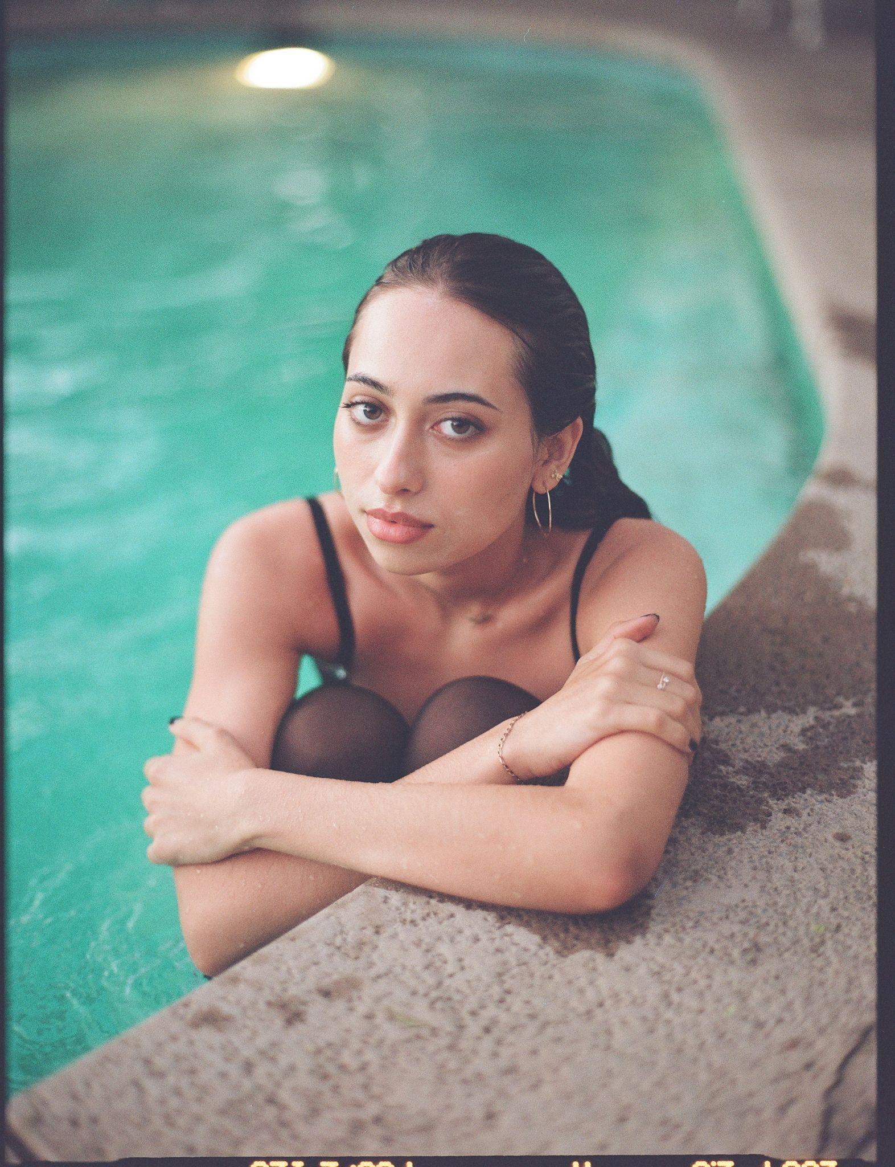
PHOTO CREDIT: Carissa Gallo

FOLLOW SOFÍA VALDÉS
INSTAGRAM
FACEBOOK
YOUTUBE
WEBSITE

PRESS INQUIRIES
Dana Meyerson / Biz 3 dana@biz3.net
Tori Johnson / Biz 3 tori@biz3.net

