SOFÍA VALDÉS ANNOUNCES
NEW EP IN BLOOM

LISTEN TO “CARBON COPY” AND WATCH THE SATCHEL LEE DIRECTED VIDEO

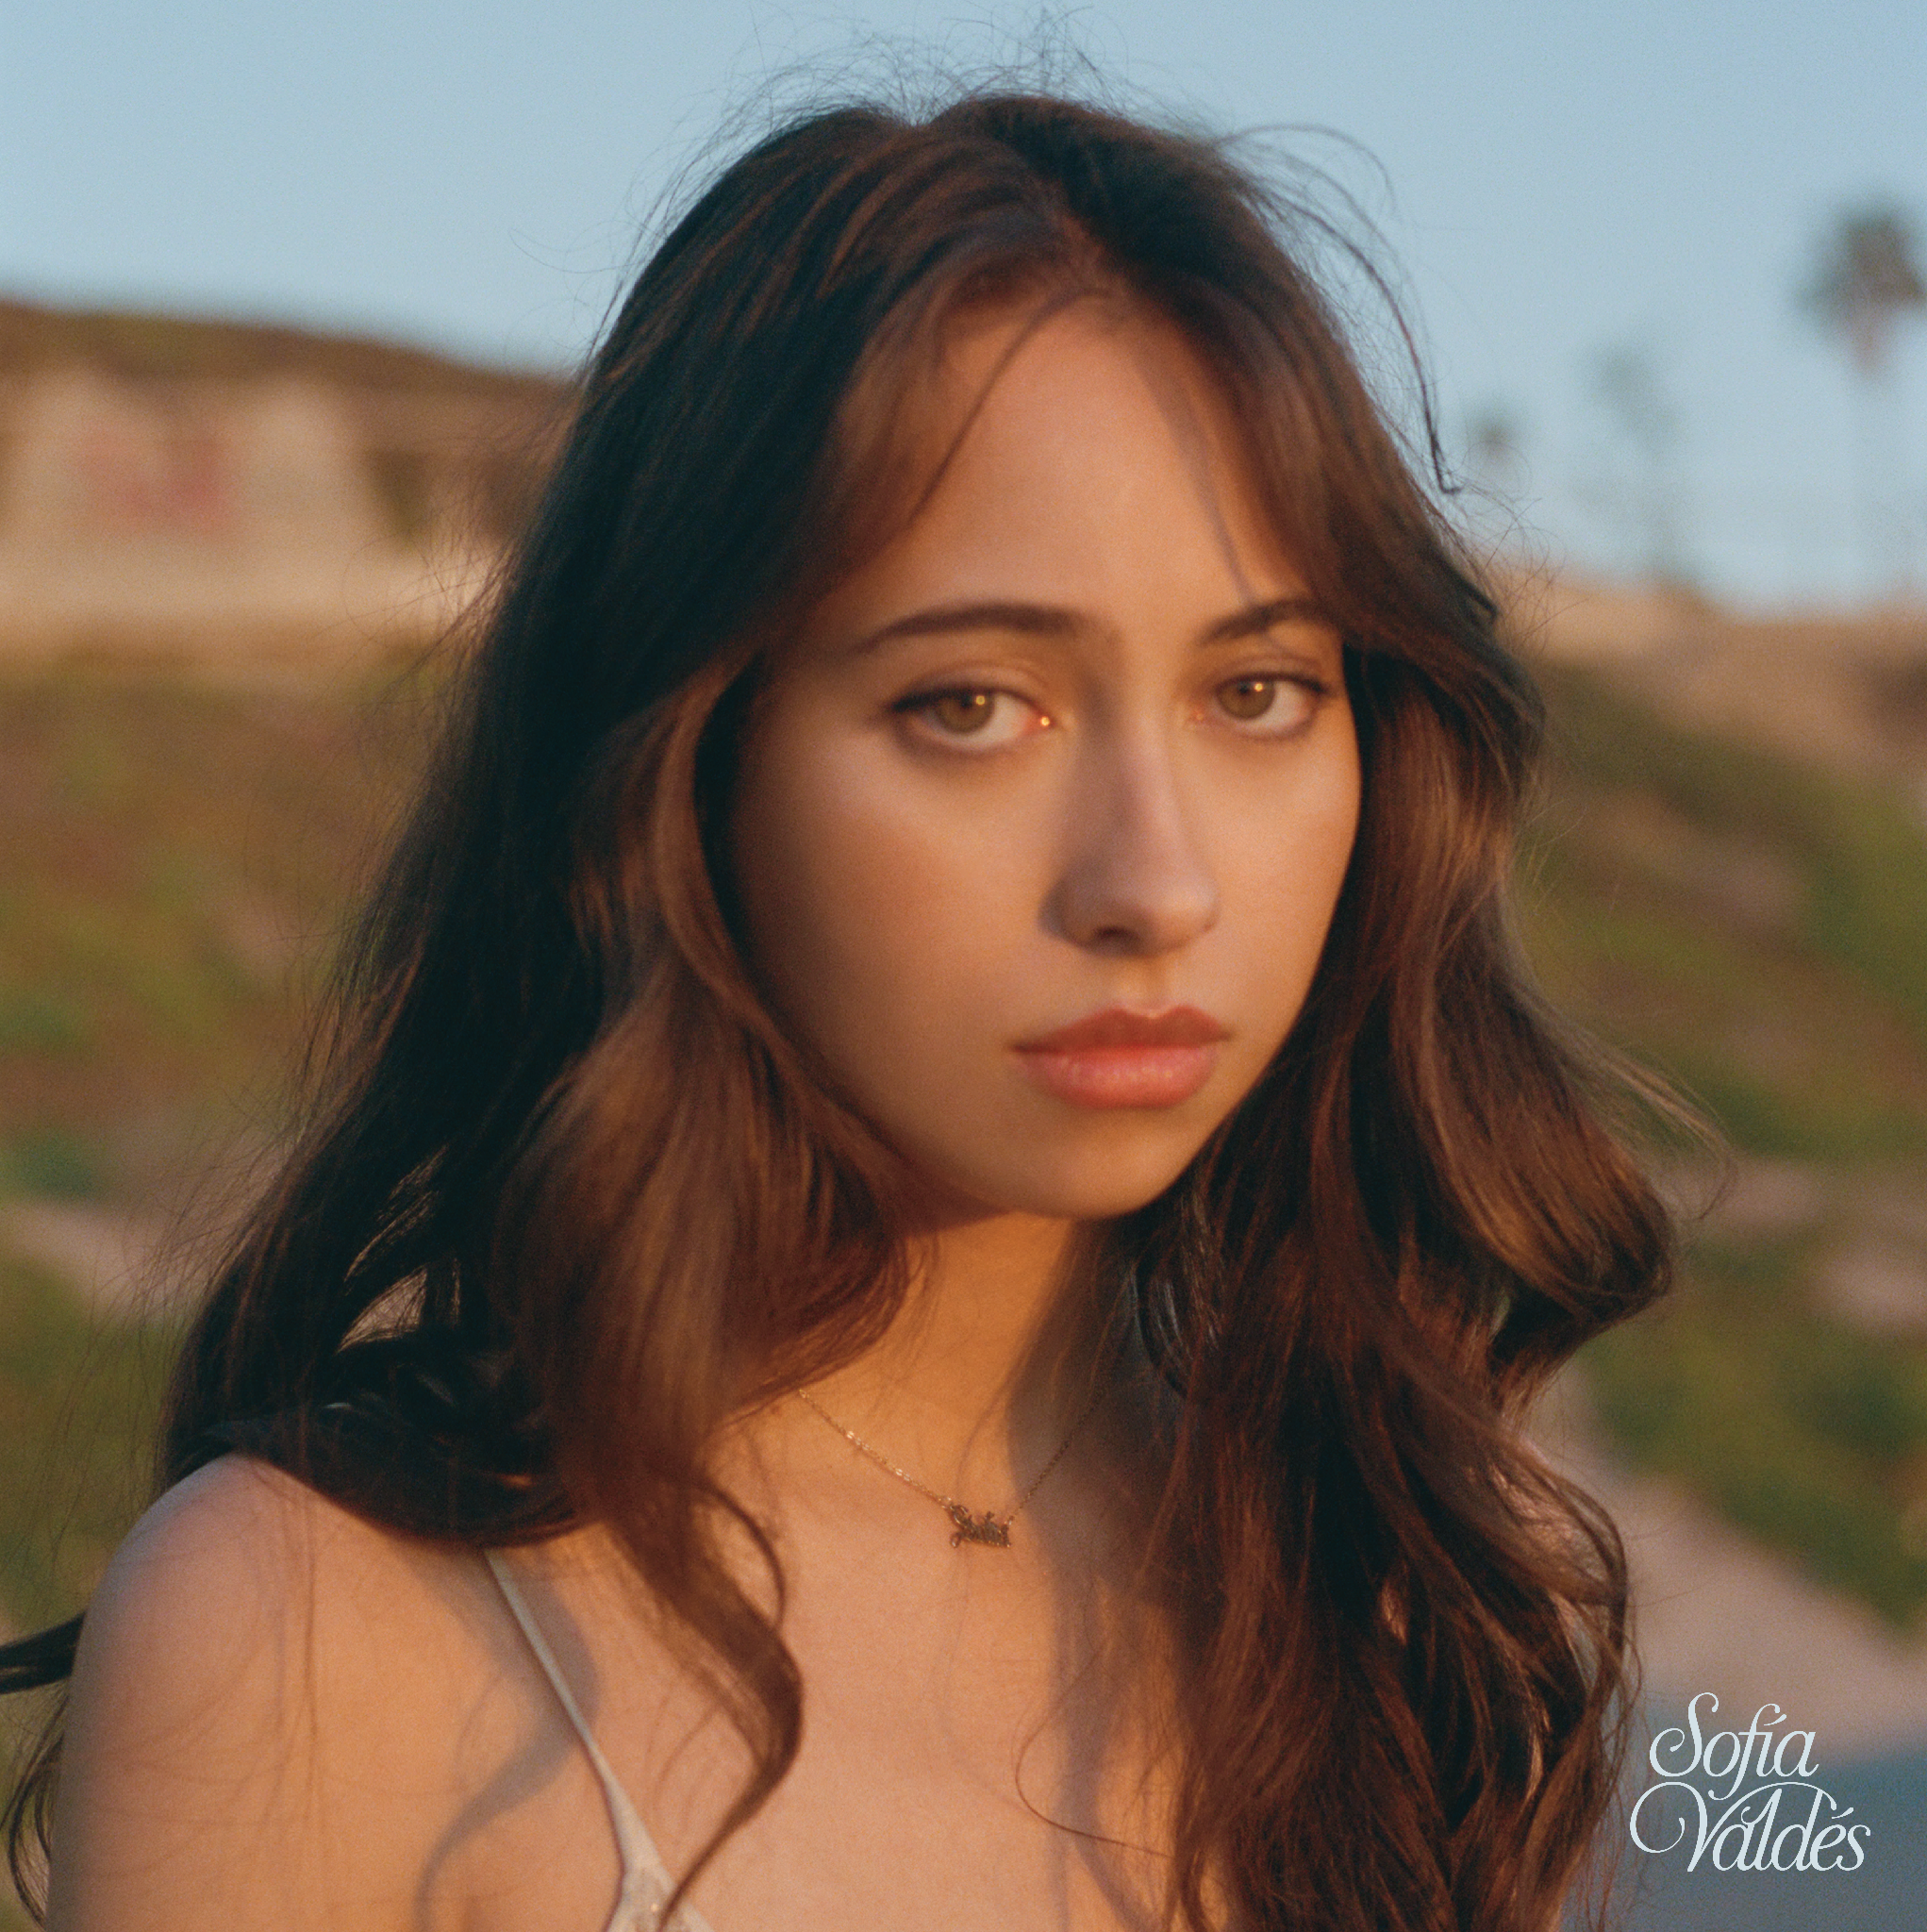
PHOTO CREDIT: SATCHEL LEE

“an eclectic singer-songwriter who’s a total vibe.” - BILLBOARD

“Valdés crafts music that feels like it was somehow made using beach sand and turquoise water, her voice a comforting breeze over smooth melodies.” - INTERVIEW MAGAZINE

“Valdés’ music is often subtle, calm—cozy, even. But still waters run deep.” - AMERICAN SONGWRITER

Panamanian singer-songwriter Sofía Valdés returns this week with new heartfelt ballad “Carbon Copy” from her forthcoming sophomore EP In Bloom out May 13 via Warner Records. The track highlights Sofía’s timeless songwriting as she explores the emotional turmoil of being replaced by someone that looks just like her. The accompanying music video, directed by Satchel Lee (daughter of Spike Lee), matches the angst and longing captured in Sofía’s writing. Sofía walks a lonely beach road and sits alone in her room pouring out her heart to the lost love who is now nothing more than a memory. On writing the song, Sofía says, “The song is about a breakup and how it can affect one person, but in this particular case he goes off and finds someone who looks just like me. So it's basically a song about how I came to grips with losing him, but then having to see myself in another person. The grief of losing someone you love is complicated, but the pain and anxiety surrounding seeing yourself in another woman is devastating.”

Since her 2021 debut EP Ventura, Valdes recently released the Ethan Gruska (Phoebe Bridgers, Bon Iver, etc) produced track “I Hate The Beatles” and accompanying Satchel Lee directed visual where Sofía explores her relationship to past-lovers and highlighted her growth as an artist, cementing her as an artist to watch for 2022. Valdés has garnered praise from the likes of W Magazine, Interview Magazine, V Magazine, Nylon, Flood, People Magazine and caught the eye of the renowned luxury brand, Chanel, who tapped her as a brand ambassador for their Latin American market. She performed a set for NPR "World Cafe” from her home in Panama and made her US festival debut in 2021 at Lollapalooza, Outside Lands. She has appeared on multiple playlists including Chill Latino (Spotify) and Chilled Pop (Apple Music), and was featured on WXPN, along with additional radio rotation in key markets such as Dallas, New York, Nashville, and more.

LISTEN TO “CARBON COPY”
https://SofiaValdes.lnk.to/carboncopy

WATCH THE “CARBON COPY” VIDEO
https://SofiaValdes.lnk.to/carboncopyvideo

PRE-SAVE IN BLOOM EP
https://SofiaValdes.lnk.to/inbloom

WATCH THE VIDEO FOR "I HATE THE BEATLES"
https://www.youtube.com/watch?v=qDF5tAqVqtY

FOLLOW SOFÍA VALDÉS
INSTAGRAM
FACEBOOK
YOUTUBE
WEBSITE

PRESS INQUIRIES
Dana Meyerson / Biz 3 dana@biz3.net
Tori Johnson / Biz 3 tori@biz3.net

