**CANADIAN POP SINGER/SONGWRITER SCOTT HELMAN HONORS HIS GRANDFATHER IN EMOTIONAL NEW TRACK “PAPA”**

**WATCH THE RAW VIDEO** [**HERE**](https://youtu.be/caDKJvGIwD0)

**NEW ALBUM *NONSUCH PARK (sa)* – OUT SEPTEMBER 4**

[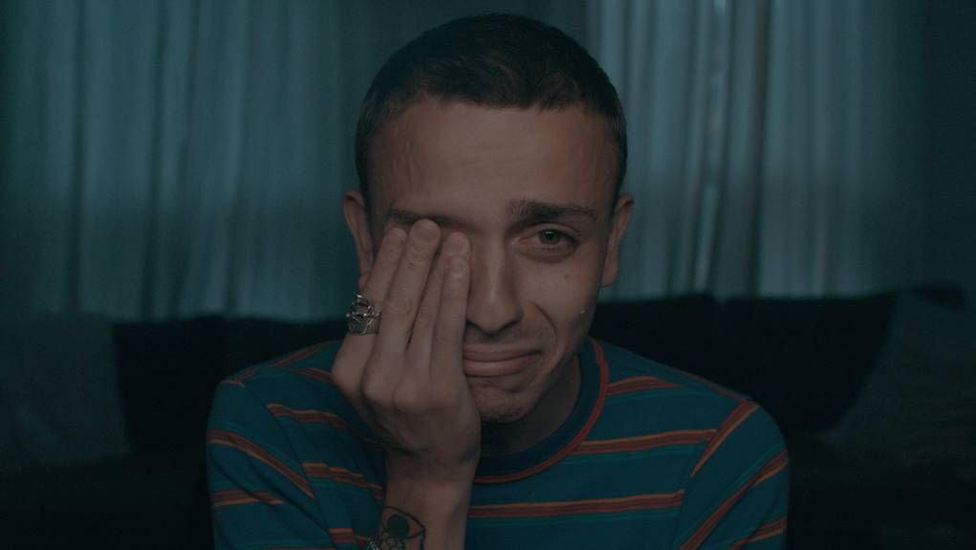](https://nam04.safelinks.protection.outlook.com/?url=https://vimeo.com/439359217/74c2c44f6f&data=02|01|Patrice.Compere@warnerrecords.com|aed10f4266c3481d7c1208d82e64155e|8367939002ec4ba1ad3d69da3fdd637e|0|0|637310354674685954&sdata=MEi5K%2BjXee6i3Wf%2BT2uUqBlVnt9VMjD9KJwPox%2BF28o%3D&reserved=0)

**July 24, 2020 (Los Angeles, CA) –** Today, Canadian pop singer/songwriter Scott Helman shares emotional new track [“Papa,”](https://warnerrecords.lnk.to/SHPapa) a tribute to his late grandfather Alan. Scott created a strikingly raw video to accompany the release, sharing his completely unedited reaction while watching the personal home video footage for the very first time. “Papa” is the latest release from the first installment of *Nonsuch Park* – an album series – due out September 4 via Warner Records, which will also feature current lead single [“Wait No More,”](https://www.youtube.com/watch?v=bPZcCdrcru0) and hit track [“Everything Sucks.”](https://nam04.safelinks.protection.outlook.com/?url=https%3A%2F%2Fwww.youtube.com%2Fwatch%3Fv%3DbHdaSx3L9_w&data=02%7C01%7CPatrice.Compere%40warnerrecords.com%7C47e1b646349448277a3608d76deba3ec%7C8367939002ec4ba1ad3d69da3fdd637e%7C0%7C0%7C637098731139115775&sdata=x5A1K6HPyAS5xkmxGT2YybyPiCsHwqpweRS591TBK0I%3D&reserved=0) *Nonsuch Park (sa)* is available now for pre-order [here](https://scotthelman.lnk.to/nonsuchparksa).

The release of “Papa” follows the explosive launch of Scott’s current single “[Wait No More](https://nam04.safelinks.protection.outlook.com/?url=https%3A%2F%2Fscotthelman.lnk.to%2FWaitNoMorePR&data=02%7C01%7CPatrice.Compere%40warnerrecords.com%7Cffb81732e41147a2f0fd08d82de820c6%7C8367939002ec4ba1ad3d69da3fdd637e%7C0%7C0%7C637309822309787303&sdata=VsvAaQwteMP8Q8rY1pysOx%2F7ccVwY0L3kyCWU3KSuAs%3D&reserved=0),” which continues its rise after making its debut as the #1 most added song at Canadian radio. The five-time JUNO Award nominee has dominated the Canadian music scene over the past few years, with two platinum and three gold certifications to date, plus collaborations with Alessia Cara and Hunter Hayes, as well as tours with the likes of Tegan and Sara, Shawn Mendes, Vance Joy, Walk Off The Earth, and Dean Lewis.

Scott explains, *“This album is about my changes, my growth, my hardships, my celebrations, my fears, my courage and my love. Each person has a sanctuary within – a place they can return to where things make sense, where the tides are kind, where colours are bright and their lives feel meaningful. For me that place was the large park just down the road from my Papa’s house in Sutton, UK – Nonsuch Park. It was here where we would walk and cackle at awful jokes, lean in for the stories, make peace with our busy lives and draw meaning from the lessons we had learned since our last visit.* *This work is a declaration – a declaration of love, meaning, questions and truth, and it is all dedicated to you, Papa.”*

***NONSUCH PARK (sa)* TRACK LIST:**

1. (nonsuchpark)
2. Wait No More
3. Lois
4. Good Problems
5. Evergreen
6. (california)
7. Afraid Of America
8. Everything Sucks
9. True Crime
10. (meetagain)
11. Papa



*Nonsuch Park (sa) album artwork. Hi-res available* [*here*](http://press.warnerrecords.com/scott-helman/)

###

**For further information, contact:**

Patrice Compere / [Patrice.Compere@warnerrecords.com](mailto:Patrice.Compere@warnerrecords.com)

Jaime Rosenberg / [Jaime.Rosenberg@warnerrecords.com](mailto:Jaime.Rosenberg@warnerrecords.com)

**Follow Scott Helman:**

[Press Assets](http://press.warnerrecords.com/scott-helman/) | [Website](http://scotthelmanmusic.com/)| [Facebook](https://www.facebook.com/scotthelmanmusic) | [Twitter](https://twitter.com/scotthelman) | [Instagram](https://www.instagram.com/scotthelman/) | [YouTube](https://www.youtube.com/user/scotthelmanmusic/)

cid:image005.jpg@01D59FA6.454672D0