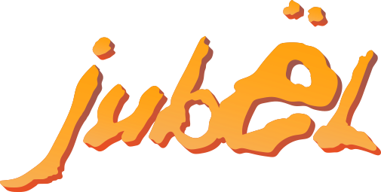
SWEDISH POP-DUO JUBËL RELEASES RENDITION OF NE-YO’S “SO SICK”
- LISTEN HERE

ADDS THEIR TRADEMARK SOUND OF BREEZY SUMMER FEEL GOOD VIBES TO THE ORIGINAL TRACK’S SMOOTH RNB

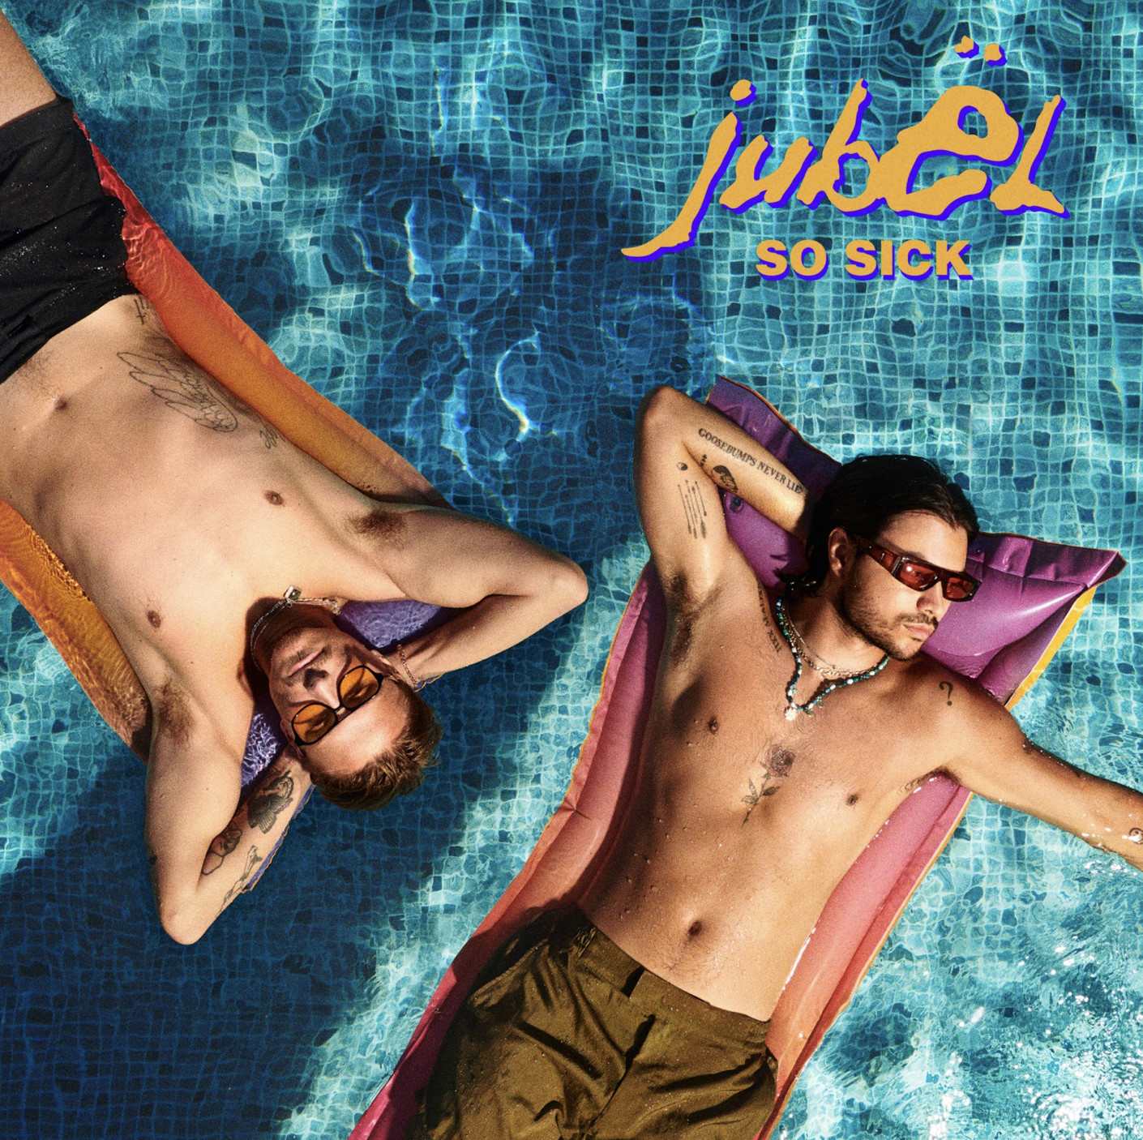
High Res Here - Credit: Jubël

Friday, April 1, 2022 (Los Angeles, CA) - Today, Swedish pop-duo, Jubël, shares their rendition of Ne-Yo’s “So Sick.” Listen to “So Sick” HERE via Warner Records. On “So Sick,” the duo is staying true to the original’s smooth RnB while adding their trademark sound of organic guitars and breezy summer feel good vibes.

The Swedish duo has been performing “So Sick” live and at radio shows for years, as Ne-Yo’s “So Sick” was a personal favorite of the duo growing up. After being requested by fans, Jubël is finally releasing it as a single along with a behind-the-scenes making of the track. Watch the BTS footage here.

Today’s release follows the massive success of Jubël’s breakthrough track “Dancing In The Moonlight” ft NEIMY, which received multi-platinum certifications across Europe and a remix from Tiësto himself while landing #1 on the UK radio play chart and Top 10 on the UK airplay year-end chart.

“We’re like a live band with electronic elements and influences,” Jubël says. “We have songs with pop-structures, but it's all very danceable, four-on-the-floor music.” That winning formula has garnered the chart-topping, platinum-selling group millions of cross-platforms streams – all within a couple short years.

Consisting of Sebastian Atas as primary producer and lead vocalist and Victor Sjöström as the key songwriter and player of all instruments, both artists started off in their local EDM scene with Victor DJing and Sebastian producing. With nearly 700 million streams worldwide, Jubël continues to deliver dance-pop hits like “Dancing In The Moonlight,” as well as “Weekend Vibe” and “Dumb” off of their 2021 EP, 6115 Orange Street which received acclaim from FLAUNT, The Music Essentials and more.

For more information, contact:
Connor Hunt | Warner Records
Connor.Hunt@warnerrecords.com

Follow Jubël:
Instagram | YouTube | Facebook | TikTok | Press Materials



