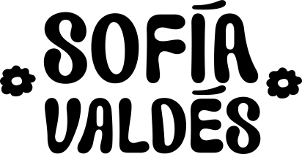

PANAMANIAN SINGER/SONGWRITER SOFÍA VALDÉS UNVEILS LUSH NEW TRACK “HANDFUL OF WATER”

Watch the Video Here

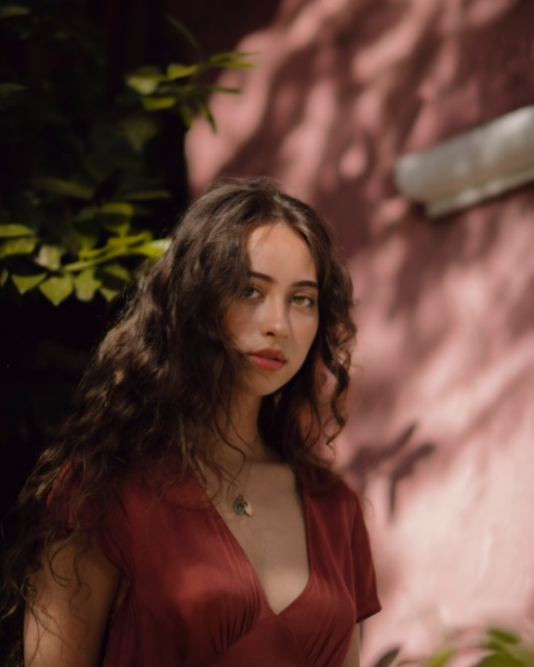
Photo Credit: Val Schnack

October 16, 2020 (Los Angeles, CA) — Panamanian singer/songwriter Sofía Valdés unveils lush new song “Handful of Water,” the latest taste of her forthcoming Ventura EP coming early next year on Warner Records. On “Handful of Water,” the lyrics sometimes drift into Spanish—an unintentional deviation Valdés ultimately chose to keep in the final version, in recognition of her multi-cultural musical heritage. The song is released alongside a gorgeous self-shot video filmed in Hawaii.

Listen/Share “Handful of Water” HERE

Last month, Sofía shared her poignant, dreamy pop music with the world for the first time with the release of “Little Did I Know,” the debut track off Ventura, which she co-produced. The writing and recording process has brought her even closer to her roots, which FLAUNT describes as, “a rich Latin heritage that bleeds through her music and everyday life… she injects emotion and honesty into her smooth, sultry, pop ballads.”

In some ways, the singer has been preparing for her debut since first picking up a guitar at age 8, but music has always been in her blood. Her great-grandfather was legendary Cuban musician Miguelito Valdés, and her great-great grandmother was Silvia De Grasse, a Panamanian singer who once performed with Louis Armstrong. Growing up, Valdés learned English by listening to pop, before expanding her palate with British folk, ’60s Motown, ’70s soul, classical, and bossa nova. As a blossoming bilingual songwriter, she’s come to embrace all of this inspiration, subtly weaving it into a sound that’s refreshingly light and lush.

Sofía explains, “The deeper I get into working on my music, the more I realize how much it’s connected to the music that people in my family were making a long time ago. Now I want everyone to know that my culture is amazing, that I’m so proud of it, and that everyone else should be proud of their culture too.”

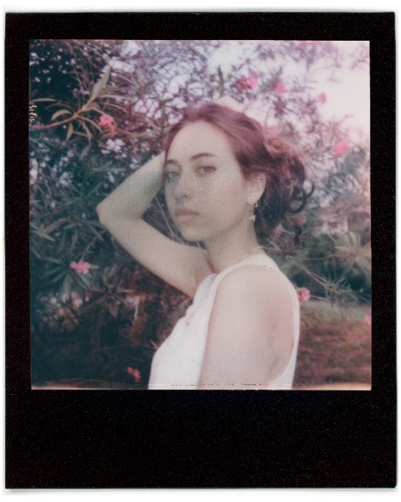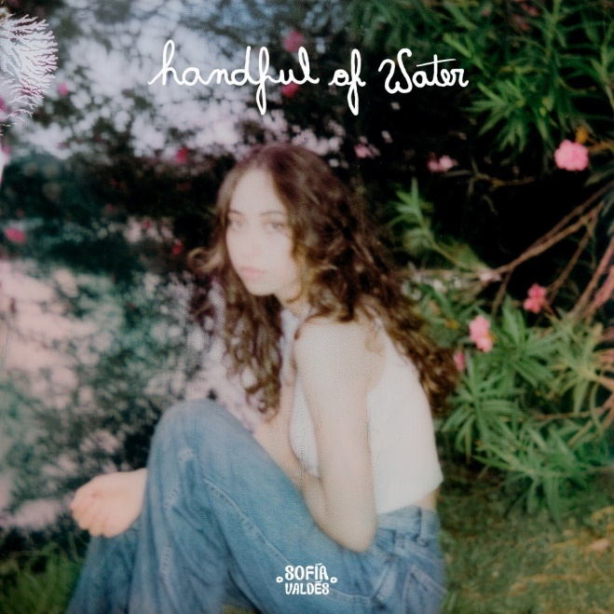
Photo Credit: Titi Motta “Handful of Water” Artwork

For more information on Sofia Valdés, please contact Jaime Rosenberg:
Jaime.Rosenberg@warnerrecords.com

Or visit:
Website Instagram Facebook Twitter YouTube

