SOFÍA VALDÉS RELEASES SPANISH VERSION OF “AMSTERDAM”

VENTURA DEBUT EP OUT NOW ON WARNER RECORDS

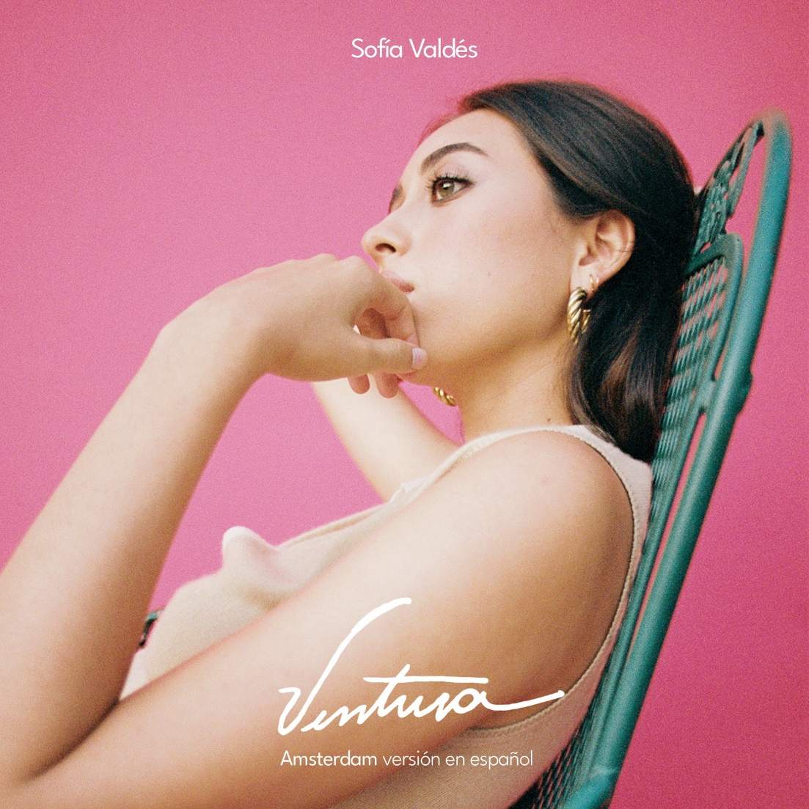

Panamanian singer/songwriter Sofía Valdés shares a Spanish version of “Amsterdam” from her debut EP, Ventura released in February of this year. The single details the pain of wanting to be with someone when they’ve since moved on to be with someone else. Sofia’s music offers a unique quality of being relatable to anyone who has experienced heartbreak while avoiding cliche. The song begins and ends with a scratched sample of a Spanish poem, “El Mar” by Jorge Luis Borges. This paired with the kinetic hand percussion, inspired by sounds she heard growing up in Panama, beautifully displays Valdés’ musical talent.

Upon releasing her EP Ventura Valdés felt a deep connection to her cultural roots, the singer noting that, “The deeper I get into working on my music, the more I realize how much it’s connected to the music that people in my family were making a long time ago.” Beyond her cultural background, Valdés has a lineage of musical inspirations in her own family. Her great-grandfather was the legendary Cuban musician Miguelito Valdés, and her great-great grandmother was Silvia De Grasse, a famed Panamanian singer who once performed with Louis Armstrong.

Though Valdés just released her first EP, she has already received early press praise from W Magazine, Interview Magazine, V Magazine, ColorsxStudio and more. She made her digital Sundance Film Festival debut in January, performing at the 2021 official music event, Sound & Vision, and performing a set for NPR "World Cafe" from her home in Panama. She has appeared on multiple playlists including Chill Latino (Spotify) and Chilled Pop (Apple Music), a artist featured on WXPN/Philly’s “Artist To Watch” for April, along with additional radio rotation in key markets such as a Dallas, New York, Nashville, and more. She was recently confirmed on the lineup for the Outside Lands festival taking place in San Francisco, California in late October 2021, which will be her US festival debut.

LISTEN TO “AMSTERDAM”
https://sofiavaldes.lnk.to/amsterdamespanol

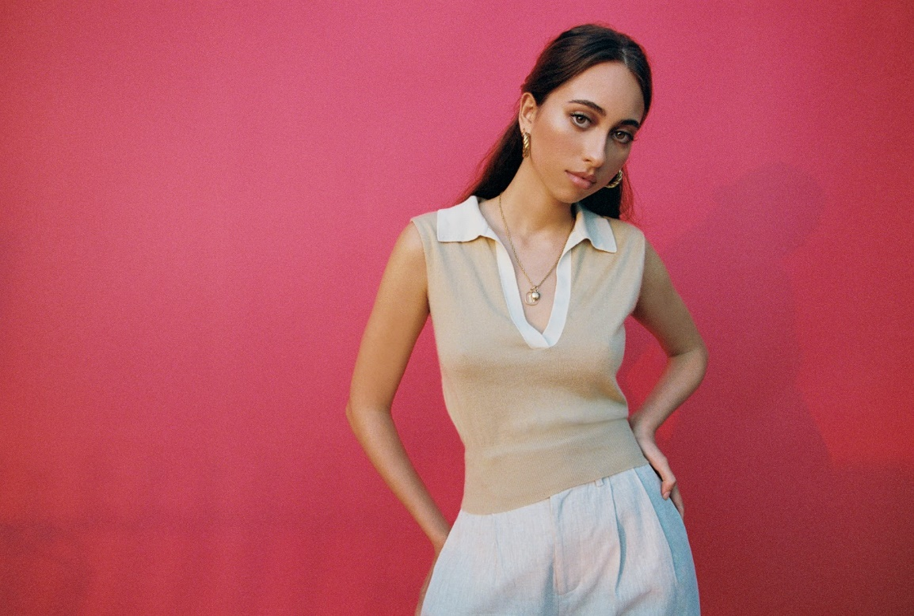
PHOTO CREDIT: JULIAN BURGUEÑO

FOLLOW SOFÍA VALDÉS
INSTAGRAM
FACEBOOK
YOUTUBE
WEBSITE

PRESS INQUIRIES
Dana Meyerson / Biz 3 dana@biz3.net | Tori Johnson / Biz 3 tori@biz3.net

