

**THE FLAMING LIPS ANNOUNCE THEIR FIRST OFFICIAL LIVE ALBUM**

[***THE SOFT BULLETIN RECORDED LIVE AT RED ROCKS WITH THE COLORADO SYMPHONY ORCHESTRA***](https://FlamingLips.lnk.to/SoftBulletinLivePreSave)

**Featuring their groundbreaking 1999 album performed live with full orchestra and choir conducted by Andre De Ridder**

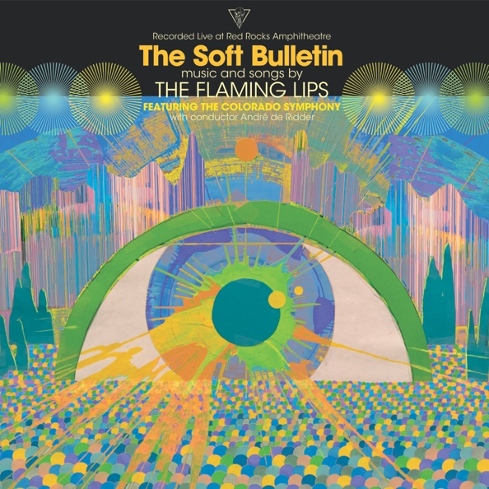

**October 18, 2019 (Los Angeles, CA)** – On May 26, 2016, [**THE FLAMING LIPS**](https://protect-us.mimecast.com/s/BKzQCW6jqZh8WEOxi6pKU0) performed their universally acclaimed 1999 Warner Records album [***The Soft Bulletin***](https://open.spotify.com/album/0Gpcuci4CMpKHvZPM34KWg) in its entirety with the Colorado Symphony at Red Rocks Amphitheatre in Morrison, Colorado. This particular event has been regarded by those in attendance as one of the most awe-inspiring, moving and magical moments of a lifetime. For the LIPS and their fans, perhaps the apex of a magnificent interpretation that will remain as rewarding and emotionally-charged as it was that night in 2016. Album pre-orders begin today and will include an instant download of **“**[**Race for the Prize”**](https://flaminglips.lnk.to/SoftBulletinLive)from the album. Additional instant grat downloads will follow on November 15th (**“The Spark That Bled”**). Click [**here**](https://FlamingLips.lnk.to/SoftBulletinLivePreSave) to pre-order and pre-save. Click [**here**](https://FlamingLips.lnk.to/RFPVideo) to view and share the “**Race For The Prize”** visualizer.

**The Flaming Lips** (Wayne Coyne, Steven Drozd, Michael Ivins, Derek Brown, Jake Ingalls, Matt Kirksey and Nicholas Ley) were accompanied by a 69-piece orchestra and 56-strong chorus. The performance was conducted by the internationally celebrated conductor [**Andre de Ridder**](https://en.wikipedia.org/wiki/Andr%C3%A9_de_Ridder).

The Flaming Lips performed the 12-track album in its original sequence with new arrangements for each song that use the full orchestra with chorus to greatest possible effect. Response from the media of the original was overwhelming in its praise:

“This is one of those albums people are going to obsess over for many years to come.” – ***Pitchfork***

“A joyous, celestial celebration of sound.” – ***NME (UK)***

“Once you’ve labored in cult obscurity, fielded rumors that John Tesh wanted to cover once of your songs, appeared on Beverly Hills 90210, composed an orchestra for forty automobile tape decks and enjoyed a Top Forty blip, what do you do for a follow-up? The eccentric Oklahoma outfit The Flaming Lips serenely release another winning neo-psychedelic recording. Densely textured but melodic…No one else has posited a parallel universe in which the Sixties and the Nineties exist simultaneously.” – ***Rolling Stone***

“The Soft Bulletin echoes the oft-mimicked Smiley Smile by The Beach Boys, with its psychedelic wobbliness, songs-within-songs and airy temperament.” – ***Q Magazine (UK)***

“A vertiginous rainbow swirl that crams so many ideas into so many tight spaces that each track is like a perfectly rendered Joseph Cornell box.” – ***Entertainment Weekly***

“Not just the best album of 1999, The Soft Bulletin might be the best record of the entire decade.” – ***All Music***

This entire concert was produced by The Flaming Lips, Scott Booker and their long-time collaborator [**Dave Fridmann**](http://www.davefridmann.com/dave/Main.html). The resulting live album is being released to celebrate the 20th anniversary of ***The Soft Bulletin***, originally released in the summer of 1999. The album was the band’s breakthrough moment and featured the hit singles **“Race for the Prize”** and **“Waitin’ for a Superman.”** The album will be released in all formats as a double vinyl album, CD and digital.

***THE SOFT BULLETIN RECORDED LIVE AT RED ROCKS WITH THE COLORADO SYMPHONY ORCHESTRA* Track list:**

1. Race for the Prize

2. A Spoonful Weighs a Ton

3. The Spark That Bled

4. The Spiderbite Song

5. Buggin’

6. What Is the Light?

7. The Observer

8. Waitin’ for a Superman

9. Suddenly Everything Has Changed

10. The Gash

11. Feeling Yourself Disintegrate

12. Sleeping on the Roof

**# # #**

Contact: **Rick Gershon** at Warner Records 818-953-3473 / [**rick.gershon@warnerrecords.com**](mailto:rick.gershon@warnerrecords.com)

**Follow The Flaming Lips:**

Website: [**www.flaminglips.com**](http://www.flaminglips.com/)

Twitter: [**@TheFlamingLips**](https://twitter.com/theflaminglips)

Facebook: [**Facebook.com/FlamingLips**](http://www.facebook.com/FlamingLips)

YouTube: [**YouTube.com/FlamingLips**](http://www.youtube.com/FlamingLips)

Press Materials: [**http://press.warnerrecords.com/flaminglips/**](http://press.warnerrecords.com/flaminglips/)