THE FLAMING LIPS ANNOUNCE THE WORLD’S FIRST SPACE BUBBLE CONCERT SET FOR DECEMBER 11TH IN OKLAHOMA CITY

TICKETS ON SALE FRIDAY NOVEMBER 13TH AT 10:00AM CT

LIPS SHARE NEW LIVE VIDEO “BROTHER EYE” - WATCH HERE

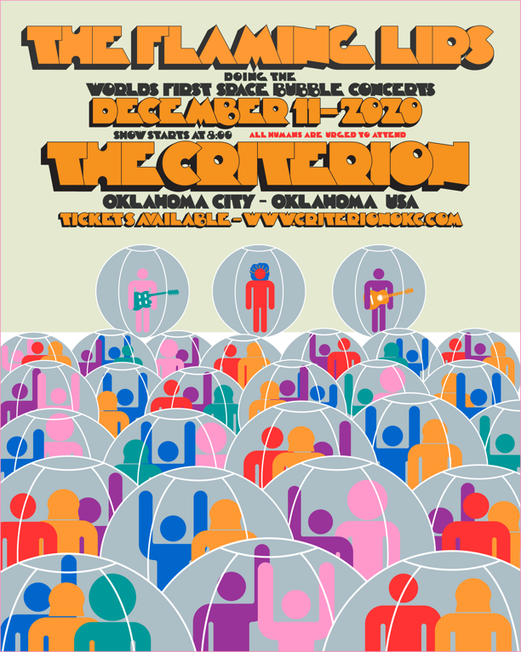

November 12, 2020 (Los Angeles, CA) – Once again, Multiple GRAMMY Award®-winning band The Flaming Lips, make history by staging the world’s first actual Space Bubble live concert set for December 11th at The Criterion in their hometown of Oklahoma City. Tickets go on sale Friday at 10:00 AM CT. Go to criterionokc.com to purchase tickets. Local health and safety standards will be strictly observed. This will be a full-production live Lips extravaganza.
To celebrate this very special, social-distanced, first-of-its-kind prophylactic event, the Lips share a brand new video for “Brother Eye” from their internationally acclaimed Warner Records album AMERICAN HEAD. The video was filmed live at the same venue in Oklahoma City as a test run for the December show. Just as the “Assassins Of Youth” video, this was directed by Coyne and filmed/edited by Blake Studdard for AtriaCreative.co. Click here to view and share “Brother Eye.”
Contact Rick Gershon at Warner Records Publicity
Rick.Gershon@warnerrecords.com

Follow The Flaming Lips
Website | YouTube | Twitter | Instagram | Facebook | Spotify | Publicity Materials

