For Immediate Release September 24, 2021

THE REGRETTES SHARE NEW SONG AND VIDEO FOR “MONDAY”
VIA WARNER RECORDS

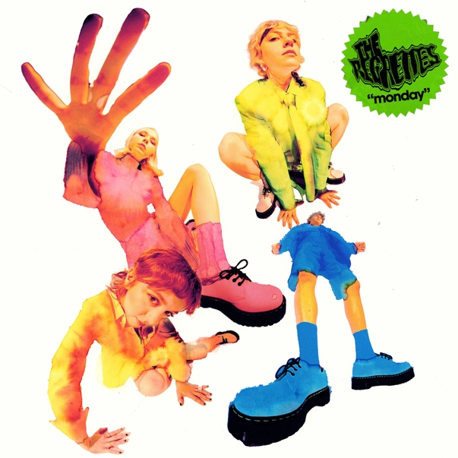
Today, The Regrettes share their new song, “Monday,” inspired by and written over the last year’s pandemic lockdown. The song comes alongside a video directed by Dillon Dowdell. Lydia Night shares of the video “The video introduces “Joy” – a spooky pink character representing the false image of one’s ‘perfect and ideal self’ which began to taunt me and I think many people in middle school. She will be an ongoing character and theme in music to come. We had a blast making it with some of our besties.” Watch the music video for “Monday” here.
“Monday” is their first new music since the release of their sophomore LP in 2019 which NPR Music proclaimed “a terrific culmination of a band that has been honing and perfecting their sound.” The band consists of lead singer and songwriter, Lydia Night, as well as Genessa Gariano (guitar), Brooke Dickson (bass) and Drew Thomsen (drums), listen to it here.
Lydia Night of the band reveals about “Monday”:
I wrote our new song “Monday” on Zoom during the pandemic with my producer Tim Pagnotta and talented writer Michelle Buzz.
At the time I was pretty much at the peak of my anxiety disorder, every morning I was waking up and absolutely dreading the idea of functioning and being “productive” (whatever the hell that even means) for another day. Like most of us, I was still at home, where all my issues still existed. So, whatever I was dealing with didn’t slowly fade away while stuck in traffic on the way to go write somewhere. I didn’t have the space to think of “what do I want to write about”, instead, I just rolled out of bed and all my horrible fucking thoughts were still with me, just waiting to be unboxed.
As LA locked down, I felt a huge part of my Identity and ego being stripped away because of no touring, and no connecting with people at our shows. I’ve been touring since about age 12, so I had to come up with a new way to function in the world. It was really rough, and still is rough, but I found writing this song to be super therapeutic.
It’s special that this is the first song we’ve put out in a while because it’s an important moment in time for me to mark. Part of the healing process for me is really learning and trying my best to keep on dancing the pain away so I hope people can relate to that and dance with me, even if it’s not at a show and in the safety of their own kitchen.
The Regrettes continue to solidify their reputation for unapologetically honest pop songs and powerful live shows. The band earned widespread acclaim with the 2019 release of their sophomore LP How Do You Love?, including NME who declared them “truly unstoppable,” and Teen Vogue who praised their “incredibly self-aware, empowering pop-punk” with additional accolades from Vogue, Rolling Stone, Billboard, and more. The band has headlined sold-out shows throughout North America and Europe, performed at festivals including Coachella and Reading + Leeds, and have appeared on Good Morning America, Conan and Jimmy Kimmel Live!. The band’s new song “Monday” comes in advance of tonight’s performance at Ohana 2021.
Credit: Lissyelle Laricchia

https://www.theregrettes.com/
https://www.facebook.com/regrettes
https://twitter.com/regrettesband
https://www.instagram.com/theregrettesband/
https://youtube.com/theregrettes
https://www.tiktok.com/@theregrettes
For more information, please contact Emilio Herce (emilio@qprime.com) and Mary Moyer (mary@qprime.com) at Q Prime, 212.302.9790 or Jaime Rosenberg (Jaime.Rosenberg@warnerrecords.com) and Patrice Compere (Patrice.Compere@warnerrecords.com) at Warner Records, 212.707.2038.

