For Immediate Release December 3, 2021

THE REGRETTES SHARE NEW SONG, “YOU’RE SO FUCKING PRETTY,” VIA WARNER RECORDS
CONFIRM “GET THE F*CK OUT OF LA” TOUR IN JANUARY AND FEBRUARY 2022

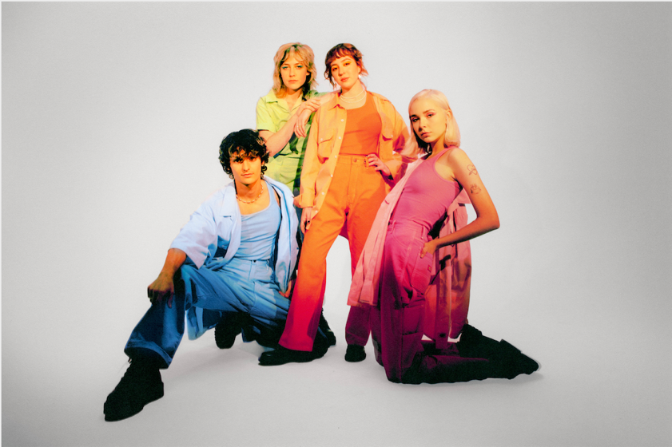
Today, The Regrettes share their new song “You’re So Fucking Pretty” via Warner Records. The song, built upon bassist Brooke Dickson’s arpeggiated piano melody, reflects on unspoken crushes, fear of rejection, and the resulting regret which comes from not sharing one’s true feelings. Listen to “You’re So Fucking Pretty” here.
Credit: Lissyelle Laricchia
Lead singer Lydia Night shares: “It's the first time I've ever written directly about a girl I had a crush on, and it took me a while for me to even allow my brain to accept the fact that I'm bisexual. I always felt like I couldn't validate my own feelings because I had never been in a relationship with a girl. But I had a pretty big crush on one of my friends a while ago and this song is an exaggeration of that, but it’s still coming from a very real place. It was the first experience where I was like, ‘Oh, these are real feelings, this isn’t just a sexual attraction,’ and that helped me realize I wasn’t straight. This song means so much to me because it also represents the time we spent in Joshua Tree and opening up to my whole band about that experience and not feeling embarrassed or scared of talking about it. Writing this was important for me because it just validated my own sexuality.”
Guitarist Genessa Gariano also adds: “As a queer person growing up it definitely felt like there weren't many songs I could relate to fully and I feel like this song would have been something I would have held really close to my heart as a kid. I hope that happens with other people. I don't think it necessarily has to be this queer anthem but I think someone else could listen to it and feel the same way, or someone could feel that way about a boy they like. Boys can be pretty too.”
Today, the band also confirms their extensive “Get The F*ck Out of LA” Tour in January & February 2022 in cities including Tulsa, Albany, Richmond, New Orleans, Houston and more (full dates below). Tickets for these dates will go on sale on Friday, December 10th at 10am Local Time here.
Last week, The Regrettes performed two sold-out “Get The Fuck Out of LA” shows in Santa Ana and San Diego and will perform in Pioneertown on December 9th. Tickets for this show are on sale now here. The band will also appear at Fort Lauderdale’s Audacy Beach Festival 2021 tomorrow and has confirmed appearances at Alt-AZ’s Ugly Sweater Holiday Party 2021, Atlanta’s Shaky Knees Festival 2022, and Madrid’s Mad Cool Festival 2022.
The band previously shared the official video for their recent single “Monday” directed by Dillon Dowdell. “Monday” is their first new music since the release of their sophomore LP in 2019 which NPR Music proclaimed “a terrific culmination of a band that has been honing and perfecting their sound.” The song is top 25 and growing at radio. The band consists of lead singer and songwriter, Lydia Night, as well as Genessa Gariano (guitar), Brooke Dickson (bass) and Drew Thomsen (drums). Watch the music video for “Monday” here.
The Regrettes continue to solidify their reputation for unapologetically honest pop songs and powerful live shows. The band earned widespread acclaim with the 2019 release of their sophomore LP How Do You Love?, including NME who declared them “truly unstoppable,” and Teen Vogue who praised their “incredibly self-aware, empowering pop-punk” with additional accolades from Vogue, Rolling Stone, Billboard, and more. The band has headlined sold-out shows throughout North America and Europe, performed at festivals including Coachella and Reading + Leeds, and have appeared on Good Morning America, Conan and Jimmy Kimmel Live!.
The Regrettes Upcoming Tour Dates (Get The F*ck Out of LA Tour Dates in Bold)
Sat, Dec 04 Fort Lauderdale, FL Audacy Beach Festival
Thu, Dec 09 Pioneertown, CA Pappy And Harriet's Pioneertown
Sat, Dec 11 Mesa, AZ Alt-Az’s Ugly Sweater Holiday Party
Mon, Jan 24 Fort Collins, CO The Aggie Theatre
Tue, Jan 25 Colorado Springs, CO The Black Sheep
Thu, Jan 27 Tulsa, OK The Vanguard
Fri, Jan 28 St. Louis, MO Delmar Hall
Sat, Jan 29 Milwaukee, WI Rave II
Sun, Jan 30 Ft. Wayne, IN Piere’s
Tue, Feb 1 Buffalo, NY Rec Room
Thu, Feb 3 Syracuse, NY Westcott Theatre
Fri, Feb 4 Burlington, VT Higher Ground
Sat, Feb 5 Poughkeepsie, NY The Chance Theatre
Sun, Feb 6 Albany, NY Empire Live
Weds, Feb 9 Richmond, VA The Broadberry
Fri, Feb 11 Louisville, KY Headliners Music Hall
Sat, Feb 12 Cincinnati, OH The Ballroom – Taft Theatre
Tue, Feb 15 New Orleans, LA Toulouse Theatre
Wed, Feb 16 Houston, TX Warehouse Live – The Studio
Thu, Feb 17 San Antonio, TX Paper Tiger
Apr 29 – May 01 Atlanta, GA Shaky Knees Festival
Mon, Jun 06 Madrid, Spain Mad Cool Festival
Fri, Jul 08 Glasgow, UK TRNSMT Festival
https://www.theregrettes.com/
https://www.facebook.com/regrettes
https://twitter.com/regrettesband
https://www.instagram.com/theregrettesband/
https://youtube.com/theregrettes
https://www.tiktok.com/@theregrettes
For more information, please contact Emilio Herce (emilio@qprime.com) or Mary Moyer (mary@qprime.com) at Q Prime, 212.302.9790.

