7.5M Online
https://uproxx.com/music/bktherula-matt-ox-placement-video/
Bktherula Rages Into The Night With Matt Ox In Their Video For ‘Placement’
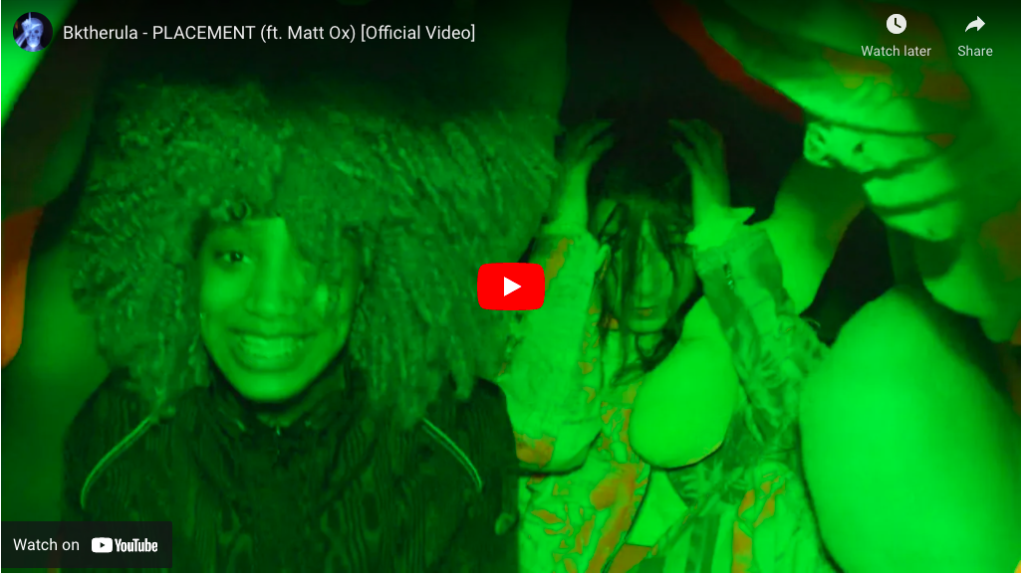
Bktherula is almost a year removed from her last full-length project, Nirvana. Luckily, for those who have taken a liking to the Atlanta native’s artistry, she has a brand new body of work on the way for her supporters. However, before fans can get their hands on it, Bktherula returns with “Placement,” her brand new track that arrives with a guest feature from Matt Ox and a new music video. In the visual, the duo hang out in a futuristic Chinatown filled with holograms, flying cars, and flashing lights.

On October 22, Bktherula will deliver her newest project, Love Black. Despite it being labeled as an EP, Love Black will arrive complete with 16 songs which gives fans plenty of music to enjoy from the Atlanta rager. The project will also feature her previously released single, “Santanny,” a track she delivered last spring in the form of a double single that was paired with “Blue.”
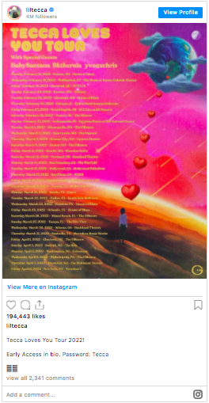
Furthermore, Bktherula is gearing up to hit the road as a supporting act for Lil Tecca’s upcoming tour. The Tecca Loves You Tour kicks off February 22, 2022 in Boston, Massachusetts, and continues until April 5, 2022 where it comes to an end in New York.

You can press play on the video for “Placement” above.

Love Black is out 10/22 via Warner Records. Pre-order it here.

