PANAMANIAN SINGER/SONGWRITER SOFÍA VALDÉS RELEASES DEBUT EP

WATCH LIVE PERFORMANCE OF NEW SINGLE “LONELY”

VENTURA EP OUT NOW ON WARNER RECORDS

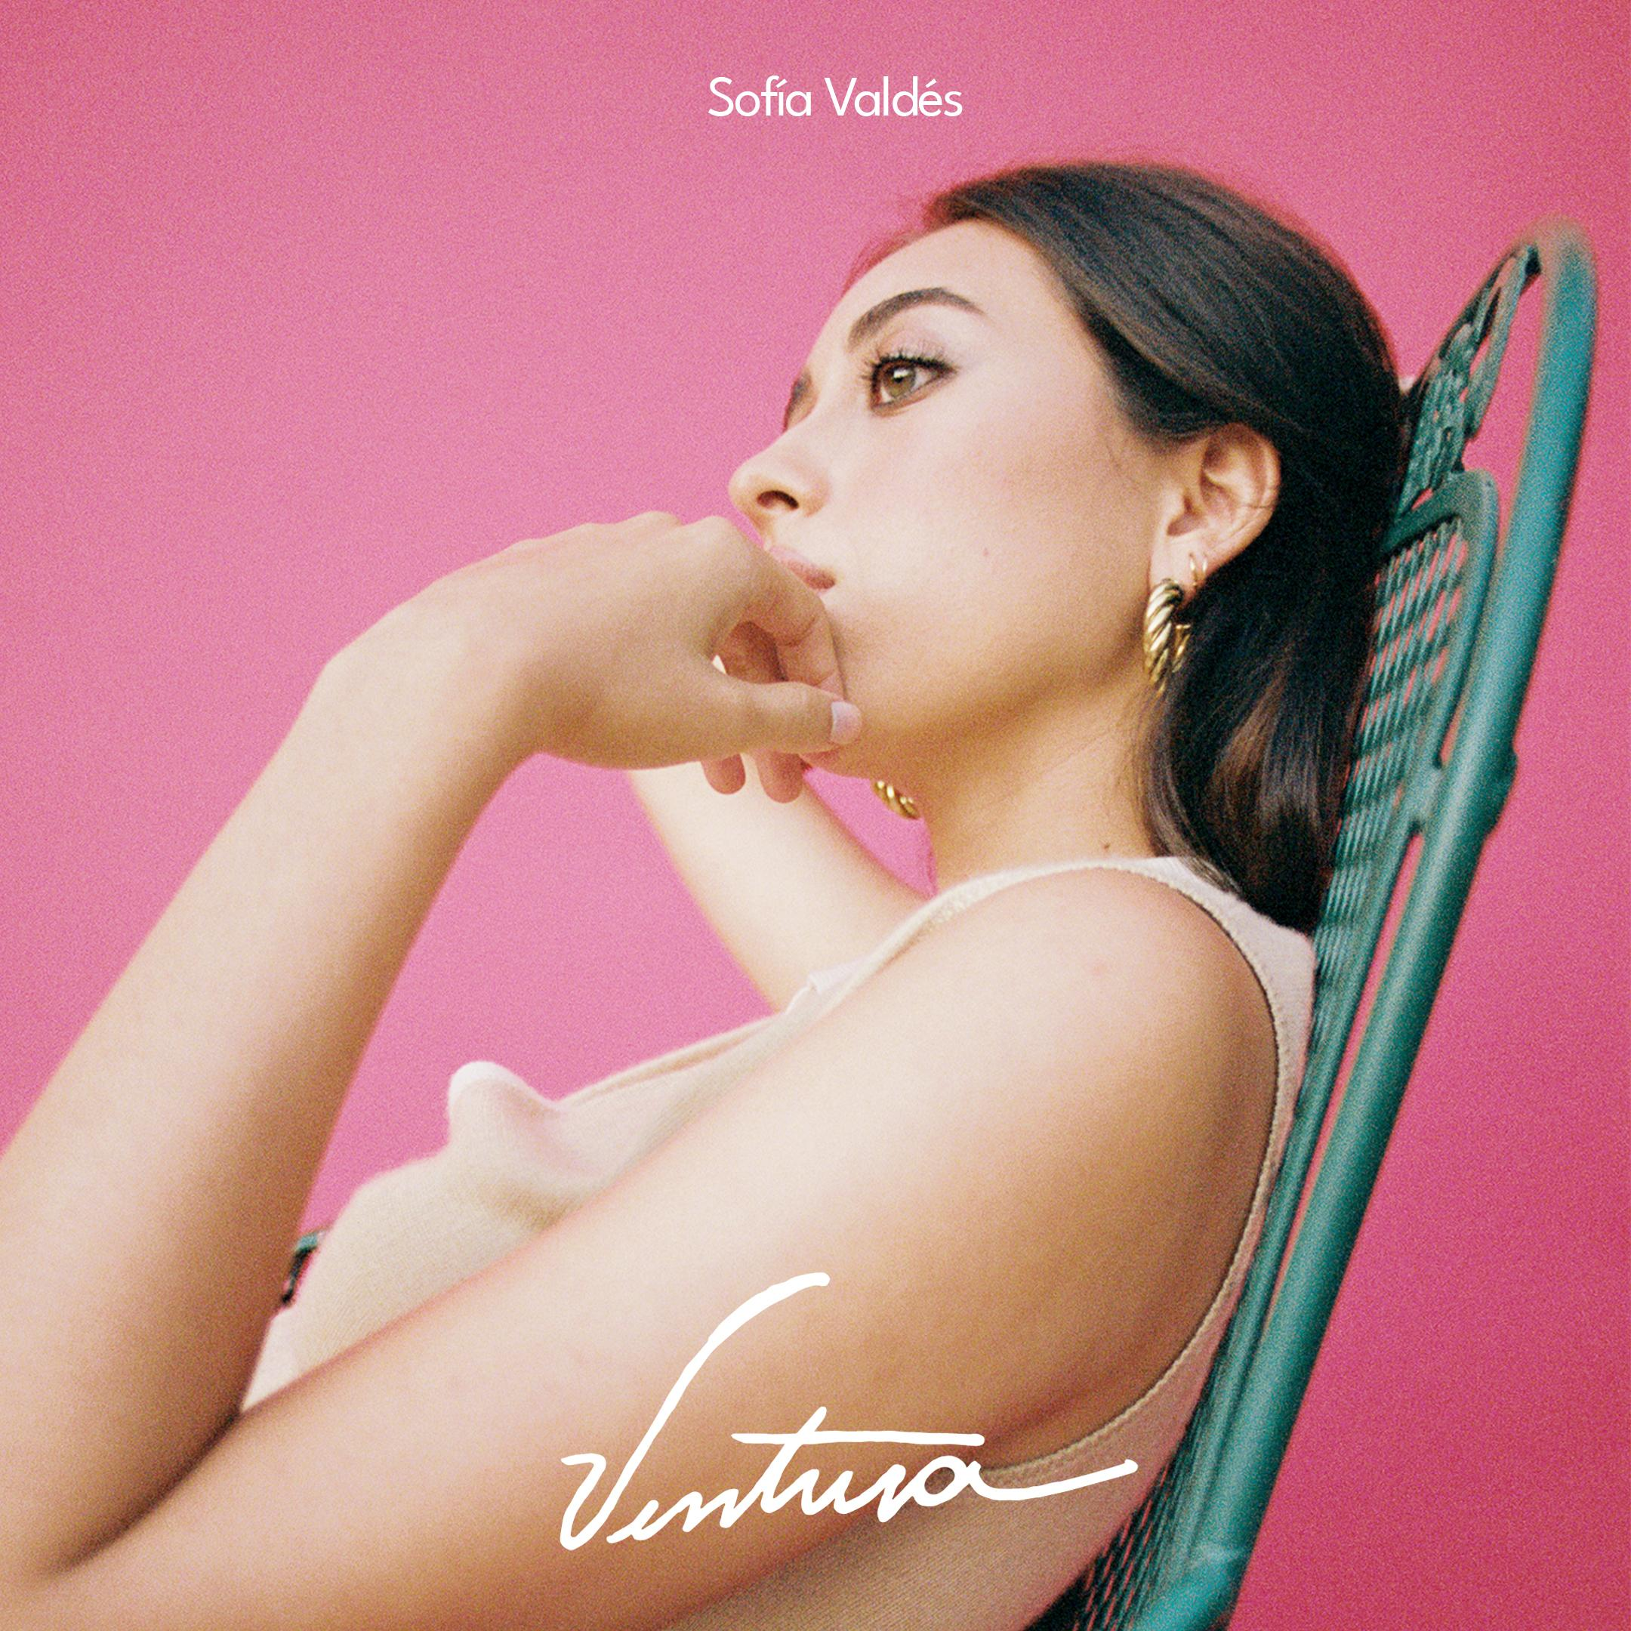
PHOTO CREDIT: JULIAN BURGUEÑO

VENTURA EP TRACKLISTING:
Handful of Water
Lonely
Amsterdam
Gems
Little Did I Know
Oceans Away

Panamanian-native singer/songwriter Sofía Valdés has released her debut EP Ventura, out now on Warner Records. Entirely written and co-produced by Sofía, Ventura acted as a conduit for introspection and more macroscopically, her culture. “Ventura is a collection of songs I wrote in the past 4 years. Some were written at recess with my best friend in high school, some in my kitchen, some in my dorm room. All are very special songs I hold close to my heart. Ventura means ‘good luck and good fortune’ in Spanish. While I was going through certain situations, I was writing about how I felt like it was the worst thing that could’ve happened to me at the time. But now, I see it as feelings that brought me to these songs which ended up changing my life for the better.”

Sofía’s eclectic influences include a mix of British folk, ‘60’s Motown, ‘70s soul, classical, and bossa nova. The combination of these influences come together on Ventura to create a distinct sound that is dreamy, light and lush.

While Sofía made her dream pop debut in 2020 with the release of “Little Did I Know” and “Handful of Water,” both of which appear on Ventura, music has been in her blood forever. Her great-grandfather was the legendary Cuban musician Miguelito Valdés, and her great-great grandmother was Silvia De Grasse, a Panamanian singer who once performed with Louis Armstrong. The bilingual beauty has already struck a chord with press, earning early praise from VICE, Clash, American Songwriter, Remezcla, Flaunt, Refinery 29, Clash , Consequence of Sound and more, and this week, made her Sundance Film Festival debut, performing at the 2021 official music event, Sound & Vision. Earlier this year, Valdés recorded a min-concert for NPR’s World Cafe, broadcasting February 9th at https://xpn.org/.

Sofía effortlessly balances pop and poetic songwriting with sounds from her musical roots and Latinx inspirations, making her a completely charming modern day muse and classic in every sense of the word. Listen to Ventura now and stay tuned for more news coming soon!

LISTEN TO VENTURA
https://sofiavaldes.lnk.to/Ventura

LISTEN TO “OCEANS AWAY”
http://sofiavaldes.lnk.to/OceansAway

WATCH “LONELY”
https://www.youtube.com/watch?v=ZudvwRGo4RE

WATCH “LITTLE DID I KNOW”
https://www.youtube.com/watch?v=qOKS7qN0who

WATCH “HANDFUL OF WATER”
https://www.youtube.com/watch?v=znN_ZULrX_k

PHOTO CREDIT: JULIAN BURGUEÑO

FOLLOW SOFÍA VALDÉS
INSTAGRAM
FACEBOOK
YOUTUBE
WEBSITE

PRESS INQUIRIES
Dana Meyerson / Biz 3 dana@biz3.net
Tori Johnson / Biz 3 tori@biz3.net
Jaime Rosenberg, Warner Records
Jaime.rosenberg@warnerrecords.com

