**ZACH BRYAN’S *AMERICAN HEARTBREAK* DEBUTS AT #5 ON BILLBOARD TOP 200 ALBUMS CHART AND #1 ON TOP COUNTRY ALBUMS CHART**

**AMONG THE HIGHEST STREAMING COUNTRY ALBUM DEBUTS IN HISTORY - SURPASSES ONE BILLION GLOBAL STREAMS TO DATE**

**LISTEN**[**HERE**](https://nam04.safelinks.protection.outlook.com/?url=https%3A%2F%2Fzachbryan.lnk.to%2FAmericanHeartbreak&data=05%7C01%7CRick.Gershon%40warnerrecords.com%7Cdd2808841baa4c70343608da3c155b45%7C8367939002ec4ba1ad3d69da3fdd637e%7C0%7C0%7C637888359664190159%7CUnknown%7CTWFpbGZsb3d8eyJWIjoiMC4wLjAwMDAiLCJQIjoiV2luMzIiLCJBTiI6Ik1haWwiLCJXVCI6Mn0%3D%7C3000%7C%7C%7C&sdata=8qrt88a1GDv3%2F8tgn%2BylsCx88rO58LeqexZDR2gBTOc%3D&reserved=0)

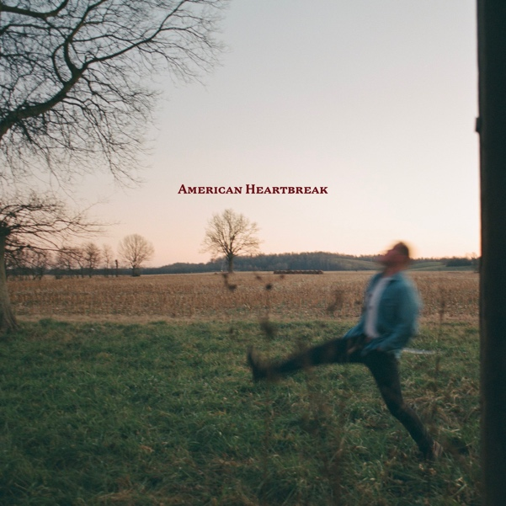

**(click**[**HERE**](https://nam04.safelinks.protection.outlook.com/?url=https%3A%2F%2Fpress.warnerrecords.com%2Fwp-content%2Fuploads%2F2022%2F05%2FAmerican-Heartbreak-artwork.jpg&data=05%7C01%7CRick.Gershon%40warnerrecords.com%7Cdd2808841baa4c70343608da3c155b45%7C8367939002ec4ba1ad3d69da3fdd637e%7C0%7C0%7C637888359664190159%7CUnknown%7CTWFpbGZsb3d8eyJWIjoiMC4wLjAwMDAiLCJQIjoiV2luMzIiLCJBTiI6Ik1haWwiLCJXVCI6Mn0%3D%7C3000%7C%7C%7C&sdata=fieadjh4sOcvC8tlN%2Bxv8CwjAruw27M31fwTamTUifU%3D&reserved=0)**for hi-res album cover art)**

**May 31, 2022 (Los Angeles, CA)** – With the breakout success of his modern epic ***American Heartbreak***, Oklahoma songwriter **Zach Bryan** cements his reputation as a bona fide country music superstar. The Navy veteran’s debut album for Warner Records has debuted at **#5** on **Billboard’s Top 200 Albums chart** and **#1** on their **Top Country Albums chart.** On the heels of last week’s announcementfor breaking the record for single album streams in a 24-hour period, and pushing **Bryan** well past **1 billion** streams globally, this week finds ***American Heartbreak*** to be one of the highest streaming country albums in history of the genre.

**Bryan** announced further domestic tour dates at the end of last week, including stops at Lollapalooza, Bonnaroo, Palomino Festival, and ending the tour at the prestigious Red Rocks Amphitheater in Colorado on November 3rd. All headline dates **sold out** in under an hour. Click [**HERE**](https://www.zachbryan.com/tour) for tour dates and details.

First and foremost, **Bryan** is a storyteller — he recently nabbed the **#1** spot on ***Billboard*’s Country Songwriters chart** — and ***American Heartbreak*** earns him a spot in the canon of great American narrative songwriters. The album has incited passionate and wide-reaching critical acclaim for its earthy sound and **Bryan’s** endlessly poignant lyricism, which evokes unforgettable vignettes of modern American life. It caps five years of living what Bryan himself has called, “a true tall-tale.” Stream ***American Heartbreak*** [**HERE**](https://nam04.safelinks.protection.outlook.com/?url=https%3A%2F%2Fzachbryan.lnk.to%2FAmericanHeartbreak&data=05%7C01%7CRick.Gershon%40warnerrecords.com%7Cdd2808841baa4c70343608da3c155b45%7C8367939002ec4ba1ad3d69da3fdd637e%7C0%7C0%7C637888359664190159%7CUnknown%7CTWFpbGZsb3d8eyJWIjoiMC4wLjAwMDAiLCJQIjoiV2luMzIiLCJBTiI6Ik1haWwiLCJXVCI6Mn0%3D%7C3000%7C%7C%7C&sdata=8qrt88a1GDv3%2F8tgn%2BylsCx88rO58LeqexZDR2gBTOc%3D&reserved=0)**.**

The album’s singles—the recently released “[**Whiskey Fever**](https://www.youtube.com/watch?v=92wkKCfHSgg),” along with “[**Open The Gate**](https://www.youtube.com/watch?v=YjqtbXcp87k),” “[**Something in the Orange**](https://www.youtube.com/watch?v=lA8F9sIhGdg),” “[**Highway Boys**](https://www.youtube.com/watch?v=sqSa2dAmb-M),” “[**From Austin**](https://www.youtube.com/watch?v=trrHTp7wp9c),” “[**Heading South**](https://www.youtube.com/watch?v=VkodWQ6EElc),” and “[**Late July**](https://www.youtube.com/watch?v=q_UQafyHrRM)”—have become events at Bryan’s spirited, Springsteen-esque live shows, inspiring fan singalongs. [“](https://www.youtube.com/watch?v=d9bmS1UkFBs)**[Heading South](https://www.youtube.com/watch?v=d9bmS1UkFBs)**[,”](https://www.youtube.com/watch?v=d9bmS1UkFBs) the track that started it all, just picked up a Gold certification from the RIAA. “**Something in the Orange**” peaked at **#11**on the ***Billboard* Hot Country chart** and was the **#18** global streaming track overall. “**From Austin**” claimed**#1** Country Song on **Apple Music** and debuted at**#4** on **Spotify’s Global Country chart.**On the strength of its deeply personal story, the track has garnered over **37 million** global streams.

**Bryan** is now a regular presence on the most coveted playlists in country music because, simply put, he’s the genuine article. The rollout of ***American Heartbreak*** has built a dedicated audience that grows by the millions each week via Spotify, TikTok, and YouTube. Upon the album’s release, **Bryan** trended at **#14** on US trends on TikTok and in the **Top 30** on Twitter.

And the boundless enthusiasm for Bryan’s music is happening all over the country in real life, too, of course. His blistering Stagecoach set was one of the most talked-about shows of that weekend, and his recent stops on the road have found him forging profound connections with fans thanks to music that is simple, undiluted, genuine, and captivating.

As ***American Heartbreak*** and its numerous accolades testify, **Zach Bryan** is a once-in-a-lifetime songwriter, and his rise is only beginning. He’s on tour now; don’t miss the show. ***American Heartbreak*** will be released on triple vinyl in early 2023.

**About Zach Bryan:**

**Zach Bryan** is a singer/songwriter from Oologah, Oklahoma, proud of his small-town roots and whose music is fueled by a desire to stay true to himself. The 24-year-old is a recent active-duty member of the US Navy, previously stationed in Washington state—a family tradition that has instilled a sense of honor and humility that is clear in his music. His success is found in his raspy voice, a mix of classic folk melody and outlaw country with a raw edge that cuts to the bone. His breakthrough moment makes all that clear as day. In the video for **“Heading South,”** shot by phone outside of his Navy barracks in humid 95-degree heat, Bryan’s passion echoes off the strings of his trusted Guild. Drenched in sweat and belting words that he had written minutes earlier, the moment is authentic, brutal, and real. Millions of fans have now seen that video without any sort of industry assist, and millions more have connected to the tender, sincere songs found on both Bryan’s 2019 debut album ***DeAnn***—dedicated to his late mother—and his 2020 follow-up, ***Elisabeth***, an ode to those he loves. His recent show at Nashville’s famed Ryman Auditorium sold out in record time and now finds Bryan amidst a headline tour of sheds and festivals through summer 2022. His recent hit single **“From Austin”** topped both the **Spotify** and **Apple Music’s** Country charts. Most recently his Warner Records album debut ***AMERICAN HEARTBREAK*** has topped the **Billboard County Album** chart at **#1** and debuted at **#5** on **Billboard’s** **Top 200 Album chart** making it one of the most success full country album debuts in the history of the genre. A man of simple words, Bryan’s ability to create depth in his work is rivaled by few artists. He believes that who you are only extends to the person you are today, an ideology reflected in everything he creates. Zach Bryan is on tour in 2022 – all dates SOLD OUT in record time.

**# # #**

**For more information, please contact:**

Rick Gershon | Warner Records

[**Rick.Gershon@warnerrecords.com**](mailto:Rick.Gershon@warnerrecords.com)

**FOLLOW ZACH BRYAN:**

[**Website**](https://www.zachlanebryan.com/) **|** [**Instagram**](https://www.instagram.com/zachlanebryan/?hl=en) **|** [**TikTok**](https://www.tiktok.com/@zachlanebryan?lang=en) **|** [**Twitter**](https://twitter.com/zachlanebryan?ref_src=twsrc%255Egoogle%257Ctwcamp%255Eserp%257Ctwgr%255Eauthor) **|** [**YouTube**](https://www.youtube.com/channel/UCwK3C8Vgphad4PweezfUBAQ)

