**RISING ALT-COUNTRY RENEGADE ZACH BYRAN GOES FROM ACTIVE DUTY IN THE NAVY TO THE STAGE OF THE GRAND OLE OPRY ON APRIL 10**

**“HEADING SOUTH” RAPIDLY CLIMBING AT AAA RADIO CHARTS**

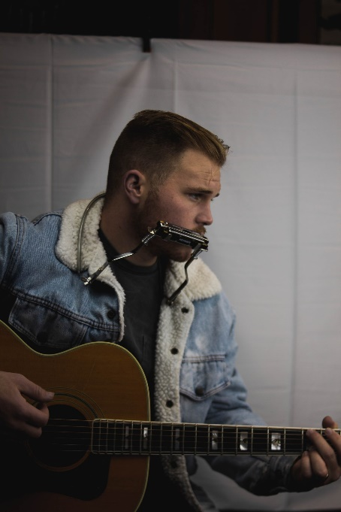

**April 1, 2021 (Los Angeles, CA) –** Going right from active duty in the U.S. Navy to one of the most hallowed stages in the world, rising alt-country renegade Zach Bryan will make his Grand Ole Opry debut on April 10, 2021. Guitar in hand, he steps into the circle for a performance on the Saturday night broadcast on [Circle TV](https://www.circleplus.com), marking the beginning of a new chapter in what is certain to be a monumental career. He’ll deliver a rendition of his ascendant anthem “Heading South” and more. Currently stationed in Washington State, with 6 years in the Navy under his belt, Zach is hopping on the road and heading straight to Nashville, TN for the Opry Performance.

It’s the kind of story suited for those old dog-eared American paperback novels you find in small town libraries and truck stop giftshops. Oklahoma native **Zach Bryan** got his first guitar at 14-years-old and never put it down. Following a family tradition, he enlisted in the Navy, writing and recording dozens of songs during his limited downtime. In late 2019, he grabbed his guitar, sat outside of a Navy barracks during some downtime, and performed “Heading South” under the watchful eye of his iPhone. The [self-shot video](https://www.youtube.com/watch?v=d9bmS1UkFBs) exploded as a viral phenomenon, amassing 9.4 million views organically. In its wake, the official version of the song naturally picked up just as much independent traction, eclipsing 70M global streams and gaining 1.6 million total streams weekly. It also just hit #12 at AAA radio.

“Heading South” touched hearts with its plaintive acoustic strumming and rough and tumble story of a dreamer who defied everyone’s expectations until *“the masses screamed the lyrics of a messed up a kid*.”

Recently, he also joined forces with six-time GRAMMY-winner Dave Cobb [Chris Stapleton, Sturgill Simpson, Jason Isbell] at Nashville’s legendary Studio A for the release of the two-track collection, *Studio A Recordings (Live)*. Together, they re-recorded and recharged his indie fan favorites “Condemned” and “Hell Or Highwater.”

Right now, he’s averaging 7 million-plus streams per week across his catalog and has amassed a total of 240 million global streams thus far. He shows no signs of stopping or slowing down.

Zach’s working on more original music for release soon. He’s just begun to write his story now.

**About Zach Bryan**

Zach Bryan is a singer/songwriter from Oologah, Oklahoma, proud of his small-town roots and whose music is fueled by a desire to stay true to himself. The 24-year old is an active-duty member of the US Navy currently stationed in Washington state, a family tradition that has instilled a sense of honor and humility that is clear in his music. His success is found in his raspy voice, a mix of classic folk melody and outlaw country with a raw edge that cuts to the bone. His breakthrough moment makes all that clear as day. In the video for “Heading South,” shot by phone outside of his Navy barracks in humid 95 degree heat, Zach’s passion echoes off the strings of his trusted Guild. Drenched in sweat and belting words that he had written minutes earlier, the moment is authentic, brutal, and real. Millions of fans have now seen that video without any sort of industry assist, and millions more have connected to the tender, sincere songs found on both Zach’s 2019 debut album *DeAnn*—dedicated to his late mother—and his 2020 follow-up, *Elisabeth*, an ode to those he loves. A man of simple words, Zach’s ability to create depth in his work is rivaled by few artists. He believes that who you are only extends to the person you are today, an ideology reflected in everything he creates.

**About the Grand Ole Opry:**

Opry presents the best in country music live every week from Nashville, Tenn.  The Opry can be heard at [opry.com](http://opry.com/) and [wsmonline.com](http://wsmonline.com/), Opry and WSM mobile apps, SiriusXM, and its flagship home, 650 AM-WSM. The Grand Ole Opry is owned by Ryman Hospitality Properties (NYSE: RHP).  For more information, visit [opry.com](http://www.opry.com/).Opry is broadcast live on [Circle](https://nam04.safelinks.protection.outlook.com/?url=https%3A%2F%2Fwww.circleplus.com%2F&data=04%7C01%7Cjaime.rosenberg%40warnerrecords.com%7Cb3887159c5c14c193a4708d8ee2eb5ed%7C8367939002ec4ba1ad3d69da3fdd637e%7C0%7C1%7C637521231833582043%7CUnknown%7CTWFpbGZsb3d8eyJWIjoiMC4wLjAwMDAiLCJQIjoiV2luMzIiLCJBTiI6Ik1haWwiLCJXVCI6Mn0%3D%7C0&sdata=XhzUJPg5tzCujm0ub1PFxWWdIgZIvs5Lr1%2BDZyF7uB0%3D&reserved=0) and Gray TV stations, DISH Studio Channel 102, Sling TV and other TV affiliates in addition to a companion live stream on Circle All Access and YouTube and could be heard on 650 AM WSM and SiriusXM.

Tickets at opry.com

###

**For more information, contact:**

Rick.Gershon@warnerrecords.com

**Follow Zach Bryan:**

[Website](https://www.zachlanebryan.com/) | [Instagram](https://www.instagram.com/zachlanebryan/?hl=en) | [TikTok](https://www.tiktok.com/@zachlanebryan?lang=en) | [Twitter](https://twitter.com/zachlanebryan?ref_src=twsrc%5Egoogle%7Ctwcamp%5Eserp%7Ctwgr%5Eauthor) | [YouTube](https://www.youtube.com/channel/UCwK3C8Vgphad4PweezfUBAQ)

**Press Materials:**

[press.warnerrecords.com/zachbryan](https://press.warnerrecords.com/zachbryan)

