MOTHER MOTHER’S RYAN GULDEMOND REVEALS FIRST NEW MUSIC FROM SOLO PROJECT GLDMTH

DEBUT ALBUM OUT SEPTEMBER 24TH VIA WARNER RECORDS

“THE PEOPLE” OUT NOW
Listen HERE / Watch HERE

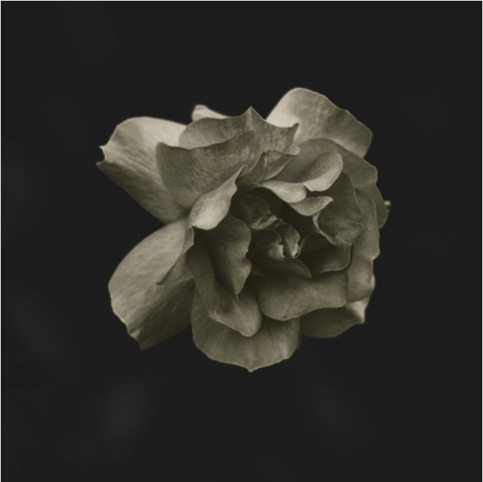
(Click HERE for Hi-Res album cover image)

August 24, 2022 – (Los Angeles, CA) -- Ryan Guldemond, songwriter and frontman for internationally acclaimed alt-rock band MOTHER MOTHER has unveiled the first new single from his upcoming solo project GLDMTH (pronounced Goldmouth). The new music, deeply personal and introspective, springs forth as an art project conceived by Guldemond where his music, photography, videography, and poetry intersect. The self-titled album is set for September 24th release via Warner Records and underscores Guldemond’s unflinchingly honest world view and the sardonic dark humor that he is known for. In “The People,” the first track from the album, Guldemond brings the listener to a more intimate, private space. As a true multi-media project, “The People” arrives with an official lyric video, featuring Guldemond’s photography and creative direction. Click HERE stream the track and HERE to watch the video.

Of this new song, Guldemond says, "This is my favorite song on the album. The chords and the mood opened up a space where I felt like I could be really honest about who I am, which like everybody, I imagine, is a lot of different and contrasting people. 'A drugger, a drinker, a monk up on a hill in Nirvana.' I’ve been through all of those phases, and though I may not be living some of them out any longer, the voices of those characters are still very much alive and vocal in the darker spaces of my mind."

For all the latest information on GLDMTH, follow on Twitter, Instagram, Facebook, YouTube or visit the official website.

Track listing
- You Did It
- Alone Again
- The Symphony
- Oh Life
- Letting Go
- Start Today
- Feelings
- The People
- To Love You
- I’m Afraid
- Dream of You

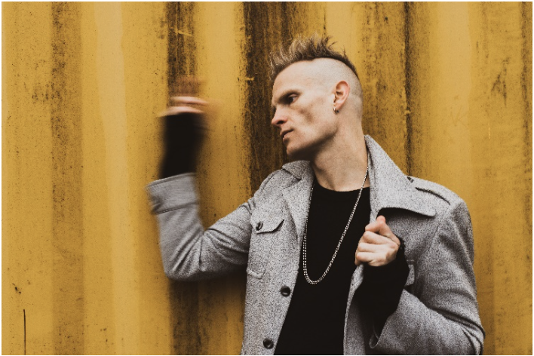

(Click HERE for Hi-Res image by Rich Smith)

# # #

For more information, please contact:
Rick Gershon | Warner Records
Rick.Gershon@warnerrecords.com

Follow GLDMTH:
Official | Twitter | Instagram | TikTok | Facebook | YouTube | Press Materials

