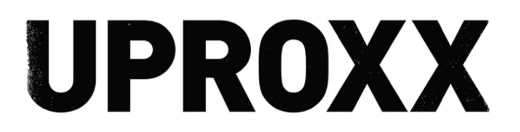
6.3M Online

https://uproxx.com/music/the-best-new-hip-hop-this-week-megan-thee-stallion-lil-uzi-vert-joey-badass/
