WARREN ZEIDERS IS “UP TO NO GOOD” ON NEW SINGLE OUT THIS FRIDAY VIA 717 TAPES/WARNER RECORDS

ANNOUNCES UP TO NO GOOD TOUR
ACROSS NORTH AMERICA THIS FALL

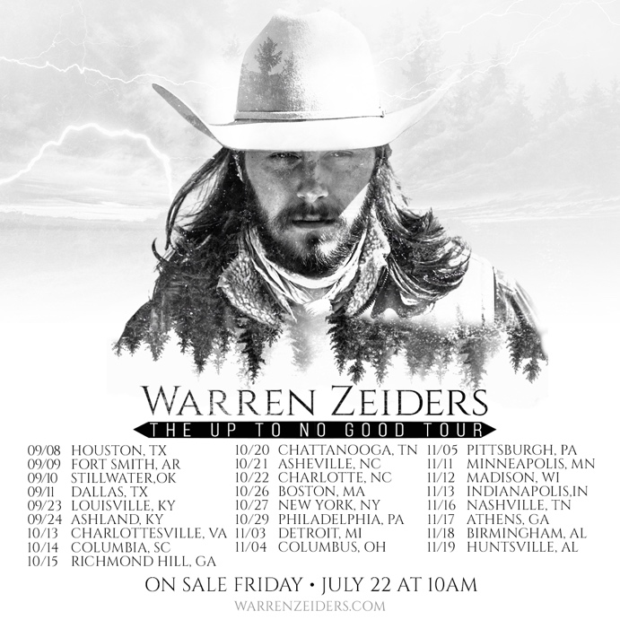

July 18, 2022 (Los Angeles, CA) – Country music’s fastest rising star Warren Zeiders will unveil a new single entitled “Up To No Good” this Friday, July 22 via 717 Tapes/Warner Records. “Up To No Good” is another instantly irresistible anthem from Zeiders. Produced by Lindsay Rimes [Kane Brown], the track snaps like a touchdown pass from acoustic verses into an electric guitar-charged hook. Meanwhile, he muses about the best kind of trouble with a confession, “She’s the drug I can’t say no to.” Pre-order/pre-save “Up To No Good” HERE.

Zeiders also expands his already packed itinerary and adds three more months to his current tour named after the new track. Catch his Up To No Good Tour this fall. “Up To No Good says it all. From the live shows, my music, and my personality. This new single is one that I think my fans will keep on repeat,” Zeiders shared. “I found it fitting to call my Fall tour the Up To No Good Tour with my new single being released and a list of shows that people won’t wanna miss out on.”

This new round of full-band dates kicks off on September 8 in Houston, TX at the White Oak Music Hall, sees him perform in New York City for the first time at Irving Plaza on October 27, and concludes on November 19 in Huntsville, AL. Artist Fan Club pre-sales begin Tuesday, July 19 with a Spotify pre-sale following on Wednesday, July 20. General on-sale commences Friday, July 22 at 10am local time HERE. Stay tuned for the premiere of the cinematic music video very soon.

Reaching yet another major milestone, Zeiders recently completed a rite of passage for country’s best and brightest with his Grand Ole Opry debut. The legendary institution welcomed Zeiders last Saturday, July 9.

Continuing to make headlines, Zeiders just shared a new version of his RIAA Gold-certified hit “Ride The Lightning” with none other than iconic genre-crossing drummer/producer Travis Barker. Listen to the recently released remix of “Ride The Lightning” featuring Travis Barker HERE via 717 Tapes.

The 23-year-old burst onto the country music scene in the last year or so, emerging as one of the genre’s fastest rising success stories in recent history. With his brooding tunes and gravelly voice, it’s no surprise that he’s inspired a massive social media following, garnering over 975 million views on TikTok and over 412 million global streams across platforms.

Zeiders has earned a rep for sharing his searing, authentic songs directly with fans and has collected that work in the critically acclaimed 717 Tapes EPs — you can find volumes 1 and 2 HERE. You can also stream the thrilling full-band take of “Ride the Lightning” HERE, and check out the video HERE. 717 Tapes EP Vol. 2 also contains his most recent single and fan favorite “Wild Horse,” along with “Dark Night” and “Burn It Down.”

“Warren Zeiders is a ‘Wild Horse’ who sings about "the truth.’" – People Magazine

Zeiders delivered the kind of show that becomes the stuff of legend once an artist hits it big. And boy, will he hit it big.” -- The Music Enthusiast

“Fueled by tens of millions of streams, millions of fans, and a desire to reach out and touch those fans with his music, Zeiders is set to take the next step in his meteoric rise to the top of the charts with The 717 Tapes EP Vol. 2.” - Outsider

2022 717 Tapes Tour Dates:
July 21 Kansas City, MO Knuckleheads
July 22 Petersburg, IL Menard Country Fair
July 23 Springfield, MO Midnight Rodeo
July 28 West Bend, WI Washington County Fair Park
Aug 05 New Haven, CT Toads
Aug 06 Clearfield, PA Clearfield County Fair
Aug 13 Omaha, NE Barnato Live & Loud
Aug 14 Dubuque, IA Q Casino supporting Sam Hunt
Aug 26 Glasgow, KY Plaza Theatre – FREE SHOW

2022 Up To No Good Tour Dates:
Sep 08 Houston, TX White Oak Music Hall
Sep 09 Fort Smith, AR Temple Live
Sep 10 Stillwater, OK Outside City Limits Festival
Sep 11 Dallas, TX Studio at the Factory
Sep 23 Louisville, KY Mercury Ballroom
Sep 24 Ashland, KY Foxfire Music & Arts Festival
Oct 13 Charlottesville, VA Jefferson Theatre
Oct 14 Columbia, SC The Senate
Oct 15 Richmond Hill, GA Great OgeeChee Fest
Oct 20 Chattanooga, TN The Signal
Oct 21 Asheville, NC The Orange Peel
Oct 22 Charlotte, NC The Underground
Oct 26 Boston, MA Paradise Rock Club
Oct 27 New York, NY Irving Plaza
Oct 29 Philadelphia, PA TLA
Nov 03 Detroit, MI St. Andrew’s Hall
Nov 04 Columbus, OH Newport Music Hall
Nov 05 Pittsburgh, PA Stage AE
Nov 11 Minneapolis, MN Varsity Theatre
Nov 12 Madison, WI Majestic Theatre
Nov 13 Indianapolis, IN Deluxe at Old National Centre
Nov 16 Nashville, TN Brooklyn Bowl
Nov 17 Athens, GA Georgia Theatre
Nov 18 Birmingham, AL Iron City
Nov 19 Huntsville, AL Mars Music Hall

ABOUT Warren Zeiders:
Warren Zeiders’ distinctive, high energy country music is powered by a steady supply of youthful grit, honesty, and muscle. Hailing from Hershey, Pennsylvania, the 22-year-old singer/songwriter delivers outlaw sermons in a gravelly, world-weary voice that bely his young age. His music is suited more to the vast wilderness of his home state than the bright lights of Nashville, injecting a healthy dose of Heartland ethos into the honky tonks of Music City. But it’s that space he lives in—between lonesome outsider and magnetic performer—that helps him relate to listeners from all walks of life through songs fueled by unshakeable soul-searching. His original solo acoustic version of “Ride The Lightning” became an instant hit with fans and racked up over 975 million global views on TikTok alone and been certified Gold sales status in the US in late January 2022. He has amassed over 412 million streams globally. The track has impacted the Billboard Hot Country Songs charts as his audience continues to grow by the million’s week by week. Warren Zeiders’ has just completed his first live tour – all 14 dates sold out within 72 hours, prompting the newly minted headliner to add more dates to his 717 Tapes Tour featuring a full band this summer. Zeiders’ latest fan favorite single/video, “Wild Horse,” beautifully illustrates his vision of chasing –and realizing-- his dreams in real time. 717 Tapes EP Vol. 2, is available now with a view to release his debut album in the months ahead.

# # #
Warner Records Contacts:
Rick Gershon | rick.gershon@warnerrecords.com
Regional/Tour: Jenny Huynh | jenny.huynh@warnerrecords.com

FOLLOW WARREN ZEIDERS:
Facebook | Instagram | Twitter | TikTok | YouTube | Spotify

