DISTURBED – DIVISIVE BIO
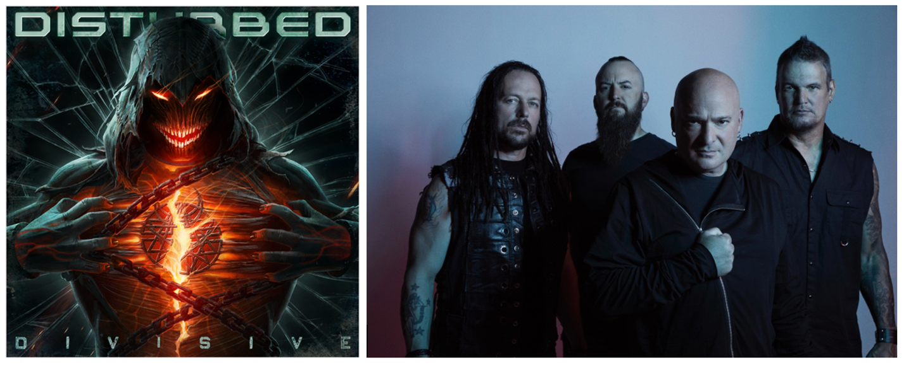
As much as the world pulls us apart, music draws us back together. It can close the gap between even the widest fissure. Disturbed continue to unify audiences around heavy and hypnotic hard rock anthems underpinned by guttural grooves, incendiary riffs, and chaotically catchy vocals. The two-time GRAMMY® Award-nominated multiplatinum Chicago quartet—David Draiman [vocals], Dan Donegan [guitar, programming], Mike Wengren [drums], and John Moyer [bass]—make the kind of music that pushes you to hold on tighter, fight harder, and persevere forever. It’s why they’ve quietly claimed a place at the forefront of 21st century rock with record-breaking success, sales of over 17 million-plus units, nearly 8 billion streams, and sold out shows around the globe.
It’s also why they hit harder than ever on their eighth full-length offering, Divisive [Reprise Records].
“Partisan tribal warfare has become a part of our regular existence nowadays,” observes David. “It’s one big battle of the cliques. The whole idea of the record is to be a wakeup call for everyone. Our society has become addicted to outrage. Music is the best cure for what ails us though. If only everyone reached out and used it. There’s no better environment to forget about all of this shit than live music. We can be together and realize we have more in common than not. Recognize what’s happening and let’s make a change for the better.”
“Whatever it takes, we’ve got to pull it together,” agrees Dan. “We’ve always tried to take negative topics and spin them in a positive light. From touring around the world, we’ve seen the power of music as the universal language to bring everyone together from all walks of life. We can still play songs to unite people, and it’s a pretty powerful feeling.”
Speaking of unity, the musicians subconsciously rallied around a shared vision for what would become Divisive. After a period of dormancy in the midst of the Global Pandemic, the group finally congregated in early 2022. Dealing with the same frustrations for nearly two years, the guys followed a collective muse without question.
“We wanted to get heavy again,” exclaims Dan. “We’ll always be melodic, but there’s more attitude now. We’re showcasing David’s animalistic side again. It touches on our early days with modern elements.”
David adds, “After 25 years, we’ve begun to anticipate each other’s direction. We were all hankering to get back to chunky goodness,” he laughs.
In order to do so, the band tapped Drew Fulk [Motionless In White, Lil Peep] as producer. With members based around the country, they chose Nashville to record, cutting ten tracks in Spring 2022. After Dan shared initial ideas with the rest of the group, they locked in like never before with the groove as the backbone. Mike bolted down some of the strongest and boldest rhythms of their career punctuated by John’s punchy bass.
“Once we finally did get in a room together, it felt so good,” Dan recalls. “It was nice to get the ball rolling and have that outlet in the studio again. Throughout our lives, music has been our therapy—as it is for most people.”
Fittingly, the group kicked off this phase with the opener “Hey You.” Powered by menacing electronics, a bone-crushing riff, and undeniable chorus, it marked their 15th #1 hit at Radio, completing their quickest rise to the top and setting the tone for what was to come.
“It’s the quintessential rallying cry,” notes David. “It’s like, ‘Hey you, do you realize what you’re doing? Do you see you’re your own worst enemy? How are we making mountains out of mole hills everywhere we go and looking for enemies where there are none?’ It was the perfect way to start.”
Meanwhile, the follow-up single “Unstoppable” charges ahead with a battering ram riff and pummeling flurry of drums. The onslaught relents just long enough for Draiman to issue a warning on the chorus, “There’s no escape. I am unstoppable.”
“It’s definitely one of the heavier tracks on the record,” says David. “The groove builds into a bombastic animal. It’s the fight song.”
“We always have a big rock anthem on every album,” Dan goes on. “We love to write empowering songs for motivation. We’re avid sports fans, and that’s definitely part of it. It’s an in-your-face track.”
Then, there’s “Bad Man.” Ominous string orchestration echoes around a jagged riff as the verses snake into an incisively infectious chant. Pressing down on the whammy pedal, Dan rips a screeching cinematic guitar lead rife with razor-sharp shredding.
“From a lyrical perspective, says David. “There’s no shortage of evil maniacs on the planet who take advantage of their positions of power and have unchecked narcissism and egomania that fuels their decisions though. There was damn sure plenty of inspiration in current world events.”
On “Don’t Tell Me,” Disturbed join forces with none other than Ann Wilson of Heart for an epic duet. In two decades, it breaks ground as the first-ever guest collaboration on a Disturbed record. Clean guitar soundtracks the story of a long-term relationship in the middle of its last gasp. David and Ann engage in a call-and-response before locking into a skyscraping harmony as the solo reaches for the heavens.
“It was very personal to me,” admits Dan. “I was going through my divorce, and I wanted to touch on the fact I was in a very long marriage to a wonderful woman. She’s a great mother to my kids. We were together for 18 years. Even though the marriage was in a tough spot, it was hard to leg go, because we’d invested so much into each other. I felt like listeners could relate to it.”
“In my humble opinion, I think Ann is probably the greatest female rock voice of all time,” David states. “She’s untouchable. We had connected on Twitter, and I sent her the song. She agreed to jump on it, and it was humbling to work with her. She was totally pro. Her vocals are mind-blowing. It was a gift. Out of ten tracks, we needed to take at least one left turn,” he smiles.
The album reaches its cathartic conclusion with a final knockout blow on “Won’t Back Down” As the guitars toss and turn, the chorus assures, “I won’t back down from this fight.”
They’ve never backed down though…
Instead, Disturbed have dominated hard rock on their own terms. Thus far, they have notched five consecutive #1 debuts on the Billboard Top 200, occupying rarified air alongside Metallica—the only other hard rock group to accomplish this feat. Since their influential 5x-platinum debut The Sickness in 2000, they have built a bulletproof catalog highlighted by a procession of smashes, including the platinum “Stupify,” “Inside The Fire,” and “Land of Confusion,” 2x-platinum “Stricken,” 6x-platinum “Down With The Sickness,” and 7x-platinum “The Sound of Silence,” to name a few. The latter notably received a GRAMMY® Award nomination in the category of “Best Rock Performance” as the band earned “Best Rock Artist” at the 2017 iHeartRadioMusic Awards.
In the end, Disturbed still wield the power to unite.
“We have a lot left in us,” concludes Dan. “I know for certain I’m not done. We’re always going to need an outlet for our personal sanity. I feel inspired every time we do a record. We bring the best out of one another. I’m just excited for what the future holds.”
David leaves off, “When audiences hear the album, I hope the reaction is, ‘After the last three years, this is exactly what I wanted to get out the frustration, anger, and addiction to outrage’. There are better ways. I hope you use it as an outlet and a means of exorcising the demons once again.” – Rick Florino, September 2022
BOILER
Emerging out of Chicago at the turn of the century with an insidious, infectious, and inimitable vision without comparison, Disturbed have quietly dominated hard rock on their own terms. They make the kind of music that pushes you to hold on tighter, fight harder, and persevere forever. It’s why they’ve quietly claimed a place at the forefront of 21st century rock with record-breaking success, sales of over 17 million-plus units, nearly 8 billion streams, and sold out shows around the globe. The two-time GRAMMY® Award-nominated quartet have notched five consecutive #1 debuts on the Billboard Top 200, occupying rarified air alongside Metallica—the only other hard rock group to accomplish this feat. Since their influential 5x-platinum debut The Sickness in 2000, they have built a bulletproof catalog highlighted by a procession of smashes, including the platinum “Stupify,” “Inside The Fire,” and “Land of Confusion,” 2x-platinum “Stricken,” 6x-platinum “Down With The Sickness,” and 7x-platinum “The Sound of Silence,” to name a few. The latter notably received a GRAMMY® Award nomination in the category of “Best Rock Performance” as the band earned “Best Rock Artist” at the 2017 iHeartRadioMusic Awards. Still, Disturbed never stop, igniting their next chapter with their 2022 album Divisive featuring their 15th #1 at Rock Radio “Hey You,” “Unstoppable,” and more.

