GLOBAL SUPERSTARS DAVID GUETTA & BEBE REXHA LINK UP ON HOTLY ANTICIPATED VIRAL SINGLE
“I’M GOOD (BLUE)”

LISTEN HERE

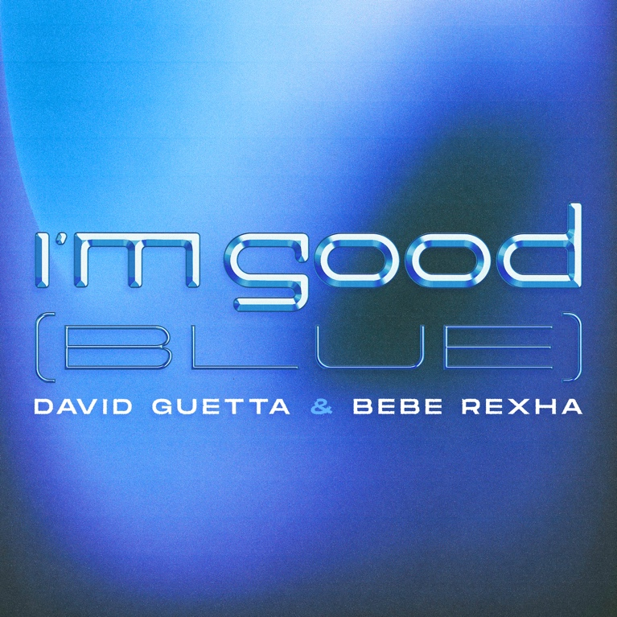

August 26, 2022 (Los Angeles, CA) – Global superstars David Guetta and Bebe Rexha join forces on anticipated new single “I’m Good (Blue),” out today on What A DJ/What A Music/Warner Records. Listen HERE.

“I’m Good (Blue)” combines Bebe’s soulful vocals with euphoric piano chords and infectious dancefloor energy. Already a TikTok smash, the sound has amassed 130,000 total creations and over 500 million views. Rexha and Guetta first began working on this song five years ago, and after generating serious online buzz it is finally now ready for an official release.

It follows a typically prolific run of singles from Guetta, including a monstrous modern rework of “Satisfaction” with Benny Benassi and dancefloor heater “Family Affair (Dance For Me),” which has achieved over 10 million streams since its release. Guetta also continues to dominate the pop world, with recent hits “Don’t You Worry” with Black Eyed Peas and Shakira and the world-conquering “Crazy What Love Can Do,” a certified smash that has already surpassed 150 million global streams, has been certified gold and is currently sitting at No. 5 on the UK Singles chart.

The only DJ to have two residencies in Ibiza this season, the legendary ‘F*** Me I’m Famous’ party is underway on Mondays at Ushuaïa, where last month Armin Van Buuren joined Guetta onstage for a showstopping B2B set. His Future Rave residency with MORTEN is also taking place on Fridays at Hï, fresh off the back of a sold-out US tour.

Diamond-certified and Grammy-nominated pop superstar Bebe Rexha propelled herself into the spotlight with her platinum-certified debut album Expectations in 2018, which featured smash hit “I’m a Mess” and the diamond-certified single “Meant to Be” featuring Florida Georgia Line, which remained on top of the Billboard Hot Country Songs for a record-setting 50 consecutive weeks, making it the longest reign ever by a female lead artist. Not stopping there, Bebe received two Grammy nominations (Best Country Duo/Group Performance and Best New Artist) to date, has surpassed 4 billion YouTube views and more than 12 billion total global streams and counting. Her sophomore album Better Mistakes, released last May, includes the continuously rising dance anthem “Sacrifice.”

Releasing cutting-edge track after cutting-edge track, there is a reason why David Guetta is widely considered to be the most complete artist in dance music today.

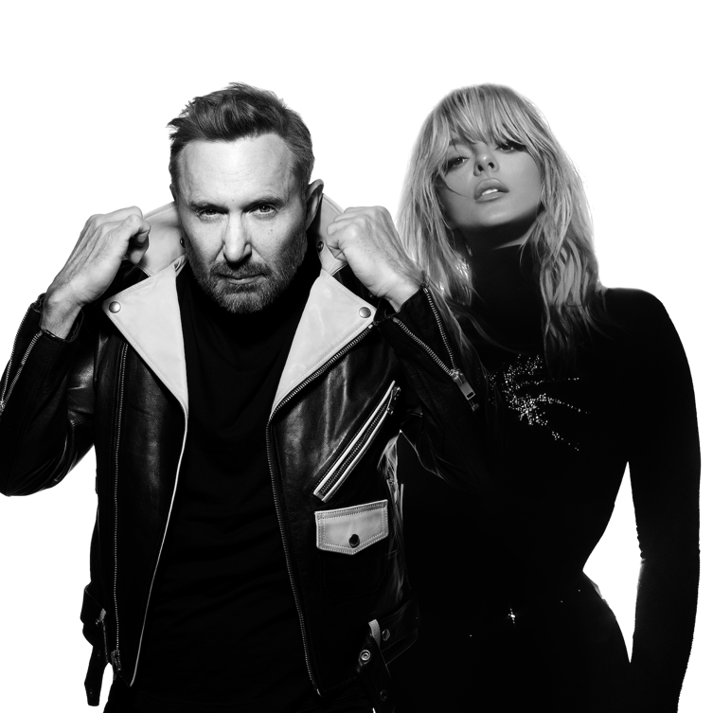
###
FOLLOW DAVID GUETTA:
YouTube | Instagram | Twitter | Facebook | Website | Spotify

FOLLOW BEBE REXHA:
Facebook | Twitter | Instagram | TikTok | Spotify | YouTube

For more information please contact:
Laura Swanson | Warner Records
Laura.Swanson@warnerrecords.com

Darren Baber | Warner Records
Darren.Baber@warnerrecords.com

