RISING POP STAR JENNA RAINE DROPS BREAKUP SINGLE “FUMBLED THE BAG” – WATCH VIDEO HERE

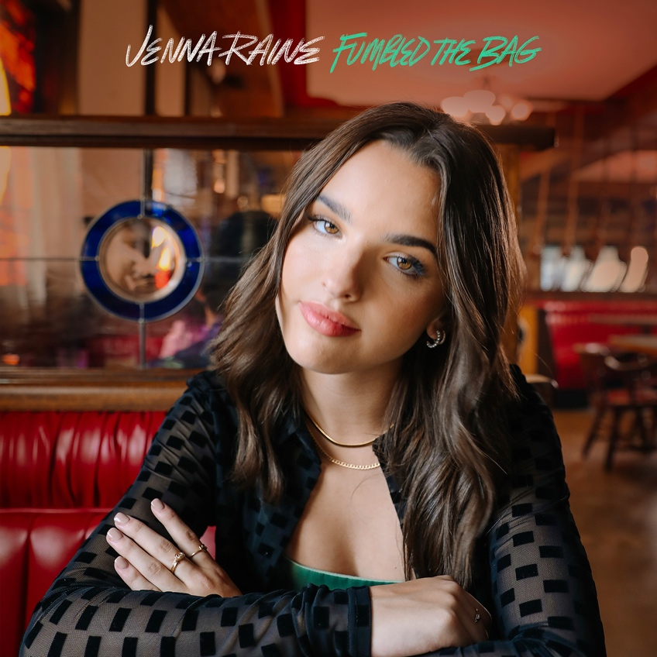

September 2, 2022 (Los Angeles, CA) – Today, rising pop artist Jenna Raine releases her emotional new single “Fumbled the Bag” via Warner Records. Listen to the powerful new track HERE and watch the video HERE. “Fumbled the Bag” follows Raine's empowering “NOT AGAIN” as well as her breakthrough EP see you later, the release that contains her hit “see you later (ten years),” which has racked up over 77 million global streams.

On “Fumbled the Bag,” the Texas native details an awkward encounter with an ex. Singing over gentle guitar strums, the narrator is flooded with mixed emotions, and the lingering desire to set their past flame straight. “What if the best thing that you had is somebody that you want back,” she sings on the heartfelt chorus. “What if the moment you walked away, you wished you turned around.”

It turns out, Raine based the track on real-life events. “‘Fumbled the Bag’ was inspired by two of my close friends who had breakups before the summer,” she says. “I wanted to write a song that captures how terribly these guys fumbled the bag.” Ultimately, the song is about reclaiming your power: “It’s meant to help them realize that their ex is the one who messed up, not them.”

The millions of streams that see you later has garnered are a marker of the success that Raine has been building toward for more or less her whole life, since she first entered a talent show to sing at age 8. She’s currently working on new music with some of today’s top songwriters and producers. With the arrival of “Fumbled the Bag,” Raine reminds everyone listening that she is a force to be reckoned with in the pop world.

ABOUT JENNA RAINE:
Jenna Raine’s songs brim with hope and wide-eyed wonder. “My goal is to be a light in a troubled world,” the 18-year-old says. “I want my music to make people feel less alone.” By documenting her hopes and dreams in diary-like detail on her major-label debut EP, see you later, she reminds listeners that the growing pains of adolescence are universal and best approached with positivity. Even the teen’s sad songs look on the bright side. Take her breakout hit, “see you later (ten years),” which exploded on TikTok in 2021. “It’s heartbreaking when the timing is all wrong,” the Dallas, Texas native says of dating the right person at the wrong time. However, instead of giving up, she manifested a happy ending. “It doesn’t have to mean goodbye, simply see you later.” The song went on to amass more than 77 million global streams and resulted in a deal with Warner Records. It’s a goal she has been working towards since entering her first talent show at age 8. A four-year stint in girl group L2M followed as well as world tours and a pair of independently released EPs. Raine’s growth as an artist is now showcased on her new project. In addition to the titular smash, the three-song set contains a new version of “see you later (ten years)” featuring JVKE and a loved-up anthem called “2%,” which is about beating the odds and marrying your childhood sweetheart. With her see you later EP, Raine will touch hearts and lift spirits — one loved-up ballad at a time.

###

FOLLOW JENNA RAINE:
TikTok | Instagram | Twitter | Facebook | YouTube

For more information on Jenna Raine, please contact:
Darren Baber | Warner Records
Darren.Baber@warnerrecords.com

