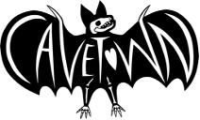
CAVETOWN RELEASES NEW SINGLE “FROG”
WATCH THE MUSIC VIDEO HERE

ANNOUNCES “THIS IS HOME PROJECT”
BENEFITTING LGBTQ+ YOUTH

UPCOMING ALBUM WORM FOOD OUT NOVEMBER 4TH

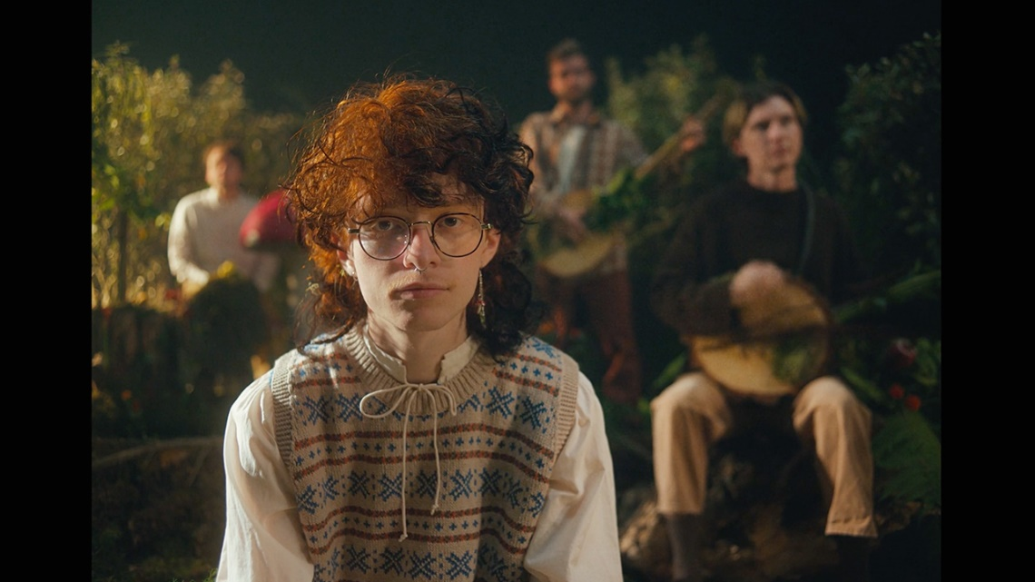

October 19th, 2022 (Los Angeles, CA) – Multi-RIAA Platinum and Gold certified singer/songwriter and producer Cavetown, also known as Robin Skinner, releases the third single, “frog” from his upcoming album worm food out November 4th. The single, along with a music video directed by Skinner, is available everywhere now via Sire Records.

CLICK HERE TO WATCH “FROG”
CLICK HERE TO PRE-SAVE WORM FOOD

“frog” and the corresponding music video continue to embody the dreamy bedroom-pop aesthetic that Cavetown is known for. The video, directed by Skinner, depicts the lead singer and his woodland instrument-playing band surrounded by a mossy forest as well as, of course, frogs.

On “frog,” Cavetown shares, “‘frog’ is about my girlfriend! We were both too shy to ask each other to be boyfriend and girlfriend, so one day I showed her a frog meme that said ‘GF stands for girl-frog and BF stands for boy-frog’ and I said ‘that's us!’ She makes me feel better when I'm too inside my head and helps me remember to be present with the ones I care about.”

He continues, “The frog synth is a combo of logic synths that I mixed together and was really fun to create. Similar to “1994”, I thought about how the synth sounds would translate live and how people could hop around during the frog solo. I used to play a melodica at shows, which would have had a similar effect as the frog synth, but then we’d have to retune the entire set, so the melodica was retired for now.”

The first full length album since 2020’s Sleepyhead, Cavetown delivers his most elaborately realized body of work to date on worm food, shaping his idiosyncratic storytelling into songs that ultimately give voice to our own most intimate emotions. As with all his output, Skinner produced the album on his own at his home studio, holing up in his garage and infusing his understated alt-pop with a powerful new vitality.

“frog” marks skinners third single from worm food following “Fall In Love With A Girl” with beabadoobee, which was featured in Billboard’s “The 25 Best Pride Songs of 2022 (So Far)” earlier this year, and “1994” which has gained nearly 3 million streams since its release.

In alignment with the release of “frog,” Skinner has announced the formation of the This Is Home Project. The foundation’s aim is to donate to various organizations to empower and support LGBTQ+ youth. This Is Home Project and Cavetown have selected five organizations to kick off the donations, including Black LGBTQIA+ Migrant Project (BLMP), True Colors United, Trans Lifeline, Black Trans Femmes in the Arts, and Stonewall. Over the next three years, This Is Home Project will donate a minimum of $1 million.

Skinner shares, “I’m so excited to finally share this with u!!! For the past year, I’ve been working on something special called the This Is Home Project. I wanted to create a way to better support young LGBTQ+ people who are in need of financial help and resources, both on an individual and community-wide scale. I'm also aiming to bring more funding to foundations whose sole focus is providing access to LGBTQ+ youth for physical and mental healthcare, safe housing, and a whole bunch more. u can learn lots more at tihp.cave.town!!!”

This summer Cavetown opened for Bleachers at the Kia Forum in Los Angeles, CA, following a US Tour that wrapped up in May. With over 50,000 tickets sold, Skinner sold out venues across the country including the Hollywood Palladium in Los Angeles and Terminal 5 in New York City. He is currently on a headline tour in Europe and the UK and has sold out his largest headline show to date in London at the Eventim Apollo, with over 5,000 fans attending.

2022 TOUR DATES
October 19 - Fryshuset Arenan - Stockholm, Sweden
October 21 - Astra Kulturhaus - Berlin, Germany - SOLD OUT
October 23 - Palladium Club - Warsaw, Poland - SOLD OUT
October 24 - Velky Sal Lucerna - Prague, Czech Republic
October 25 - Simm City - Vienna, Austria - SOLD OUT
October 27 - Alcatraz B - Milan, Italy - SOLD OUT
October 29 - Exil - Zurich, Switzerland - SOLD OUT
October 30 - KUZ - Mainz, Germany - SOLD OUT
November 1 - Mojo Club - Hamburg, Germany - SOLD OUT
November 3 - Doornroosje - Nijmegen, the Netherlands - SOLD OUT
November 4 - Melkweg - Amsterdam, the Netherlands - SOLD OUT
November 5 - Eventim Apollo - London, United Kingdom - SOLD OUT
November 7 - Olympia Theatre - Dublin, Ireland - SOLD OUT
November 8 - Ulster Hall - Belfast, United Kingdom - SOLD OUT

2023 TOUR DATES
February 14 - Brighton Dome - Brighton, England
February 15 - O2 Academy Leeds - Leeds, United Kingdom
February 16 - O2 Academy Birmingham - Birmingham, United Kingdom
February 18 - O2 Apollo Manchester - Manchester, United Kingdom
February 19 - Barrowland Ballroom - Glasgow, Scotland - SOLD OUT
February 20 - Barrowland Ballroom - Glasgow, Scotland
February 22 - The Corn Exchange - Cambridge, England
March 3 - Blackberry Auditoriume - Mexico City, Mexico

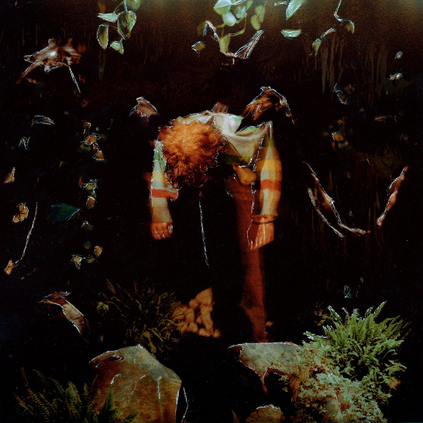
DOWNLOAD ARTWORK AND PRESS PHOTO HERE
About Cavetown:
An innately DIY artist, Cavetown first discovered the depths of his imagination as a child, when he’d write and illustrate his own storybooks. After taking up guitar, he began writing and recording in his bedroom in his early teens, then releasing his lo-fi yet emotionally intricate songs on Bandcamp. Not long after the arrival of his 2018 album Lemon Boy, Cavetown inked a deal with Sire Records and started selling out venues across the U.S. and U.K. as well as performing at festivals like Reading & Leeds and Lollapalooza—all while forging such an intensely personal connection with his audience that he’s taken to keeping a cupboard full of letters received from fans. Now 23, the Cambridge-based artist, otherwise known as Robin Skinner, has emerged as one of the preeminent voices in the bedroom pop scene, with more than 2.5 billion global streams to date, including nearly 8 million monthly Spotify listeners and over 2 million YouTube subscribers. Along the way, Cavetown has co-written and produced for artists like Tessa Violet, chloe morindo, and mxmtoon. The follow-up to his 2021 EP Man’s Best Friend, worm food arrives as Cavetown’s latest full-length since his major-label debut Sleepyhead, a 2020 release that inspired NME to hail him as a “bedroom-pop hero building worldwide community.” His upcoming album worm food will be released November 4th. New singles “1994” and “frog” are available now.

FOLLOW CAVETOWN:
Press Assets | Website | Facebook | Twitter | Instagram | YouTube

Cavetown US Press Contacts:

The Oriel Co
Chloë Walsh
chloe@theoriel.co
Amy Fennie
amy@theoriel.co

Warner Records
Patrice Compere
patrice.compere@warnerrecords.com

