GENRE-BLURRING ARTIST TEDDY SWIMS DROPS STELLAR SLEEP IS EXHAUSTING EP – LISTEN HERE

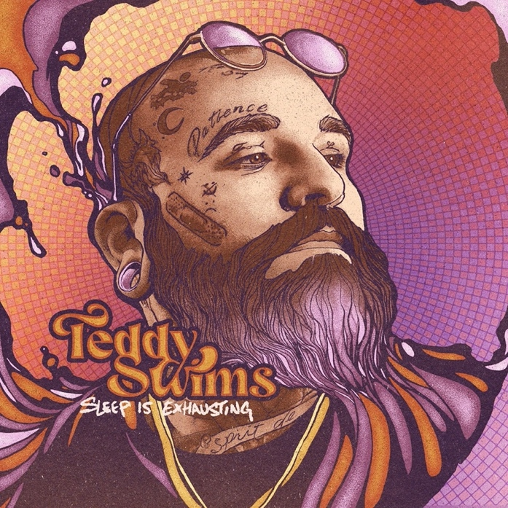
Download Hi-Res artwork HERE

November 4, 2022 (Los Angeles, CA) – Today, Atlanta, GA singer-songwriter Teddy Swims unveils his eclectic Sleep is Exhausting EP. Listen HERE via Warner Records. The six-track set, which includes recent singles “Devil in a Dress,” “2 Moods,” “dose,” and “Someone Who Loved You,” showcases the breakout performer’s jaw-dropping vocal abilities and knack for penning emotionally resonant lyrics.

EP opener “Devil in a Dress,” a soulful lament about the pitfalls of loving the wrong woman, sets the tone for the project: soulful and completely unfiltered. That’s particularly true of “Someone Who Loved You,” which tugs ruthlessly at the heartstrings. After confessing his feelings over palm-muted guitar and hand claps, Swims has a moment of clarity: “At least I can sleep with some peace ‘cause all I had to lose was someone who didn’t love me.”

While Teddy revels in balladry, Sleep is Exhausting showcases his eclectic style. Singles “2 Moods” and “dose” are both an infectious, upbeat distillation of Swims’ lovingly irreverent perspective on life, love and beyond. He switches it up again on the EP’s new tracks. “The Plan” is folk-adjacent and sparse, while the solemn, piano-driven “Hold Me” is a testament to the artist’s boundless range and technical proficiency.

“The title Sleep is Exhausting comes from my inability to shut my mind off and sleep some nights,” Swims says of the EP. “Even if I get sleep, there’s nightmares.” While the project is born out of the tattooed crooner’s restlessness, it promises to be a soothing experience for the listener. “This is a body of work I’m super proud of,” he says. “I’m sure one of these songs has a blessing for you in it!"

Sleep is Exhausting is the culmination of a busy year for Swims that included dropping a viral cover of Journey’s classic “Don’t Stop Believin’” that was reposted by celebrities like Jennifer Garner and Timbaland. In August, he performed the song on America’s Got Talent with season 14 winner Kodi Lee and Journey founder and guitarist Neal Schon. He also lent his powerful pipes to ILLENIUM’s “All That Really Matters,” Meghan Trainor’s “Bad For Me,” and MK & Burns’ “Better.”

Riding this momentum to the very end of 2022, Swims headed out on a headlining tour last month, concluding with a momentous homecoming at the Georgia Theatre in Athens, GA, on November 18, and the Hargray Capitol Theatre in Macon, GA, on November 19 and November 20. Check out the full confirmed itinerary below. Tickets are available HERE.

With Sleep is Exhausting, Swims has six new songs, both gut-wrenching and upbeat, to add to his already-stacked setlist.

TOUR DATES
11/3 Buffalo, NY Town Ballroom
11/5 Albany, NY Empire Live
11/6 Providence, RI Fete Music Hall
11/8 New Haven, CT Toad’s Place
11/9 Baltimore, MD Baltimore Soundstage
11/11 Harrisburg, PA XL Live
11/12 Charlottesville, VA Jefferson Theater
11/13 Louisville, KY Mercury Ballroom
11/15 Charlotte, NC The Underground – Fillmore Charlotte
11/16 Charlotte, SC Music Farm
11/18 Athens, GA Georgia Theatre
11/19 Macon, GA Hargray Capitol Theatre
11/20 Macon, GA Hargray Capitol Theatre

Sleep is Exhausting Tracklist:
1. Devil in a Dress
2. Moods
3. Dose
4. Someone Who Loved You
5. The Plan
6. Hold Me

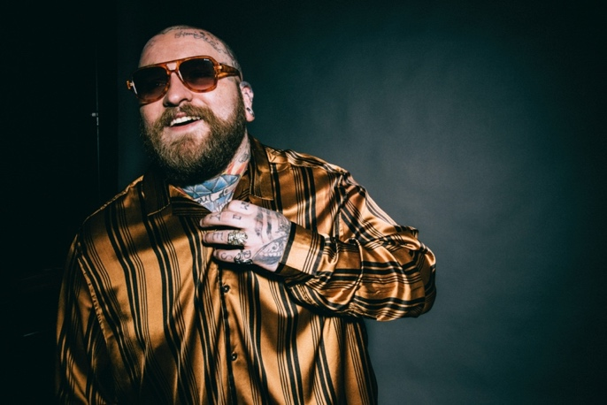
Download Hi-Res press photo HERE
Photo credit: Lindsey Byrnes

FOLLOW TEDDY SWIMS:
Official | Twitter | Instagram | Facebook | YouTube | Press Materials

For more information, please contact:

Darren Baber | Warner Records
Darren.Baber@warnerrecords.com

