For Immediate Release NOVERMBER 11, 2022
THE REGRETTES FURTHER JOY DELUXE EDITION OUT NOW VIA WARNER RECORDS

CONFIRM 29-DATE TOUR WITH YUNGBLUD IN 2023

“…captures the Regrettes’ effortless transformation from teenage punks into pop powerhouses.”
-Rolling Stone
“halfway between Gwen Stefani’s modern pop era and No Doubt’s Rock Steady phase.”
-Consequence

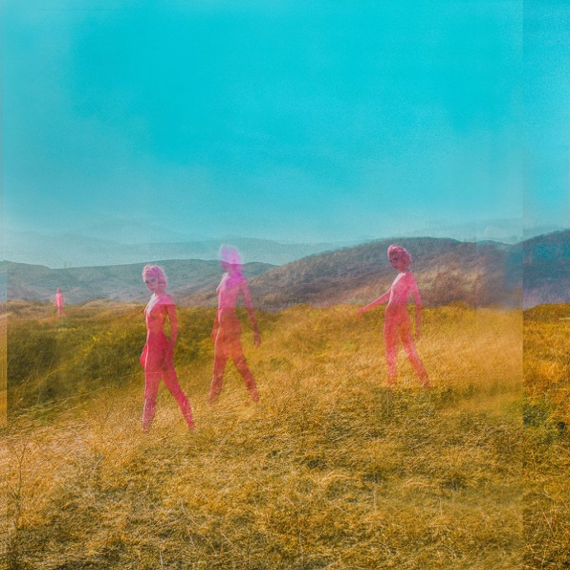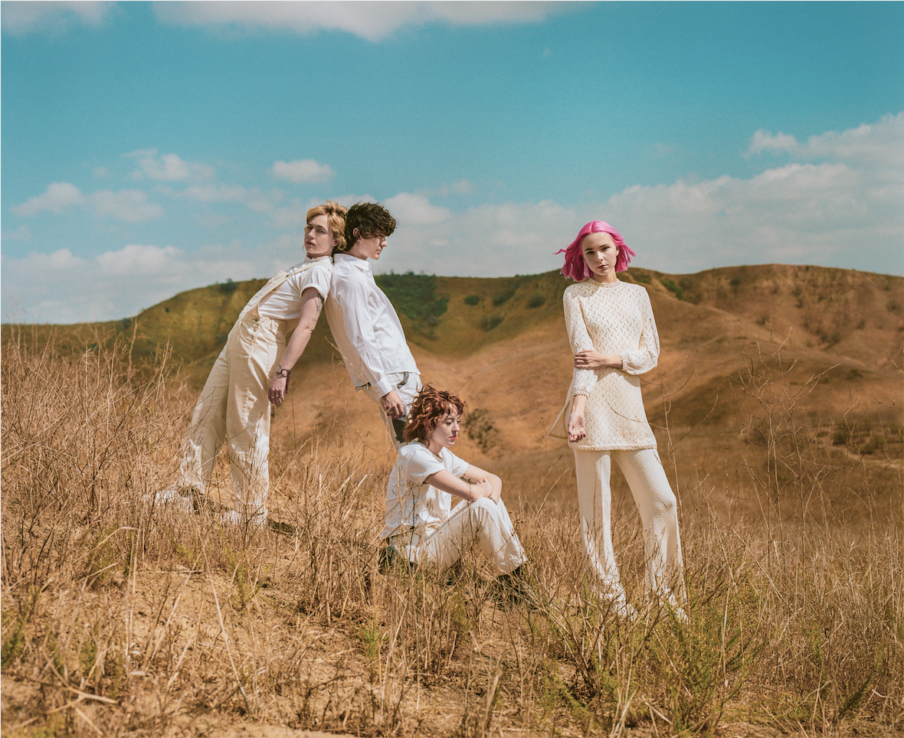

Photo Credit @oclaire / Claire Marie Vogel
Hi-res Album Art And Press Photo Available HERE
November 11, 2022 (Los Angeles, CA) – Today, The Regrettes release the deluxe edition of their celebrated third studio album, Further Joy, via Warner Records. Rolling Stone says the album “…captures the Regrettes’ effortless transformation from teenage punks into pop powerhouses.” Further Joy Deluxe includes the three new songs, "Dummy", "Shapeshifter", and "Answer." The band shared about the new, expanded edition: “We are SO excited about these three new songs that we recorded while creating Further Joy. Each one feels incredibly special to us and expands the world of further joy even deeper. We hope you love them as much as we do :’)” Further Joy Deluxe is available digitally here.
With Further Joy, The Regrettes, consisting of singer and songwriter, Lydia Night, as well as Genessa Gariano (guitar), Brooke Dickson (bass) and Drew Thomsen (drums), have written a manual for living in these times, replete with highly personalized songs about things we’re all going through. Night shares, “that phrase, ‘further joy,’ summarized what it meant to be on the hamster wheel of constantly chasing happiness, but in turn, that’s what makes you unhappy. I was stuck in a loop of wanting to be better, wanting to be good, and therefore I couldn’t be here. I couldn’t be present.” The desire to break free of that cycle is what the band’s third album, Further Joy, is all about: a joyous and self-aware soundtrack for those interested in what Lydia refers to as “dancing the pain away.” The original version of Further Joy is available here in formats including digital/streaming, CD, and vinyl.
The band recently announced that they will support Yungblud on his 29-date headlining tour of North America in 2023. The band will perform in cities including Atlanta, New York, Toronto, and Nashville. Tickets for all dates are on sale now here.
The band recently shared their music video for “Barely On My Mind,” directed by Claire Vogel. The video was recorded on the streets of Brooklyn ahead of their sold-out Irving Plaza show during the Further Joy headlining tour. Watch the music video for “Barely On My Mind” here.
The Regrettes Tour Dates w/ Yungblud
Fri Apr 28 Seattle, WA Paramount Theatre
Sat Apr 29 Vancouver, BC PNE Forum
Tue May 2 Garden City, ID Revolution Concert House And Event Center
Thu May 4 Las Vegas, NV Brooklyn Bowl
Sun May 7 Salt Lake City, UT The Complex
Thu May 11 Austin, TX Stubb's Waller Creek Amphitheater
Fri May 12 Irving, TX The Pavilion At Toyota Music Factory
Sat May 13 Houston, TX 713 Music Hall
Tue May 16 Miami, FL FPL Solar Amphitheatre
Wed May 17 St. Petersburg, FL Jannus Live
Fri May 19 Atlanta, GA Coca Cola Roxy
Sat May 20 Raleigh, NC The Red Hat Amphitheater
Sun May 21 Baltimore, MD Pier Six Pavilion
Tue May 23 Philadelphia, PA The Met
Wed May 24 Wallingford, CT The Dome At Oakdale
Fri May 26 Toronto, ON History
Sun May 28 Montreal, QC Mtelus
Fri Jul 7 Sterling Heights, MI Michigan Lottery Amphitheatre At Freedom Hill
Sat Jul 8 Indianapolis, IN TCU Amphitheater At White River State Park
Tue Jul 11 Cleveland, OH Jacobs Pavilion
Wed Jul 12 Pittsburgh, PA Stage AA
Fri Jul 14 New York, NY The Rooftop At Pier 17
Sat Jul 15 Asbury Park, NJ Stone Pony Summer Stage
Sun Jul 16 Boston, Ma MGM Music Hall At Fenway
Wed Jul 19 Nashville, TN Ascend Amphitheater
Fri Jul 21 Maryland Heights, MO Saint Louis Music Park
Sat Jul 22 Minneapolis, MN The Armory
Mon Jul 24 Oklahoma City, OK The Criterion
Tue Jul 25 Kansas City, MO Uptown Theater
https://www.theregrettes.com/
https://www.facebook.com/regrettes
https://twitter.com/regrettesband
https://www.instagram.com/theregrettesband/
https://youtube.com/theregrettes
https://www.tiktok.com/@theregrettes
For more information, please contact Emilio Herce (emilio@qprime.com) or Mary Moyer (mary@qprime.com) at Q Prime, 212.302.9790.

