GRAMMY® NOMINATED
BEST MUSIC FILM
DIRECTED BY DARYL HANNAH FOR SHAKEY PICTURES
NEIL YOUNG WITH CRAZY HORSE DOCUMENTARY

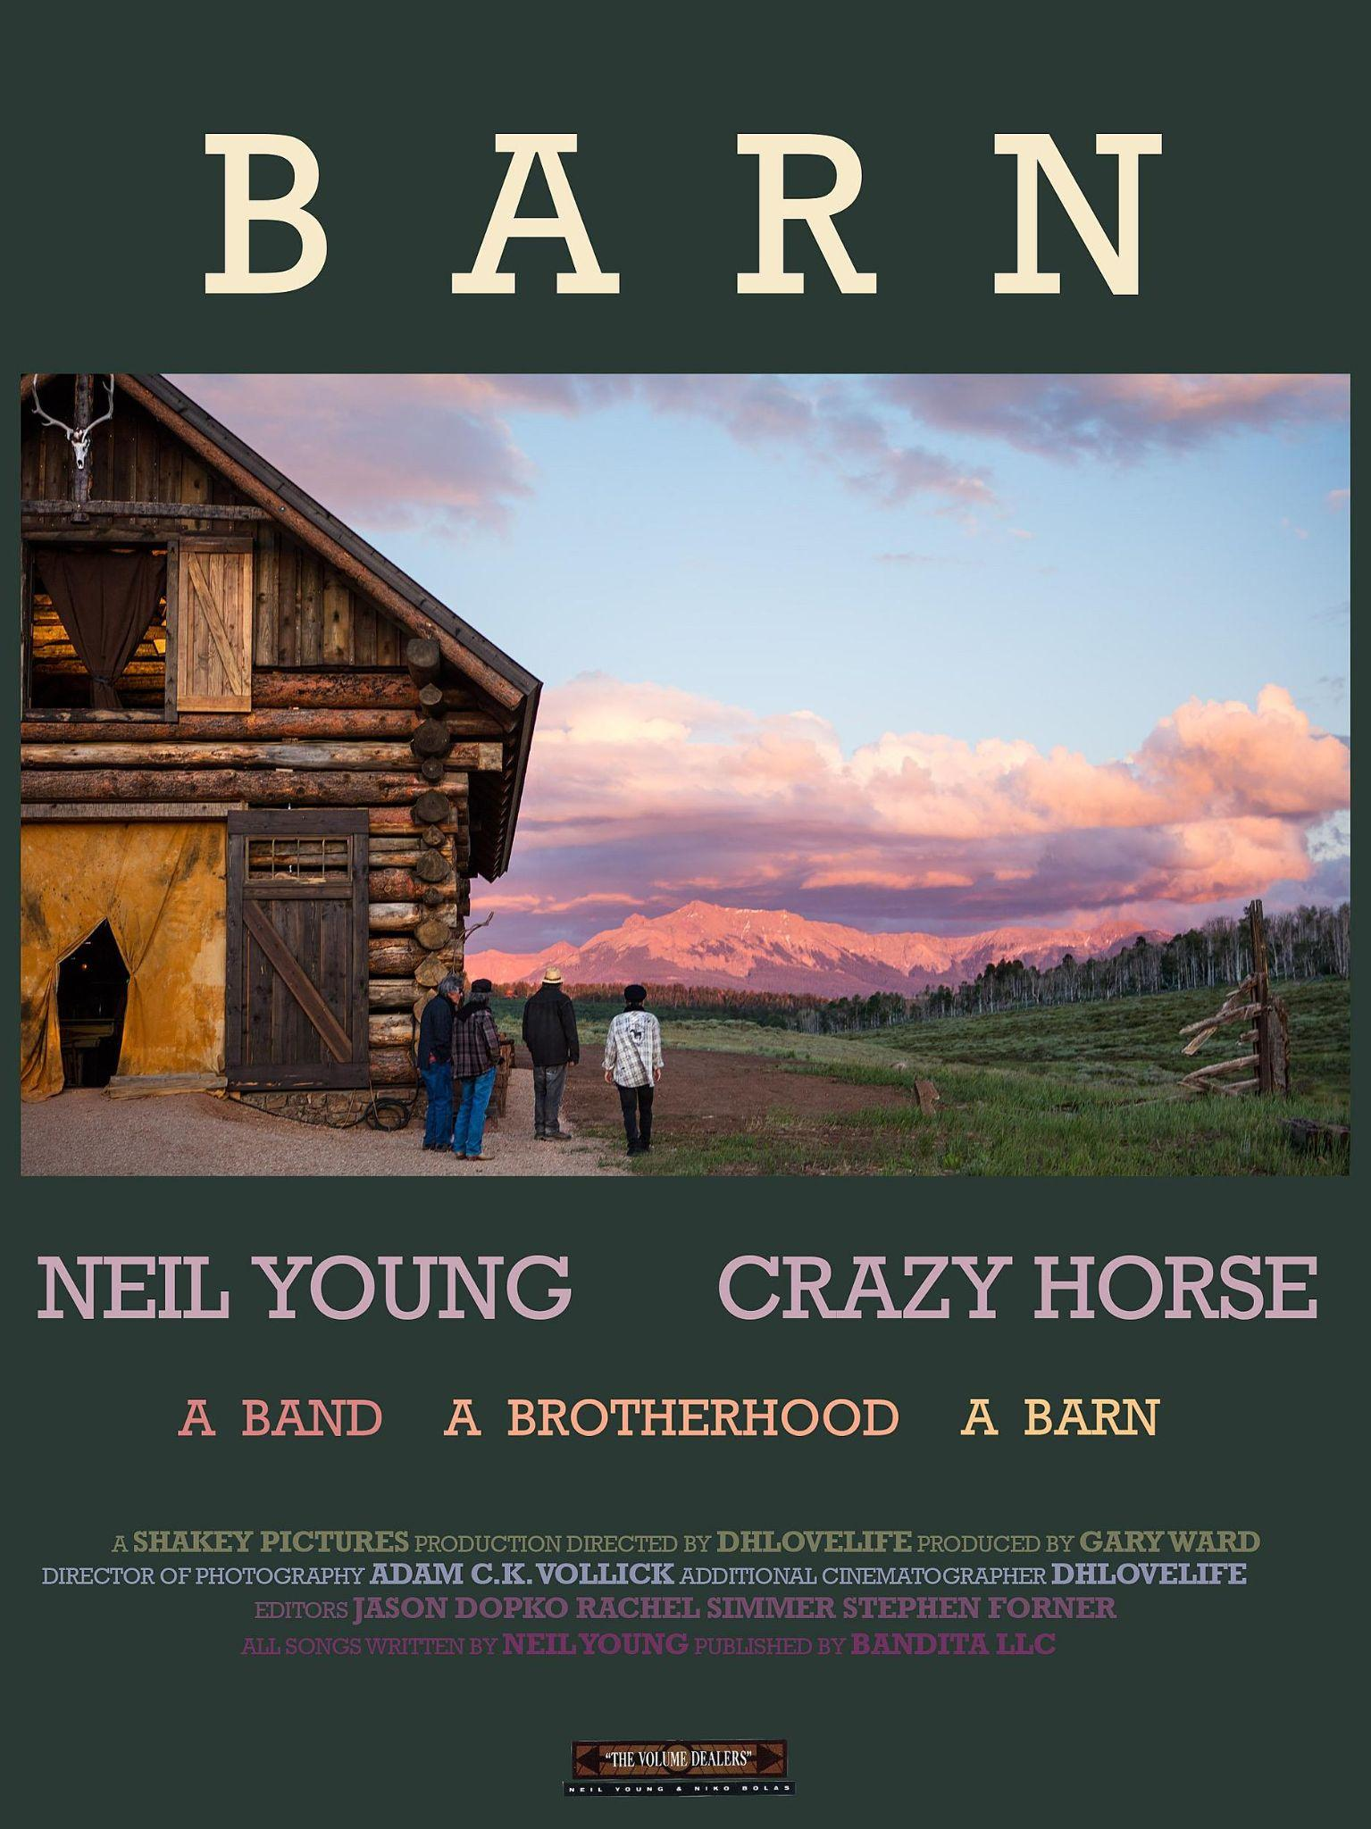

BARN
WATCH IT HERE

December 9, 2022 (Los Angeles, CA) -- Director Daryl Hannah, (dhlovelife), earns a Grammy® nomination for BARN the documentary about the making of Neil Young with Crazy Horse‘s 2020 album, BARN. The extraordinary documentary is nominated for Best Music Film alongside concert recordings from the likes of Adele, Billie Eilish, and Justin Bieber. Hannah shares the nomination with producer Gary Ward of the post-production team Lost Planet.

Due to the legendary spookiness of The Horse, BARN was filmed by the most minimal of crews with Hannah filming on her ipad and cinematographer Adam CK Vollick on camera. Young and his long-time Crazy Horse compadres Billy Talbot (bass), Ralph Molina (drums), and Nils Lofgren (guitar) played live in a restored 19th-century barn in the Rocky Mountains to record a new album with producer Niko Bolas. The film has a unique, bold and uncompromising steadiness, as it focuses on what it means to be in a real band for fifty plus years.

“I was simply hoping to disappear and capture The Horse in all its cosmic musical glory in its natural habitat. Mother Nature joined in displaying her exquisite beauty and magic happened.”
- Daryl Hannah

Intimate moments, sardonic humor, and transporting music are contrasted with stunning footage of the barn in it’s gorgeous natural surroundings.

“To me, this is a wonderful film about Crazy Horse and what it means to be in a band. It shows the humanity of our friendships over the many years, how we make music together, write songs and communicate with one another. It shows the love. This film embraces the environment where we work and how it feels to be in the world. We are very small. The music is very big. Daryl has made a masterpiece – BARN. It’s already a winner.”
- Neil Young

As well as directing music videos like “Love Earth” from the new NY/CH album WORLD RECORD, Hannah also directed for 2018’s Shakey Pictures trippy narrative film Paradox, featuring Neil Young + Promise of the Real, followed by Noise & Flowers, a snapshot of Young’s 2019 European tour with Neil and the Real. BARN, the film is included in the deluxe box-set edition of BARN the Album and is also available as a stand-alone Blu-Ray with high resolution sound exclusively through The Greedy Hand Store at Neil Young Archives. The film can currently be viewed on Young’s YouTube channel.

The winners of the 2023 Grammy® Awards will be revealed on February 5, 2023.

# # #

FOLLOW NEIL YOUNG:
NYA | YouTube | Press Materials

For more information, please contact:
Rick Gershon | Warner Records
rick.gershon@warnerrecords.com
