JAKE WESLEY ROGERS DROPS HEARTFELT LOVE EP INCLUDING “DARK BIRD,” “HINDSIGHT” & “LAVENDER FOREVER”

TWO NEW TRACKS “CALL IT LOVE” AND “MY MISTAKE”

WATCH THE VISUAL FOR “MY MISTAKE” HERE

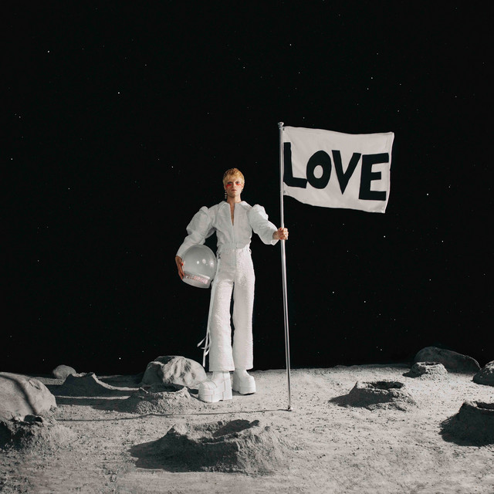

Hi-Res image HERE

October 21, 2022 (Los Angeles, CA) – Today, acclaimed pop artist Jake Wesley Rogers unveils his emotional new EP, LOVE. Listen HERE via Facet Records/Warner Records. Joyous, introspective and wholly authentic, the six-track set boasts two new tracks, “Call It Love” and “My Mistake.” The latter is accompanied by a fascinating video, which provides an intimate peek at the singer-songwriter’s creative process. Watch it HERE.

“LOVE is a follow up to my first major label EP, Pluto. It’s 6 songs of wrestling with where I’ve been with my love and where it’s leading me to. In the song ‘Lavender Forever,’ love is a celebration and in ‘My Mistake,’ it’s a devastation. When I add it all up, it feels like all of these things can be true. LOVE is containing multitude. It was beautiful to collaborate with so many magical people on this record—Eren Cannata, Justin Tranter, Mike Crossey, Ian Fitchuk and Dreamlab to name a few.” – Jake Wesley Rogers on LOVE.

LOVE kicks off with “Call It Love,” a soulful anthem with spoken-word verses that ruminate on love, family, and religion, and a soaring chorus. Meanwhile on “My Mistake,” Rogers looks back on an ill-fated midwestern romance and how it shaped him. “Someone’s gonna love me not in vain, somebody’s gonna love me just the same,” he sings on the piano-driven chorus. “Somebody’s gonna love me, I know it’s true — my mistake was thinking it was you.”

The song’s stripped-back approach is reflected in the video, which captures the quiet moments of the recording process. Rogers goofs around with instruments, steps out into the sunshine, and listens to his work. Moreover, the visual is on a loop, offering viewers the chance to revisit their favorite moments, enriching an already poignant piece of music. Watch it HERE.

In addition to those two new tracks, LOVE also includes “Hindsight” from the groundbreaking gay rom-com Bros as well as the singles “Modern Love,” “Dark Bird,” and “Lavender Forever.” The EP caps Rogers’ wild and wonderful 2022, which has included a performance at WeHo Pride’s OUTLOUD Raising Voices Music Festival, a guest judge role on HBO’s Legendary, and a fall tour with Panic! At the Disco.

Discovered by hit songwriter Justin Tranter in 2020, Rogers’ rise to stardom began last year when Apple Music’s Zane Lowe debuted “Middle of Love” and called the newcomer “wildly talented.” That opinion was shared by a wide array of tastemakers including People, Billboard, Rolling Stone, American Songwriter, and PAPER. His ambitious visual style and bold music also attracted the attention of Vogue who profiled him as part of their Youthquake series, highlighting Gen-Z creators that are radically reimagining the future.

Rogers was also able to showcase his larger-than-life stage presence with performances on Good Morning America, The Late Late Show With James Corden, and Late Night With Seth Meyers and Ellen. Now, with LOVE, Rogers delivers a deeply emotive collection of pop gems that are as infectious as they are insightful.
###

Follow Jake Wesley Rogers:
Official Site | TikTok | Instagram | Twitter | Facebook | YouTube | Press Materials

For further information, please contact:
Darren Baber | Warner Records
Darren.Baber@warnerrecords.com

