RISING POP STAR JENNA RAINE REVEALS NEW SINGLE “RENT FREE” – LISTEN HERE

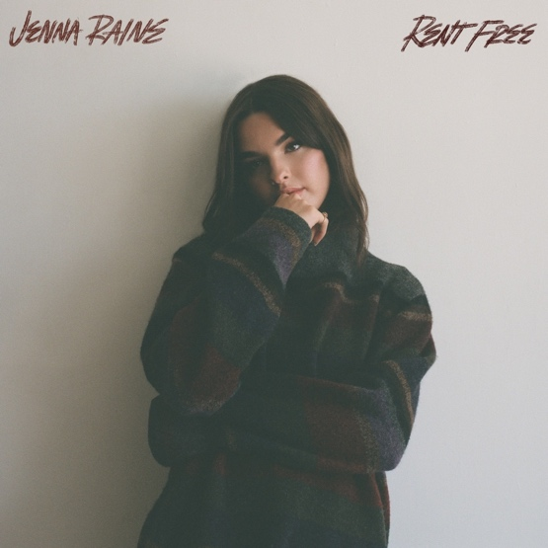
Download Hi-Res artwork HERE

November 11, 2022 (Los Angeles, CA) – Building buzz with tens of millions of streams and critical acclaim, rising pop artist Jenna Raine unveils a hyper catchy new single entitled “rent free” via Warner Records today.

Listen to “rent free” HERE and watch the accompanying visual HERE.

On the track, clean guitar underlines vivid lyrics about a one-sided relationship. Tempering a galloping rhythm with an instantly quotable refrain, the hook kicks into a high gear in a rush of energy as she ponders, “Why have I been letting you live rent free in my mind?”

About “rent free,” she commented, “‘rent free' is a song for anyone wasting too much time and energy on a crush who doesn't deserve them. I have a friend who would pay for their crush’s gas and food and give them rides everywhere. Their crush didn't have the same feelings...they didn't care about my friend nearly enough, and it bothered me. So, I wrote ‘rent free’ for everyone who needs a reminder to get rid of that crush who is living ‘rent free’ in their mind.”

It lands in the wake of the fan favorite “Fumbled the Bag,” which incited critical applause right out of the gate. OnesToWatch proclaimed, “The vulnerable track is a tell-it-like-it-is anthem that doesn’t hold back from telling an ex they’re at fault,” and she notably performed the track for GRAMMY.com who fittingly hailed it as “a scorching kiss-off to an ex.”

“Fumbled the Bag” followed the empowering “NOT AGAIN” as well as her breakthrough EP see you later, the release that contains her hit “see you later (ten years),” which has racked up over 77 million global streams. With the release of see you later, Variety predicted, “Raine’s future looks bright.”

Currently in the studio with some of today’s top songwriters and producers, Raine continues to assert herself as a force to be reckoned with in the pop world with more music to come very soon.

ABOUT JENNA RAINE:
Jenna Raine’s songs brim with hope and wide-eyed wonder. “My goal is to be a light in a troubled world,” the 18-year-old says. “I want my music to make people feel less alone.” By documenting her hopes and dreams in diary-like detail on her major-label debut EP, see you later, she reminds listeners that the growing pains of adolescence are universal and best approached with positivity. Even the teen’s sad songs look on the bright side. Take her breakout hit, “see you later (ten years),” which exploded on TikTok in 2021. “It’s heartbreaking when the timing is all wrong,” the Dallas, Texas native says of dating the right person at the wrong time. However, instead of giving up, she manifested a happy ending. “It doesn’t have to mean goodbye, simply see you later.” The song went on to amass more than 77 million global streams and resulted in a deal with Warner Records. It’s a goal she has been working towards since entering her first talent show at age 8. A four-year stint in girl group L2M followed as well as world tours and a pair of independently released EPs. Raine’s growth as an artist is now showcased on her new project. In addition to the titular smash, the three-song set contains a new version of “see you later (ten years)” featuring JVKE and a loved-up anthem called “2%,” which is about beating the odds and marrying your childhood sweetheart. With her see you later EP, and recent singles “Fumbled the Bag” and “NOT AGAIN,” Raine will touch hearts and lift spirits — one loved-up ballad at a time.

Download Hi-Res press photo HERE

FOLLOW JENNA RAINE:
Official | TikTok | Instagram | Twitter | Facebook | YouTube | Press Materials

For more information on Jenna Raine, please contact:
Darren Baber | Warner Records
Darren.Baber@warnerrecords.com

Patrice Compere | Warner Records
Patrice.Compere@warnerrecords.com

