JOSHUA BASSETT ROLLS OUT YET ANOTHER SURPRISE SINGLE WITH “DIFFERENT”

LISTEN HERE

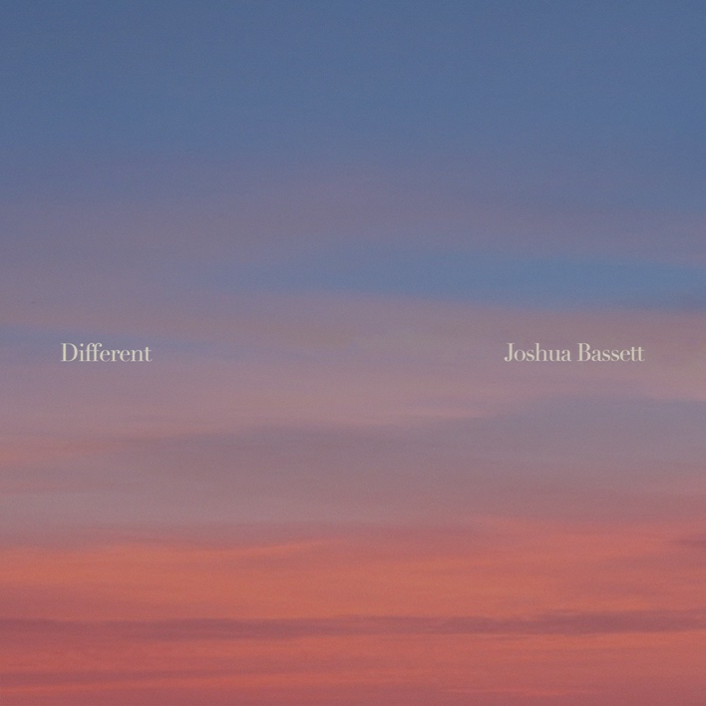

October 27, 2022 (Los Angeles, CA) – Today, singer, songwriter, and actor Joshua Bassett releases “Different,” his fourth surprise single in as many weeks. Listen HERE via Warner Records. Equal parts tentative and euphoric, the track is about rekindling an old relationship. As with his other surprise singles “would you love me now?,” “SHE SAID HE SAID SHE SAID,” and “I’m sorry,” it perfectly captures Bassett’s vocal talent and songwriting chops.

“My biggest regret was walking away, I’m not gonna make the same mistake,” the 21-year-old sings in his delicate, disarming falsetto over strummed guitar. Bassett then suggests they take a leap of faith. “I know you’re afraid we’ll end up the same, and the truth is we might,” he belts on the chorus. “But if we do this thing right, maybe this time it will be different.” It’s another disarmingly honest and heartfelt addition to his burgeoning discography.

While acknowledging that his recent spate of rogue releases dissect very different stages of a relationship, there is a thread that joins them: “They share the same truth: love is messy.” Bassett wrote all four “and a dozen more” in the same week when inspiration struck out of the blue. “Between long lost love, broken promises, reconciliation and new beginnings — you can count on one thing: it’s complicated.”

“Different” is the fourth surprise track Bassett has released this month after “I’m sorry,” “SHE SAID HE SAID SHE SAID,” and “would you love me now?” And this outpouring of pop gems comes less than a month after he dropped his critically acclaimed Sad Songs in a Hotel Room EP. Other recent highlights include performing “Smoke Slow” on Today and sold-out shows at New York’s iconic Bowery Ballroom and The Troubadour in Los Angeles.

Download Hi-Res HERE
Photo credit: Luke Rogers

###

FOLLOW JOSHUA BASSETT:
TikTok | Instagram | Twitter | Facebook | YouTube | Press Materials

For more information, please contact:

Darren Baber | Warner Records
Darren.Baber@warnerrecords.com

