**THE FLAMING LIPS SET TO LAUNCH CAREER-SPANNING *AN EVENING WITH* 2023 WEST COAST TOUR DATES – TICKET PRE-SALE BEGINS DECEMBER 8TH, PUBLIC ON-SALE DECEMBER 9TH**

**BIGGEST CAREER SINGLE “DO YOU REALIZE??” NOW CERTIFIED GOLD BY THE RIAA**

***YOSHIMI BATTLES THE PINK ROBOTS* 20TH-ANNIVERSARY CD BOX SET IS AVAILABLE NOW, 5LP VINYL EDITION COMING APRIL 14, 2023**

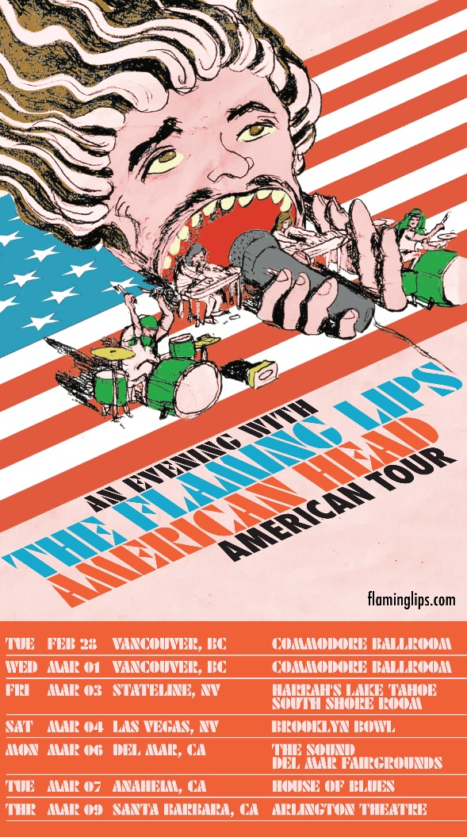

**December 6, 2022 — (Los Angeles, CA):** Returning to the road in the new year, [**The Flaming Lips**](https://nam04.safelinks.protection.outlook.com/?url=https%3A%2F%2Fwww.flaminglips.com%2F&data=05%7C01%7CDelanee.Wilson%40warnerrecords.com%7C2a3fb5e754a445e72d3808daccde7d33%7C8367939002ec4ba1ad3d69da3fdd637e%7C0%7C0%7C638047553216009457%7CUnknown%7CTWFpbGZsb3d8eyJWIjoiMC4wLjAwMDAiLCJQIjoiV2luMzIiLCJBTiI6Ik1haWwiLCJXVCI6Mn0%3D%7C3000%7C%7C%7C&sdata=xUDAxbBFCoceLgf32O4YKt9hJ06UOBMYfQgUGI3RlJA%3D&reserved=0) will embark on ***An Evening With* Tour** throughout the West Coast in 2023. These career-spanning headline gigs find the alternative rock stalwarts mining their catalog for what promises to be an epic and unforgettable two-hour set. The jaunt commences with a two-night stand in Vancouver, BC and concludes in Santa Barbara, CA at Arlington Theatre. Presales go live on **December 8** at **10am local time**, while public on-sale begins on **December 9** at **10am local time**. Click [**HERE**](https://www.flaminglips.com/#songkick-section) for details.

In other big news, the group’s classic, life-affirming single [**“Do You Realize??”**](https://www.youtube.com/watch?v=lPXWt2ESxVY) just earned a gold certification from the RIAA. It adorns their classic 2002 album, ***Yoshimi Battles the Pink Robots***.

They just celebrated the 20th-anniversary of this classic with the release of an expansive box set that includes B-sides, demos, remixes, radio sessions, two concerts, and other assorted rarities from the era. The CD set includes over 50 tracks never released and dozens of rare tracks. The LP box set has 40 tracks never released on vinyl and over 30 previously unreleased tracks. ***Yoshimi Battles the Pink Robots: 20th Anniversary Edition*** is available now, via **Warner Records,**on all streaming services and as a 6 CD box set (featuring 100 tracks).

A 5 LP package (featuring 56 tracks) will land on **April 14, 2023**. Additionally, there will be a limited edition D2C exclusive edition of the 20th Anniversary Deluxe 5 LP box set pressed on Baby Pink vinyl, released on the same day. Order the 6 CD and 5 LP box sets of ***Yoshimi Battles the Pink Robots: 20th Anniversary Edition*** [**HERE,**](https://nam04.safelinks.protection.outlook.com/?url=https%3A%2F%2Fstore.flaminglips.com%2F&data=05%7C01%7CDelanee.Wilson%40warnerrecords.com%7C2a3fb5e754a445e72d3808daccde7d33%7C8367939002ec4ba1ad3d69da3fdd637e%7C0%7C0%7C638047553216009457%7CUnknown%7CTWFpbGZsb3d8eyJWIjoiMC4wLjAwMDAiLCJQIjoiV2luMzIiLCJBTiI6Ik1haWwiLCJXVCI6Mn0%3D%7C3000%7C%7C%7C&sdata=FzAxSaeL6fHHqTEt3C%2BZnYtgZVB4yI6NSmBRpC%2BvI7U%3D&reserved=0)and order new **Yoshimi**T-shirts designed for the 20th Anniversary [**HERE**](https://nam04.safelinks.protection.outlook.com/?url=https%3A%2F%2Fstore.flaminglips.com%2F&data=05%7C01%7CDelanee.Wilson%40warnerrecords.com%7C2a3fb5e754a445e72d3808daccde7d33%7C8367939002ec4ba1ad3d69da3fdd637e%7C0%7C0%7C638047553216009457%7CUnknown%7CTWFpbGZsb3d8eyJWIjoiMC4wLjAwMDAiLCJQIjoiV2luMzIiLCJBTiI6Ik1haWwiLCJXVCI6Mn0%3D%7C3000%7C%7C%7C&sdata=FzAxSaeL6fHHqTEt3C%2BZnYtgZVB4yI6NSmBRpC%2BvI7U%3D&reserved=0)**.**

Also, [***THE FLAMING LIPS SPACE BUBBLE FILM***](https://nam04.safelinks.protection.outlook.com/?url=https%3A%2F%2Fwww.criterionchannel.com%2Fthe-flaming-lips-space-bubble-film&data=05%7C01%7CDelanee.Wilson%40warnerrecords.com%7C2a3fb5e754a445e72d3808daccde7d33%7C8367939002ec4ba1ad3d69da3fdd637e%7C0%7C0%7C638047553216009457%7CUnknown%7CTWFpbGZsb3d8eyJWIjoiMC4wLjAwMDAiLCJQIjoiV2luMzIiLCJBTiI6Ik1haWwiLCJXVCI6Mn0%3D%7C3000%7C%7C%7C&sdata=wLT1yDGT7y3LsrCpRfiIq0nKbZs1Y9%2B0fiBqIIimBD0%3D&reserved=0) is featured exclusively on **The Criterion Channel** now. This concert documentary, directed by **Wayne Coyne** and **Blake** **Studdard** and filmed in the band’s hometown of Oklahoma City in 2020**,** chronicles the logistical challenges of putting on a show at the height of the pandemic. **The Space Bubble Concerts** would feature both band and audience encased in individual transparent, prophylactic Space Bubbles to insure a Covid-safe live **LIPS** experience, connecting in a joyous, socially distanced communal way never tried before.

As previously announced, **The Flaming Lips** have scheduled shows in London and Washington, DC that will feature the album performed in its entirety. Shows in Chicago and Atlanta have just been confirmed. Click [**HERE**](https://nam04.safelinks.protection.outlook.com/?url=https%3A%2F%2Fwww.songkick.com%2Fartists%2F7453-flaming-lips&data=05%7C01%7CDelanee.Wilson%40warnerrecords.com%7C2a3fb5e754a445e72d3808daccde7d33%7C8367939002ec4ba1ad3d69da3fdd637e%7C0%7C0%7C638047553216009457%7CUnknown%7CTWFpbGZsb3d8eyJWIjoiMC4wLjAwMDAiLCJQIjoiV2luMzIiLCJBTiI6Ik1haWwiLCJXVCI6Mn0%3D%7C3000%7C%7C%7C&sdata=XGdpCxKNITNWsx4X25HGMYh8qfNsoc2ZUcFKzq38L1A%3D&reserved=0) for information.

Released in July 2002, the sci-fi-themed quasi-concept album ***Yoshimi Battles the Pink Robots*** remains the commercial high-water mark in **The Flaming Lips’** wild four-decade journey, giving them their first RIAA certified Gold Record. As the eagerly awaited follow-up to 1999’s masterwork ***The Soft Bulletin***, ***Yoshimi*** proved that singer/guitarist **Wayne Coyne** and multi-instrumentalist **Steven Drozd** had yet another masterpiece in them. The record yielded the band’s top-streamed track, [**“Do You Realize??”**](https://nam04.safelinks.protection.outlook.com/?url=https%3A%2F%2Fwww.youtube.com%2Fwatch%3Fv%3DlPXWt2ESxVY&data=05%7C01%7CDelanee.Wilson%40warnerrecords.com%7C2a3fb5e754a445e72d3808daccde7d33%7C8367939002ec4ba1ad3d69da3fdd637e%7C0%7C0%7C638047553216009457%7CUnknown%7CTWFpbGZsb3d8eyJWIjoiMC4wLjAwMDAiLCJQIjoiV2luMzIiLCJBTiI6Ik1haWwiLCJXVCI6Mn0%3D%7C3000%7C%7C%7C&sdata=w%2FGT3IFf7OKzPpNUm%2Bn8J%2BwxNQGM2qj%2BFYl4JovjGoo%3D&reserved=0) (a timeless stargazing anthem that, in 2009, was named the **Official Rock Song** of the band’s native Oklahoma) and also landed the **Lips** their first-ever GRAMMY Award® win for the cosmic album-closing instrumental **“Approaching Pavonis Mons by Balloon (Utopia Planitia).”**Click [**HERE**](https://nam04.safelinks.protection.outlook.com/?url=https%3A%2F%2Fyoutu.be%2FuJWiUd9c-8A&data=05%7C01%7CDelanee.Wilson%40warnerrecords.com%7C2a3fb5e754a445e72d3808daccde7d33%7C8367939002ec4ba1ad3d69da3fdd637e%7C0%7C0%7C638047553216009457%7CUnknown%7CTWFpbGZsb3d8eyJWIjoiMC4wLjAwMDAiLCJQIjoiV2luMzIiLCJBTiI6Ik1haWwiLCJXVCI6Mn0%3D%7C3000%7C%7C%7C&sdata=wfA2d1BpItxHtpc9EDWzT%2BmPh8YnCPegXW2LXYXqD2Q%3D&reserved=0) to view and share “Wayne listening to the multi-tracks for **“Do You Realize??”**

**AN EVENING WITH WEST COAST TOUR 2023**

February 28 Vancouver, BC Commodore Ballroom

March 1 Vancouver, BC Commodore Ballroom

March 3 Stateline, NV Harrah’s Lake Tahoe

March 4 Las Vegas, NV Brooklyn Bowl

March 6 Del Mar, CA The Sound - Del Mar Fairgrounds

March 7 Anaheim, CA House of Blues

March 9 Santa Barbara, CA Arlington Theatre

***YOSHIMI BATTLES THE PINK ROBOTS* SHOWS**

April 28 London, UK Eventim Apollo

May 05 Chicago, IL The Salt Shed

May 05-May 07 Atlanta, GA Shaky Knees Festival

May 25 Washington, DC The Anthem

**About The Flaming Lips:**

Formed in Oklahoma City, OK in 1983, **The Flaming Lips** have since become one of the most iconic, influential, unpredictable, and vital forces in American alternative rock music. The band has garnered three GRAMMY® Awards, a Tony nomination, and an RIAA Gold-certified Record for ***Yoshimi Battles the Pink Robots***. *Q*Magazine named them one of the “50 Bands to See Before You Die.”  The band has made countless late night television appearances, appeared in a Super Bowl commercial, contributed to many film soundtracks, and collaborated with artists such as Miley Cyrus, Coldplay’s Chris Martin, Kacey Musgraves, Yoko Ono, The Chemical Brothers, and so many more. They have set countless records, broken records, created spectacular interactive audio/visual events now regarded as legendary.  Front man Wayne Coyne has been recognized for works of art that graced many **LIPS** album covers along with his traveling art exhibit **“The King’s Mouth,”** an audiovisual art installation that has been featured in many contemporary art museums around the US.  Their latest LP, ***American Head***, marks a return to a more melodic and song-oriented body of work and has critically been lauded as their best work in years placing on several Year End/Best Of lists around the world. Evan after a combination of 22 studio recordings, 16 singles, 11 compilations, 11 EP’s and 11 self-released experimental collaborative oddities released in various forms, quantities and unique mediums, **The Flaming Lips** remain in a creative apex that has no bounds. To that end, they have become an American Treasure and created a genre all to themselves.

**# # #**

For further information, contact **Rick Gershon** at Warner Records:

818-953-3473 / [**Rick.Gershon@warnerrecords.com**](mailto:Rick.Gershon@warnerrecords.com)

**Official Site:**

[**flaminglips.com**](https://www.flaminglips.com/)

**Official Web Store:**

[**https://store.flaminglips.com/**](https://store.flaminglips.com/)

**Press Materials:**

[**https://press.warnerrecords.com/flaminglips**](https://press.warnerrecords.com/flaminglips)

