SOFÍA VALDÉS UNVEILS NEW SINGLE & MUSIC VIDEO “HEART OF GLASS”

LISTEN HERE – WATCH VIDEO HERE

MORE MUSIC DUE IN 2023

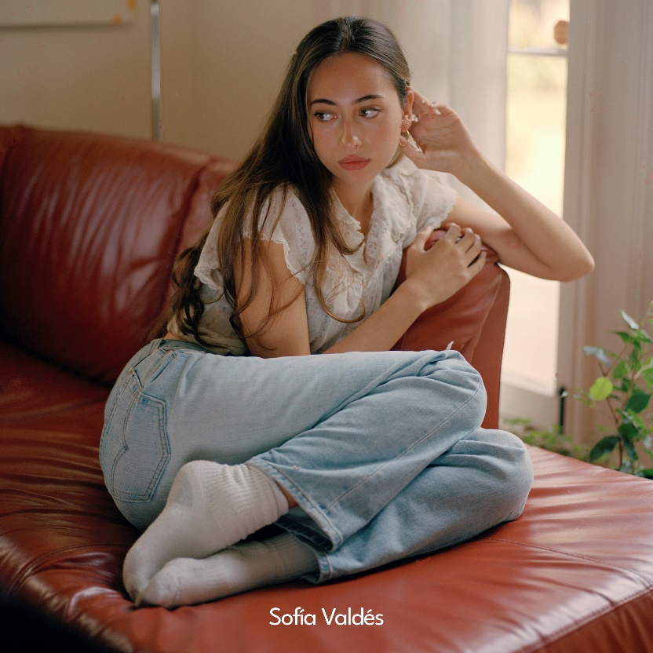
Credit: Sophia Liv Maguire

“Sofía Valdés has music in her blood”

“Sofía Valdés is in her own lane, with a rich Latin heritage that bleeds through her music”

“The rising Panamanian artist’s guitar songs are some of the prettiest you’ll hear.”

December 2, 2022 (Los Angeles, CA) – Delivering another contemplative and catchy gem for 2022, Panamanian singer-songwriter Sofía Valdés shares a new single and music video entitled “Heart Of Glass” today via Warner Records. Crafted alongside producer Michael Uzoworu [SZA, Rosalia, Frank Ocean], the new track sets the stage for a momentous 2023, with much more music to come in the new year. Listen to “Heart Of Glass” HERE and watch the music video HERE.

The track threads ethereal guitars through upbeat production as her breathy vocals shudder and soothe. With an exhale of emotion, she asks, “So, what’s gonna take to turn around? A heart of glass can break with just a sound.” The intimate visual embodies the tender spirit of the song. Featuring Sofía as its sole subject, the clip jumps between scenes of her writing in her diary, lighting a candle, watering plants, and tending to her home. At the same time, the closeups evoke her vulnerably vital spirit.

Regarding the single, Sofía said, "I wrote this song when I had just moved from Panama to LA towards the come down of the pandemic. I was new in town and felt very alone since I didn’t know anyone in the city. I always play the part of someone who is very strong emotionally (and I am), but in these times, I felt very confused and out of place. I still do, but that’s part of the journey. I’m a very sensitive person but I find power in vulnerability, so that’s how this song came to be. I wanted to share a story of mine and what was going in my mind around that time."

It lands in the wake of Sofía’s most recent single “Broken” [feat. Pink Sweat$], following her acclaimed EPs In Bloom and Ventura. Upon its release, V Magazine premiered the Satchel Lee-directed video and proclaimed, “In an effortless blend of bedroom-pop and bossa nova, Valdés has crafted a cozy breakup anthem,” adding to a long list of critical acclaim from the likes of NPR, W Magazine, Interview Magazine, NYLON, Ones To Watch, and many more for her emotionally honest and beautifully original blend of bossa nova, folk, and pop.

FOLLOW SOFÍA VALDÉS
INSTAGRAM | FACEBOOK | YOUTUBE | TIK TOK | WEBSITE

FOR PRESS INQUIRIES
Patrice Compere / patrice.compere@warnerrecords.com

