JOSHUA BASSETT ANNOUNCES THE COMPLICATED TOUR IN NORTH AMERICA AND EUROPE

BUY TICKETS HERE

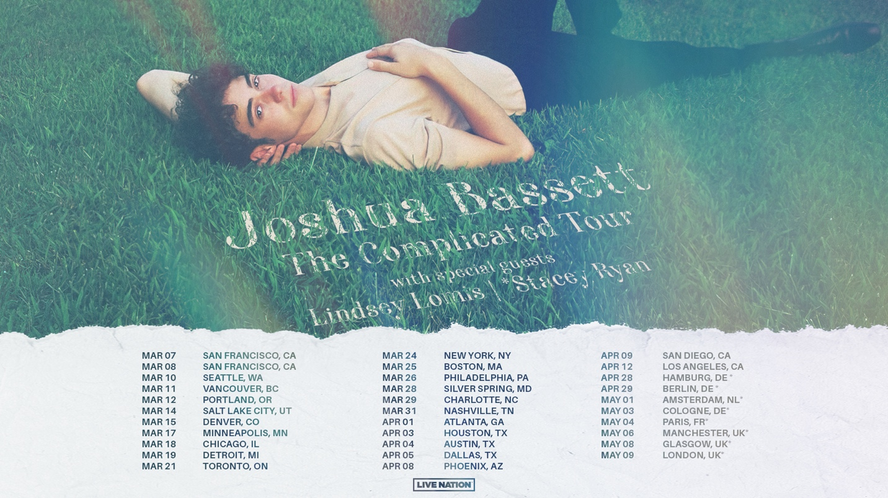

December 12, 2022 (Los Angeles, CA) – Today, singer, songwriter, and actor Joshua
Bassett announces The Complicated Tour, his 2023 run in North America and Europe.
The North American leg, produced by Live Nation and supported by Lindsey Lomis, kicks off at The Fillmore in San Francisco on March 7, then crisscrosses the continent before heading overseas. The European dates, supported by Stacey Ryan, begin in Hamburg, Germany on April 28 and wrap up at O2 Forum Kentish Town in London on May 9.

Fans who had previously purchased tickets to Joshua Bassett’s 2022 canceled shows in San Francisco, San Diego, Chicago, Philadelphia, Washington D.C., and Boston will receive messages with exclusive presale access to purchase tickets first in their city. The Original Buyers Presale will take place on December 12 at 12pm local time. Artist Presale will go live on December 13 at 10am local time, with public on-sale following on December 16 at 10am local time. See all tour dates below and get your tickets HERE.

The big announcement comes just weeks after the young crooner delighted fans by dropping four surprise tracks in October, each arriving a week apart. Heartfelt and bruisingly honest, “Different,” “would you love me now?,” “SHE SAID HE SAID SHE SAID,” and “i’m sorry” all captured different aspects of Bassett’s artistry — highlighting his vocal talent, versatility and impressive songwriting chops.

That quartet of singles capped an extraordinary year for Bassett, which included the arrival of his critically acclaimed Sad Songs in a Hotel Room EP, making his feature film debut in Disney+’s Better Nate Than Ever, and starring in the Disney+ animated film Night at the Museum: Kahmunrah Rises Again. Recently, the rising star performed “Smoke Slow” on Today and played sold-out shows at New York’s iconic Bowery Ballroom and The Troubadour in Los Angeles. Now, Bassett is ready to hit the road and share his music coast to coast.

The Complicated Tour:

March 7 – San Francisco, CA @ The Fillmore
March 8 – San Francisco, CA @ The Fillmore
March 10 – Seattle, WA @ Neptune Theatre
March 11 – Vancouver, BC @ Centre in Vancouver
March 12 – Portland, OR @ Roseland Theater
March 14 – Salt Lake City, UT @ The Complex
March 15 – Denver, CO @ The Summit
March 17 – Minneapolis, MN @ The Fillmore Minneapolis
March 18 – Chicago, IL @ House of Blues Chicago
March 19 – Detroit, MI @ Saint Andrews Hall
March 21 – Toronto, ON @ Phoenix Concert Theatre
March 24 – New York, NY @ Hammerstein Ballroom
March 25 – Boston, MA @ Big Night Live
March 26 – Philadelphia, PA @ The Theater of Living Arts
March 28 – Silver Spring, MD @ The Fillmore Silver Spring
March 29 – Charlotte, NC @ The Underground
March 31 – Nashville, TN @ Marathon Music Works
April 1 – Atlanta, GA @ Buckhead Theatre
April 3 – Houston, TX @ House of Blues Houston
April 4 – Austin, TX @ Emo’s Austin
April 5 – Dallas, TX @ House of Blues Dallas
April 8 – Phoenix, AZ @ The Van Buren
April 9 – San Diego, CA @ Observatory North Park
April 12 – Los Angeles, CA @ The Wiltern

Apr 28 – Hamburg, Germany @ Große Freiheit 36*
Apr 29 – Berlin, Germany @ Huxleys Neue Welt*
May 1 – Amsterdam, Netherlands @ Paradiso*
May 3 – Cologne, Germany @ Live Music Hall*
May 4 – Paris, France @ Le Bataclan*
May 6 – Manchester, UK @ Academy 2*
May 8 – Glasgow, UK @ SWG3 TV Studio*
May 9 – London, UK @ O2 Forum Kentish Town*
*Not A Live Nation Date

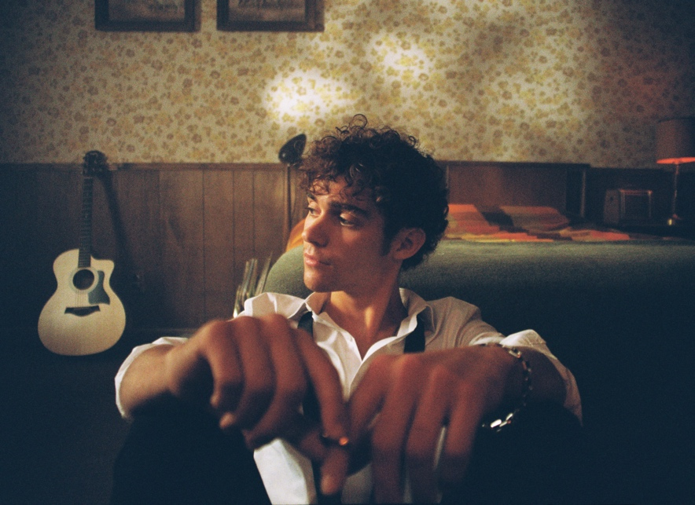

Download Hi-Res HERE
Photo credit: Luke Rogers

ABOUT JOSHUA BASSETT:
Joshua Bassett may sing, write, act, and play multiple instruments, but he humbly identifies himself as “just a kid from San Diego who loves music.” Long before starring in a Disney+ original series, generating millions of streams, and garnering widespread acclaim, he grew up surrounded by music in Oceanside, CA. He played drums in church, taught himself ukulele, guitar, and piano, and wrote his first song for his homecoming date at 15. In addition to being homeschooled alongside his five sisters, he strengthened his voice in local theater productions. Bassett landed the lead role of Ricky in High School Musical: The Musical: The Series in 2019 and soon thereafter signed with Warner Records, unveiling his solo debut “Common Sense” in 2020. That laid the foundation for his blockbuster 2021, which brought his self-titled debut EP, viral hit “Feel Something,” and “Crisis / Secret / Set Me Free” — a trio of emotional tracks that raised money for mental health organizations including a donation of $20K from Bassett himself. His winning ways continue in 2022 with the release of “Doppelgänger,” his latest EP Sad Songs In A Hotel Room, and four surprise tracks in October: “would you love me now?,” “SHE SAID HE SAID SHE SAID,” “i’m sorry,” and “Different.” Those releases lifted his total global streams to more than 425M. This year also brought a handful of headlining shows throughout the US and his film appearances in Disney+’s Better Nate Than Ever and Night at the Museum: Kahmunrah Rises Again.

ABOUT LIVE NATION ENTERTAINMENT:
Live Nation Entertainment (NYSE: LYV) is the world’s leading live entertainment company comprised of global market leaders: Ticketmaster, Live Nation Concerts, and Live Nation Sponsorship. For additional information, visit www.livenationentertainment.com.

###

FOLLOW JOSHUA BASSETT:
TikTok | Instagram | Twitter | Facebook | YouTube | Press Materials

For more information, please contact:

Darren Baber | Warner Records
Darren.Baber@warnerrecords.com

Monique Sowinski | Live Nation Concerts
MoniqueSowinski@livenation.com

