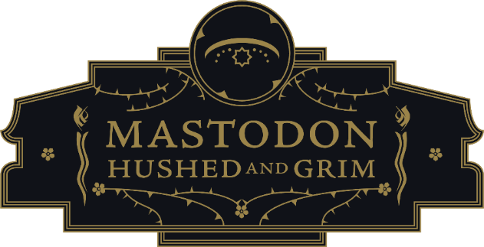

GRAMMY® AWARD-WINNING MASTODON & GOJIRA JOIN FORCES
FOR EXTENSIVE 2023 NORTH AMERICAN CO-HEADLINE TOUR
WITH SPECIAL GUESTS LORNA SHORE

TICKETS FOR THE MEGA-MONSTERS TOUR ON SALE JANUARY 20
AT 10:00 AM LOCAL TIME

PRE-SALE TICKETS AVAILABLE JANUARY 18 AT 10:00AM LOCAL TIME
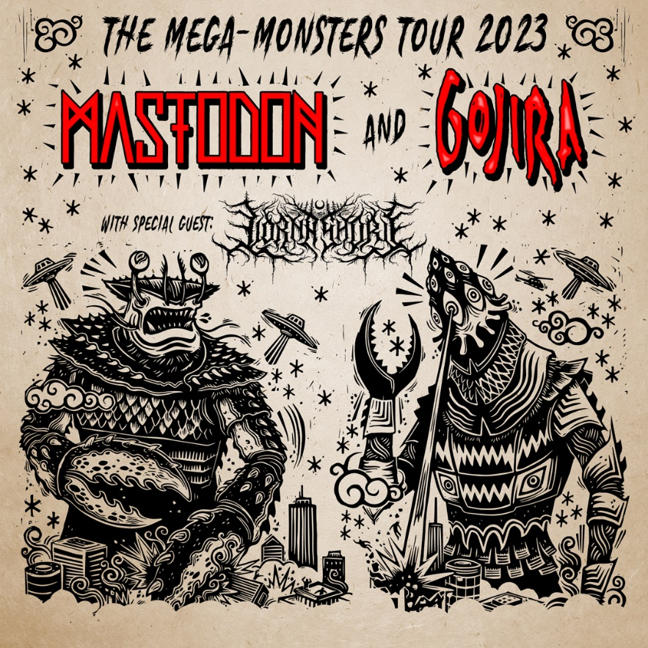
January 17, 2023 – (Los Angeles, CA) – Teaming up for what promises to be an unforgettable jaunt of epic proportions, iconic GRAMMY® Award-winning heavy rock band Mastodon will join forces with GRAMMY® Award-nominated French heavy metal luminaries Gojira for THE MEGA-MONSTERS TOUR, a massive co-headline tour across North America in 2023 along with special guests Lorna Shore on all dates. It finds these two juggernauts taking over arenas and amphitheaters throughout the Spring and Summer, alternating closing sets each night. Various fan ticket pre-sales go live January 18 at 10am local time via Mastodon, Gojira, Blabbermouth and Spotify Fans First. General on-sale launches January 20 at 10am local time. VIP ticket packages will be available. Click HERE for further details.

The tour kicks off at the Veterans Memorial Coliseum in Portland, OR on April 18, stops at legendary venues such as the Forum in Los Angeles, CA on April 21, and steamrolls through Mastodon’s hometown of Atlanta for their biggest Georgia headlining gig to date at the Ameris Bank Amphitheatre. The first leg concludes at Santander Arena in Reading, PA on May 11. Meanwhile, the tour resumes with a second leg from August 9 through September 2.

Mastodon will hit the road in support of their critically acclaimed ninth studio album, HUSHED AND GRIM. Meanwhile, Gojira are out supporting their seventh full-length album, Fortitude, which garnered a GRAMMY® Award nomination in the category of “Best Metal Performance” for “Amazonia.” These two titans previously canvased North America together in 2014, and this reunion represents yet another major milestone in their respective careers.

THE MEGA-MONSTERS TOUR 2023:
Leg 1:
Apr 18 Portland, OR Veterans Memorial Coliseum
Apr 20 Concord, CA Concord Pavilion
Apr 21 Los Angeles, CA The Forum
Apr 22 Phoenix, AZ Arizona Financial Theatre
Apr 23 Las Vegas, NV Virgin
Apr 26 Dallas, TX The Pavilion at Toyota Music Factory
Apr 28 Houston, TX 713 Music Hall
Apr 29 Austin, TX Moody Center
Apr 30 Oklahoma City, OK Zoo Amphitheatre
May 02 Nashville, TN Municipal Auditorium
May 04 Boca Raton, FL Sunset Cove Amphitheater
May 05 St. Augustine, FL St. Augustine Amphitheatre
May 06 Atlanta, GA Ameris Bank Amphitheatre
May 07 Asheville, NC Harrah’s Cherokee Center
May 09 Richmond, VA Virginia Credit Union Live
May 10 Baltimore, MD Pier Six Pavilion
May 11 Reading, PA Santander Arena

Leg 2:
Aug 09 Cincinnati, OH MegaCorp Pavilion
Aug 10 Cleveland, OH Jacob’s Pavilion
Aug 11 Pittsburgh, PA Stage AE Outdoors
Aug 12 New York, NY Coney Island Amphitheater
Aug 13 Syracuse, NY OneCenter
Aug 15 Detroit, MI Masonic Temple
Aug 17 Toronto, ON RBC Echo Beach
Aug 18 Laval, QC Place Bell
Aug 19 Portland, ME Cross Insurance Arena
Aug 20 Boston, MA MGM Music Hall
Aug 23 Milwaukee, WI BMO Pavilion
Aug 25 Hammond, IN Horseshoe
Aug 26 Omaha, NE Westfair Amphitheater
Aug 27 Minneapolis, MN Waite Park Amphitheater
Aug 29 St. Louis, MO The Factory
Aug 30 Kansas City, MO Azura Amphitheater
Sep 01 Salt Lake City, UT USANA Amphitheater
Sep 02 Denver, CO Fiddler’s Green Amphitheater

ABOUT MASTODON (Hi-res Mastodon image by Patrick McBride HERE):
GRAMMY® Award-winning band Mastodon have quietly evolved into one of the most influential, inimitable, and iconic rock bands of the modern era. Since emerging in 2000, the Atlanta quartet have defied both sonic and thematic boundaries with an uncategorizable, undeniable, and uncompromising vision unlike anything else in music. This vision manifested over the course of canonical albums such as Leviathan, which landed on Rolling Stone’s coveted The 100 Greatest Metal Albums of All Time. Following the seminal Crack The Skye [named one of the best albums of 2009 by Time Magazine], they earned three consecutive Top 10 debuts on the Billboard Top 200 with The Hunter [2011], Once More ‘Round the Sun [2014], and Emperor of Sand [2017]. Out of six career nominations, they received a GRAMMY® Award in the category of “Best Metal Performance” for “Sultan’s Curse.” They are the rare creative force whose music can be felt everywhere from Game of Thrones, Adult Swim, The History Channel, and DC Comics films to international music festivals such as Coachella and Bonnaroo. They notably supported the Hirschberg Foundation For Pancreatic Cancer Research with a rendition of “Stairway To Heaven” in honor of late manager Nick John. The group reached another critical high watermark via their ninth full-length, Hushed and Grim. Featuring the GRAMMY® Award-nominated “Pushing The Tides,” it marked the band’s third straight #1 bow on the Billboard Hard Rock Albums Chart. It concluded 2021 on over a dozen year-end lists with Rolling Stone raving, “we get everything from some of the band’s hookiest rockers to date to some of their most awe-inspiring epics.” Evolving as they usher rock into new realms, they forever remain the same unpredictable trailblazing beast—Mastodon.

About Gojira (Hi-res Gojira image by Jimmy Fontaine HERE):
Gojira bend extremes to their whim, emerging as an entrancing enigma equally driven by intuition and intensity. Balancing metallic proficiency, primal grooves, and otherworldly melodies, the French quartet continue to facilitate heavy music's progression into the future by burning down all boundaries. As such, they've unassumingly risen to the forefront of the genre as quiet trailblazers. Thus far, they've earned three GRAMMY® Award nominations and even claimed a coveted spot on Rolling Stone's "100 Greatest Metal Albums of All Time" with 2005's landmark From Mars To Sirius. Their catalog spans groundbreaking records such as L'Enfant Sauvage [2012] and Magma [2016]. However, the band leveled up again with Fortitude in 2021. Upon release, it arrived at #1 on the Billboard Top Album Sales Chart and #1 on the Top Current Album Sales Chart as the week's best-selling album in terms of pure sales. Simultaneously, it catapulted to #12 on the Billboard 200, marking a career high. "Amazonia" also garnered a GRAMMY® Award nod in the category of "Best Metal Performance." Fortitude closed out 2021 on year-end lists from Rolling Stone, The Guardian, Consequence, and Paste and would be hailed as the "#1 Best Album of the Year" by Revolver and Metal Hammer. Along the way, they've headlined legendary venues such as Red Rocks Amphitheater and more. The group capped off 2022 by contributing the standalone single "Our Time Is Now" to EA's NHL 2023. With restless creativity and infinite vision, Gojira always inspire thought, awaken passion, and incite catharsis as heavy music's most unconventional, yet undeniable force.

# # #

Mastodon Contacts:
Rick Gershon at Warner Records / Reprise Records
rick.gershon@warnerrecords.com

Regional: Delanee Wilson at Warner Records / Reprise Records
delanee.wilson@warnerrecords.com

Follow Mastodon:
Website | Facebook | YouTube | Twitter | Instagram | Spotify | Press Materials

