THE BLESSED MADONNA RELEASES BRAND NEW SINGLE
“SHADES OF LOVE” (FT. THE JOY)

LISTEN HERE

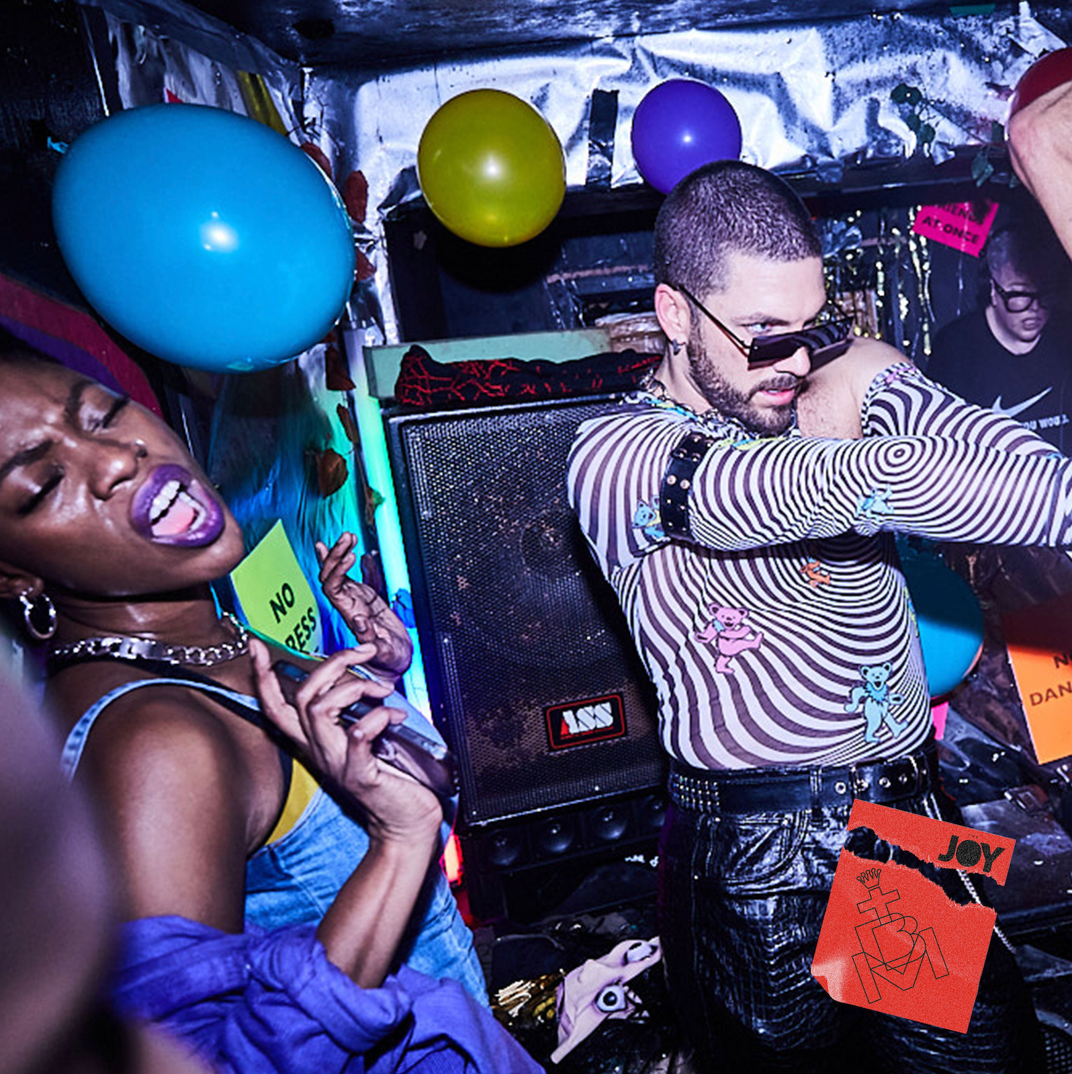
Download hi-res artwork here

February 22nd, 2023 (Los Angeles, CA) — Today, London-based artist, DJ, producer and club culture iconoclast The Blessed Madonna releases joyous new single “Shades of Love,” featuring South African five-piece The Joy. Stream the track HERE. Like so much of The Blessed Madonna's music, its DNA is firmly rooted in the origins of house and club culture, expertly updated alongside a unique range of collaborators to create something truly contemporary. Last year saw Parisian electro-pop chanteuse Uffie provide vocals on the celebratory “Serotonin Moonbeams,” last week it was Chicago house icon Jamie Principle on the anthemic “We Still Believe,” and on “Shades of Love,” it’s Durban’s The Joy who lend their tightly wound vocal harmonies and melodies to create yet another energetic and entirely electrifying track.

Speaking about the inception of the track, The Blessed Madonna says:

“’Shades of Love’ is about the one thing that we all truly share in common as humans. We need to be loved. That might be a different kind of love for every person, but it's still love and it's what ties us together”

An overnight sensation two decades in the making, The Blessed Madonna is an artist whose career is woven into the fabric of dance music past, present and future. Whether promoting illegal raves to 50 people in sweaty Kentucky basements as a teenager, headlining the biggest stages and festivals around the world, working alongside house legends like Frankie Knuckles or fearlessly taking on one of the most improbable, ambitious remix projects in recent times with Club Future Nostalgia (her collaborative album with pop icon Dua Lipa), The Blessed Madonna is synonymous with inclusive, unifying, cathartic dance music.
In recent years, The Blessed Madonna has channeled the emotions of millions as the vocalist on Fred again..’s lockdown anthem, “Marea (We Lost Dancing)”, become the voice of Saturday night radio, been immortalised as a GTA5 character and provided remixes for the likes of The Chemical Brothers, Florence & The Machine and, improbably, Elton John. With her recent run of singles, she is set to usher in a whole new era. A stop-you-in-your-tracks moment in its own right, it’s also the starting pistol for a run of new releases over the coming months; the first results from a year’s worth of blood, sweat, tears and joy in the studio for 50 hours a week with some of her best friends. There are even rumors of a debut album. Watch this space.

Credit: Eva Pentel | Download high-res here

FOLLOW THE BLESSED MADONNA:
Official | Instagram | Facebook | Twitter

For more information, please contact:

Darren Baber | Warner Records
Darren.Baber@warnerrecords.com

Judy Miller Silverman | Motormouth Media
Judy@motormouthmedia.com

