**ASHNIKKO ANNOUNCES HIGHLY-ANTICIPATED DEBUT ALBUM *WEEDKILLER* – OUT JUNE 2ND**

**ALT-POP SINGLE “WORMS”OUT TODAY**

[**LISTEN HERE**](https://ashnikko.lnk.to/Worms)

**2023 WORLD TOUR JUST ANNOUNCED**

***INCLUDING COACHELLA PLUS DATES IN NORTH AMERICA, UK/EUROPE, ASIA + AUSTRALIA***

*“lewd antics, bravado, misandry and zippy one-liners engineered for social media”*

***– The New York Times***

*“Ashnikko is one of the very few artists who blew up on TikTok whose talent exceeds the limits of the video platform.”*

***– The FADER***

*“pop powerhouse”*

***– Pitchfork***

*“Her return is very welcome”*

***– PAPER***

*“Ashnikko is a musical force of nature, and she's here to stay.”*

***– Billboard***

**March 2, 2023 (Los Angeles, CA) –** After emerging as one of today’s most innovative alt-pop artists with more than 2.5 billion streams, genre-blurring pop star **Ashnikko** (she/they) announces her highly-anticipated debut album, ***WEEDKILLER***, out June 2nd via **Warner Records**. In celebration, **Ashnikko** unveils bouncy alt-pop single “**Worms**,” the genre-spanning follow-up to fiery nu-metal inspired track “**You Make Me Sick!**” which earned global buzz from the likes of ***PAPER****,* ***The FADER****,* ***Rolling Stone***, ***NME***, ***Billboard***, and more.

Listen to “**Worms**” [here](https://ashnikko.lnk.to/Worms) and pre-order/save ***WEEDKILLER***[here](https://ashnikko.lnk.to/WEEDKILLER).

**Ashnikko** has also just announced her biggest tour to date – the **2023 WEEDKILLER World Tour** – making stops across North America, UK & Europe, Asia, and Australia, as well as several festival performances around the world, including her Coachella debut in April. Tickets are available at [ashnikko.com](https://nam04.safelinks.protection.outlook.com/?url=https%3A%2F%2Fwww.ashnikko.com%2F&data=05%7C01%7CPatrice.Compere%40warnerrecords.com%7Cc2334a20664a4651851f08db18feb64a%7C8367939002ec4ba1ad3d69da3fdd637e%7C0%7C0%7C638131254479650097%7CUnknown%7CTWFpbGZsb3d8eyJWIjoiMC4wLjAwMDAiLCJQIjoiV2luMzIiLCJBTiI6Ik1haWwiLCJXVCI6Mn0%3D%7C3000%7C%7C%7C&sdata=6WNgscj79%2FPsi25UJQSqpp%2BDdwx%2FeZis40Lljhqy%2B9Y%3D&reserved=0) next Friday, March 10th at 10am local time. See all dates [here](https://nam04.safelinks.protection.outlook.com/?url=https%3A%2F%2Fwww.ashnikko.com%2F&data=05%7C01%7CPatrice.Compere%40warnerrecords.com%7Cc2334a20664a4651851f08db18feb64a%7C8367939002ec4ba1ad3d69da3fdd637e%7C0%7C0%7C638131254479650097%7CUnknown%7CTWFpbGZsb3d8eyJWIjoiMC4wLjAwMDAiLCJQIjoiV2luMzIiLCJBTiI6Ik1haWwiLCJXVCI6Mn0%3D%7C3000%7C%7C%7C&sdata=6WNgscj79%2FPsi25UJQSqpp%2BDdwx%2FeZis40Lljhqy%2B9Y%3D&reserved=0), with US dates listed below.

Crafted with longtime collaborators Slinger and Oscar Scheller [Charli XCX, PinkPantheress, Rina Sawayama], debut album *WEEDKILLER* follows **Ashnikko’s** hugely successful 2021 mixtape [*DEMIDEVIL*](https://nam04.safelinks.protection.outlook.com/?url=https%3A%2F%2Fashnikko.lnk.to%2FDEMIDEVIL&data=05%7C01%7CPatrice.Compere%40warnerrecords.com%7Cc2334a20664a4651851f08db18feb64a%7C8367939002ec4ba1ad3d69da3fdd637e%7C0%7C0%7C638131254479650097%7CUnknown%7CTWFpbGZsb3d8eyJWIjoiMC4wLjAwMDAiLCJQIjoiV2luMzIiLCJBTiI6Ik1haWwiLCJXVCI6Mn0%3D%7C3000%7C%7C%7C&sdata=6AFrsqMOZ%2B8Yj8ufgI1XaohqbPcmBs5Aks65aakSwIw%3D&reserved=0)– which is now RIAA-certified Gold – and 2019 EP *Hi, It’s Me*, which set her straight on the path to superstardom, earning widespread global acclaim from the likes of *VOGUE, NPR, The New York Times, NME, Pitchfork, The FADER*, and many more. The *WEEDKILLER* universe that Ashnikko has created is a dystopian fantasy that tells the story of a fae civilization occupied and destroyed by machines that feed on organic matter where the faerie protagonist seeks revenge by becoming part machine – a poetic commentary on environmental disaster and the rapid evolution of technology. Full of equal parts naked vulnerability and joyful rebellion, *WEEDKILLER* gives a thundering voice to the oppressed.

**Ashnikko** states, *"My bioluminescent heart is glowing. My post-apocalyptic fae world is here for you to journey into. My wings have been ripped out, but I’ve built them anew using WEEDKILLER machine parts. I am the one sent here to eliminate you, WEEDKILLER."*

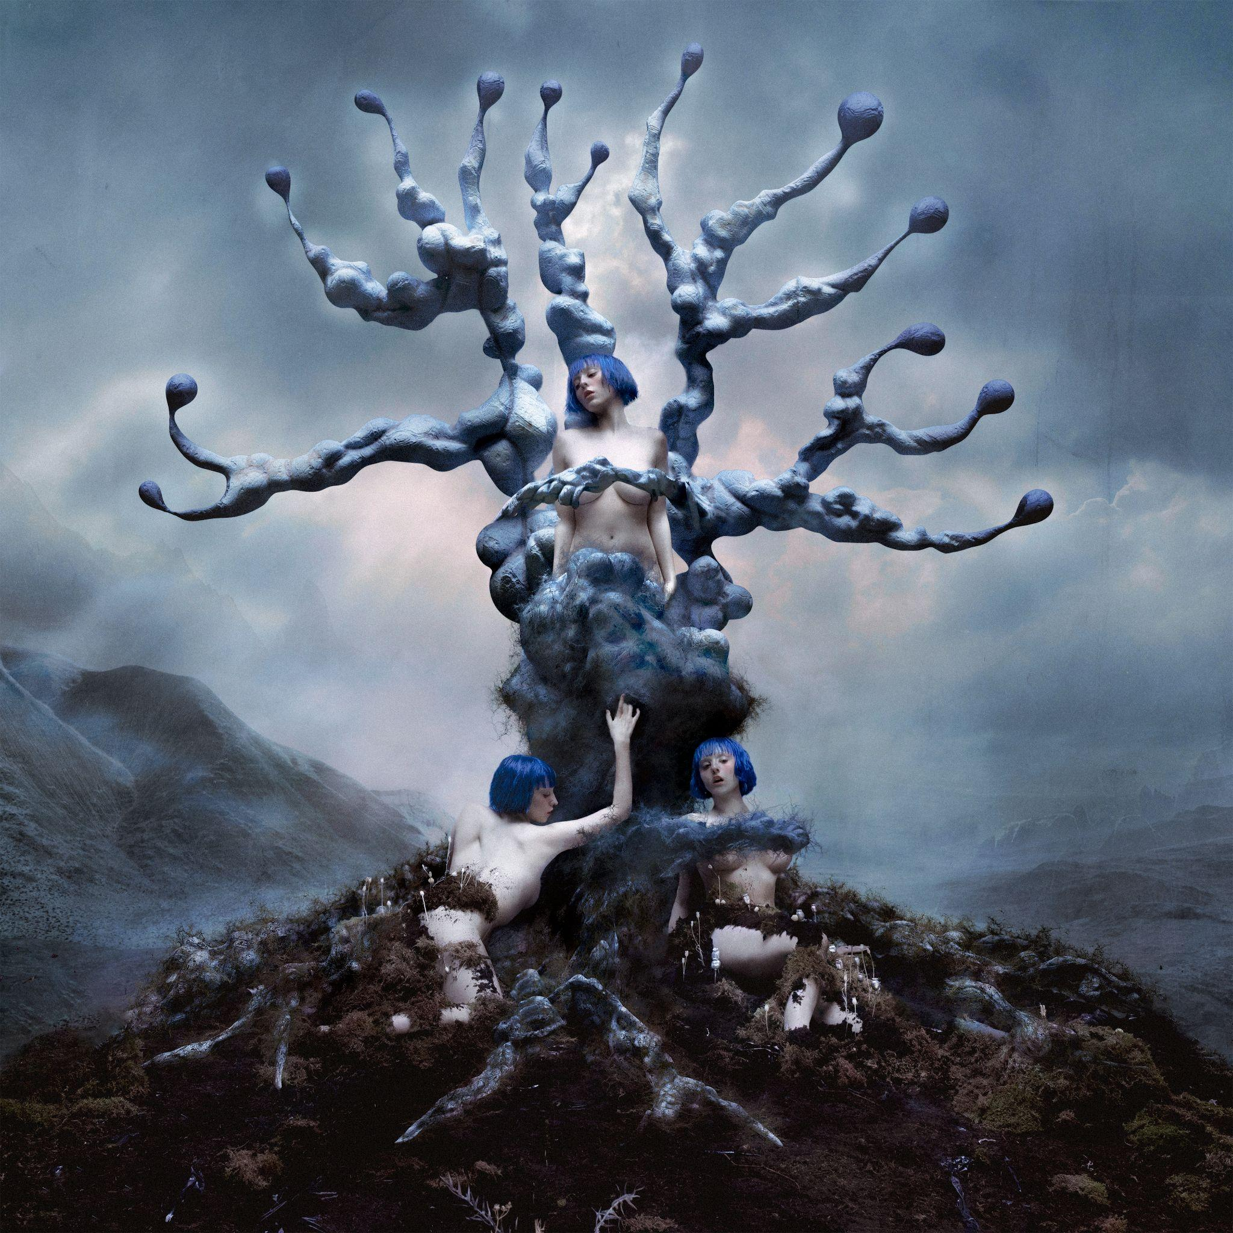

*High-res artwork + images available* [*here*](https://warnerrecords.box.com/s/6fuwkv9xrabzlzq686r7h7lw385b420z)

***WEEDKILLER* TRACK LISTING:**

1. World Eater
2. You Make Me Sick!
3. Worms
4. Super Soaker (ft. Daniela Lalita)
5. Don’t Look At It
6. Cheerleader
7. Moonlight Magic
8. Miss Nectarine
9. Chokehold Cherry Python
10. WEEDKILLER
11. Want It All
12. Possession of a Weapon
13. Dying Star (ft. Ethel Cain)

**UPCOMING US TOUR DATES**

***FESTIVALS***

April 14, 2023 - Indio, CA - Coachella

April 21, 2023 - Indio, CA – Coachella

**WEEDKILLER TOUR 2023 – *US LEG***

September 15, 2023 - Minneapolis, MN - The Fillmore Minneapolis

September 16, 2023 - Chicago, IL – Byline Bank Aragon Ballroom

September 18, 2023 - Columbus, OH - KEMBA Live!

September 19, 2023 - Pittsburgh, PA - Stage AE

September 21, 2023 - Toronto, ON - Rebel

September 22, 2023 - Royal Oak, MI - Royal Oak Music Theatre

September 23, 2023 - Cleveland, OH - Agora Theater & Ballroom

September 25, 2023 - Boston, MA - Roadrunner

September 26, 2023 - New York, NY - Brooklyn Mirage

September 28, 2023 - Philadelphia, PA - Skyline Stage at The Mann

September 29, 2023 - Washington, DC - The Anthem

September 30, 2023 - Richmond, VA - The National

October 02, 2023 - Raleigh, NC - The Ritz

October 03, 2023 - Charlotte, NC - The Fillmore Charlotte

October 05, 2023 - St. Petersburg, FL - Jannus Live

October 06, 2023 - Fort Lauderdale, FL - Revolution Live at the Backyard

October 07, 2023 - Orlando, FL - House of Blues Orlando

October 10, 2023 - Atlanta, GA - Coca-Cola Roxy

October 11, 2023 - Nashville, TN - Marathon Music Works

October 13, 2023 - St. Louis, MO - The Pageant

October 14, 2023 - Kansas City, MO - Uptown Theater

October 16, 2023 - Denver, CO - The Mission Ballroom

October 17, 2023 - Salt Lake City, UT - The Complex Rockwell

October 19, 2023 - Vancouver, BC - PNE Forum

October 20, 2023 - Seattle, WA - Showbox SoDo

October 21, 2023 - Portland, OR - Roseland Theater

October 24, 2023 - Oakland, CA - Fox Theater

October 27, 2023 - Phoenix, AZ - The Van Buren

**For further information, contact:**

Patrice Compere / Warner Records

[Patrice.Compere@warnerrecords.com](mailto:Patrice.Compere@warnerrecords.com)

**Follow Ashnikko:**

[**Instagram**](https://nam04.safelinks.protection.outlook.com/?url=https%3A%2F%2Fwww.instagram.com%2Fashnikko%2F&data=04%7C01%7CPatrice.Compere%40warnerrecords.com%7C6ac80cca8ecf474281c908d8ed9680d6%7C8367939002ec4ba1ad3d69da3fdd637e%7C0%7C0%7C637520577965538236%7CUnknown%7CTWFpbGZsb3d8eyJWIjoiMC4wLjAwMDAiLCJQIjoiV2luMzIiLCJBTiI6Ik1haWwiLCJXVCI6Mn0%3D%7C1000&sdata=LmC%2F3GJOKFS3URd8oFaXpnqWIRSeJT9JJuPT27k5q8Y%3D&reserved=0) **|** [**TikTok**](https://www.tiktok.com/@ashnikko?lang=en) **|** [**YouTube**](https://www.youtube.com/channel/UCprhwr86ckrMC2q9jX8qMnw) **|** [**Twitter**](https://nam04.safelinks.protection.outlook.com/?url=https%3A%2F%2Ftwitter.com%2Fashnikko&data=04%7C01%7CPatrice.Compere%40warnerrecords.com%7C6ac80cca8ecf474281c908d8ed9680d6%7C8367939002ec4ba1ad3d69da3fdd637e%7C0%7C0%7C637520577965538236%7CUnknown%7CTWFpbGZsb3d8eyJWIjoiMC4wLjAwMDAiLCJQIjoiV2luMzIiLCJBTiI6Ik1haWwiLCJXVCI6Mn0%3D%7C1000&sdata=URMF%2BgT75GUTJu2BMxIMX2Qt5oqVkhOx7u8eJOcdzZ8%3D&reserved=0) **|** [**Facebook**](https://nam04.safelinks.protection.outlook.com/?url=https%3A%2F%2Fwww.facebook.com%2Fashnikkomusic%2F&data=04%7C01%7CPatrice.Compere%40warnerrecords.com%7C6ac80cca8ecf474281c908d8ed9680d6%7C8367939002ec4ba1ad3d69da3fdd637e%7C0%7C0%7C637520577965548230%7CUnknown%7CTWFpbGZsb3d8eyJWIjoiMC4wLjAwMDAiLCJQIjoiV2luMzIiLCJBTiI6Ik1haWwiLCJXVCI6Mn0%3D%7C1000&sdata=l5QMa0SIOuUm1zLAE%2BYcofazLyG4MT2MxBzF%2F6wji6o%3D&reserved=0)

