WARNER RECORDS SIGNS PECOS & THE ROOFTOPS

TEXAS ROCK BAND RELEASES NEW SINGLE “5AM” AND HITS THE ROAD

LISTEN HERE / WATCH HERE

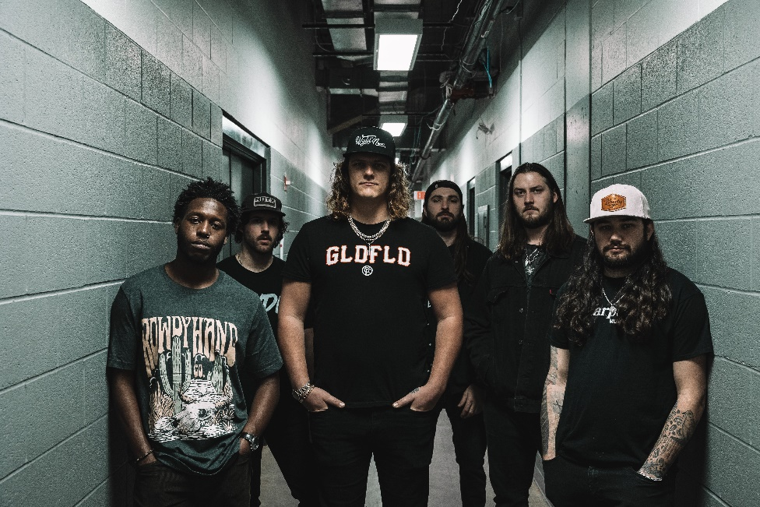
(Click HERE for hi-res image by Shiloh Hughes)

March 3rd, 2023 (Los Angeles, CA) – Warner Records has signed Texas-based band Pecos & The Rooftops. The hard workin’, hard rockin’ sextet celebrate by releasing a brand-new single/video “5AM.” Click HERE to stream and HERE to watch the lyric video.

Pecos & The Rooftops have been perfecting a signature heavy blend of lowdown country and classic rock since their inception in a big five-bedroom house in Lubbock, Texas. Formed in 2019 by a tight-knit squad of college friends, the band outfits their soulful Americana with muscular guitar grit yet remains tuneful and melodic. They’ve carved out a singular niche for themselves in the rich songwriting tradition of their home state, as evidenced by their debut Warner Records single “5AM.” Anchored by the heart-baring songwriting and booming voice of former Marine Pecos Hurley, the band is rounded out by top-tier players and songwriters Brandon Jones (rhythm guitar), Zack Foster (lead guitar), Kalen Davis (bass), Garrett Peltier (drums) and Hunter Cassell (guitars & keys).

Big things have small beginnings. Pecos & The Rooftops chose their name—a nod to the part of the house they’d hang out, drink beers, and jam on—just before self-releasing their debut single, 2019’s slow-burning “This Damn Song.” It was a runaway success, earning an RIAA Platinum certification and going on to rack up more than 250 million streams globally. Deciding to ride the wave for as long as they could, the band hit the road directly after and haven’t stopped since, touring relentlessly on the club circuit and opening for the likes of rising country star Zach Bryan. They released the Red Eye EP in 2020, expanding on their already solid sound with more guitar heroics and more complex arrangements, hinting at jazz and psychedelic influences.

Hurley has a gift for exploring the shadowy sides of life through his songwriting, offering a clear-eyed and unflinching look at heartbreak, disconnection, self-medication, and wrestling with dark times. On “5AM,” he’s stuck in a self-destructive pattern, trying to live up to the idea of being the man he wants to be, but thwarted on all sides by his own bad decisions. “Wish I could say that I saw it coming—problem is I never do,” Hurley sings over a gloomy guitar line. “It’s too late to let myself feel something, so I’ll just keep running from you.”

“It’s about having a habit of going to the bar and getting drunk and staying up all night,” Hurley says from his home outside Dallas. “You kind of know that when you go to bed it’s probably not going to end well—because you fucked up again and you can’t get out of the cycle. It’s about being by yourself in the early hours of the morning. It’s just one of those ‘You fucked up’ songs.”

Pecos & The Rooftops have earned a devoted fan base who’ve come out to support them both online and on the road, with the band garnering over 350 million global streams and more than 101 million video views. They’re currently on a nationwide headline tour with more dates to be announced soon. “5AM” is a telling preview of what’s to come, as Pecos & The Rooftops ready their major label debut LP—a bigger, bolder collection of songs set for release later this year. “At the end of the day, I just want to help people with our music, honestly,” Hurley says. Between the band’s wild road shows and their highly-anticipated upcoming full-length, Pecos & the Rooftops are set to do that and much, much more.

Pecos & The Rooftops 2023 Tour Dates
*With Koe Wetzel

Mar 10 Helotes, TX John T. Floore Country Store
Mar 11 Corpus Christi, TX Brewster Street Ice House Downtown
Mar 18 Burkevilla, TX Sabine ATV Park
Mar 30 Springfield, MO Midnight Rodeo
Mar 31 Indianapolis, IN The Vogue
Apr 01 Rosemont, IL Joe’s Live
Apr 06 Columbus, OH The Bluestone
Apr 07 Louisville, KY Mercury Ballroom
Apr 08 Lexington, KY Manchester Music Hall
Apr 13 Fort Myers, FL The Ranch Concert Hall & Saloon
Apr 14 Fort Lauderdale, FL Tortuga Music Festival 2023
Apr 15 Lakeland, FL Wild Greg’s Saloon
Apr 21 College Station, TX Hurricane Harry’s
Apr 29 Midland, TX The Tailgate
*May 1 Nashville, TN Ascend Amphitheater
*May 12 Huntsville, AL The Orion Amphitheater
*May 13 Little Rock, AR First Security Amphitheater
*Jun 02 Orange Beach, AL The Wharf Amphitheater
*Jun 03 New Orleans, LA Champions Square
Jun 09 Tulsa, OK Cain’s Ballroom
*Jun 15 Colorado Springs, CO Broadmoor World Arena
*Jun 16 Rio Rancho, NM Rio Rancho Events Center
*Jun 17 Mesa, AZ Mesa Amphitheatre
*Jun 23 Reno, NV Grand Sierra Resort and Casino
Jun 24 Filer, ID Gordy’s HWY 30 Music Festival 2023
*Jun 30 Des Moines, IA Lauridsen Amphitheater at Water Works Park
*Jul 01 Dubuque, IA Five Flags Center
Jul 07 Belton, TX Schoepf’s BBQ
Jul 27 Three Forks, MT Headwaters Country Jam 2023

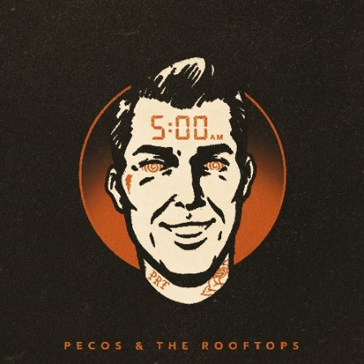
(Download hi-res artwork HERE)

# # #
Warner Records Contacts:
National: Rick Gershon | rick.gershon@warnerrecords.com
Regional/Tour: Delanee Wilson | Delanee.wilson@warnerrecords.com

FOLLOW PECOS & THE ROOFTOPS:
Twitter | Instagram | TikTok | YouTube | Website

