BENSON BOONE RETURNS WITH BREAKUP ANTHEM “SUGAR SWEET” — WATCH VIDEO HERE

ANNOUNCES SUMMER HEADLINE TOUR

NAMED AN AMAZON MUSIC BREAKTHROUGH
SPOTLIGHT ARTIST FOR 2023

Credit: Erica Hernandez | Hi-res download HERE

March 3, 2023 (Los Angeles, CA) – Today, breakout pop artist Benson Boone returns with the tantalizing new single “Sugar Sweet.” Listen HERE via Night Street Records/Warner Records. The track was produced by Jason Evigan, who has worked with Justin Bieber, Dua Lipa, Maroon 5, and more. Alongside the audacious track comes a striking music video filmed in Hawaii. Watch it HERE. To mark the occasion, Boone announces an 18-date North American summer tour. Get your tickets HERE. This will follow his European run in April, which is selling out fast.

Brimming with swagger and attitude, “Sugar Sweet” is an instantly catchy creation that highlights the hitmaker’s knack for combining unforgettable melodies with incisive lyrics. “Oh, I bet you think your honey tastes like sugar, but honey sugar don’t taste that bitter,” Boone sings in flawless falsetto over a thumping baseline and driving beat. “Baby, you ain’t sweet, look at what you did to me.” In short, it’s a kiss-off anthem for the ages.

“‘Sugar Sweet’ is my sassy song about moving on from someone who treats you like a second option instead of a priority,” Boone says of his first release of 2023. “This is for everyone that can relate and found their confidence in themselves.” The track will undoubtedly be a crowd-pleaser when his summer tour kicks off in New York on June 1. The singer-songwriter stops in most major cities including New York, Chicago, and Seattle, before winding up in San Diego on June 25. Presale begins on March 6 with all other tickets available March 10. Get tickets HERE and see the full list of dates below.

“Sugar Sweet” follows the 2022 piano ballad “Before You,” which was preceded by the release of Boone’s Walk Me Home… EP including the hits “In The Stars,” “ROOM FOR 2,” and “GHOST TOWN.” The pop star memorably performed the latter in Norway — the country where he notched his first-ever #1 hit — in front of 50,000 screaming fans. In the US, “GHOST TOWN” became Boone’s first entry on the Billboard Hot 100, entered Top 25 at both Top 40 and Hot AC radio, and has since been RIAA-certified Gold. Boone has also been named an Amazon Music Spotlight Breakthrough Artist for 2023.

First discovered by Imagine Dragons superstar Dan Reynolds, Boone was quickly signed to Reynolds’ Night Street Records in partnership with Warner Records. The 20-year-old has garnered more than 1 billion global streams to date, as well as praise from Billboard, who lauded his “restrained vocals” and Consequence, who dubbed the newcomer “an exciting new voice.” With “Sugar Sweet,” Boone builds on the momentum of his acclaimed debut project and showcases a whole new side of his growing artistry.

Benson Boone 2023 Tour Dates:

*Sold out

Apr 14 – Esch-sur-Alzette, Luxembourg @ Rockhal
Apr 16 – Brussels, Belgium @ Botanique – Chapiteau*
Apr 18 – Paris, France @ Cafê de la Danse*
Apr 19 – Cologne, Germany @ Club Volta*
Apr 20 – Amsterdam, Netherlands @ Paradiso Grote Zaal*
Apr 22 – Berlin, Germany @ Hole 44
Apr 25 – London, UK @ Scala
Apr 27 – Glasgow, UK @ King Tut’s Wah Wah Hut
Apr 28 – Manchester, UK @ Deaf Institute*
Apr 29 – Dublin, Ireland @ Green Room, The Academy
June 1 – New York, NY @ Irving Plaza
June 3 – Philadelphia, PA @ The Foundry
June 4 – Washington, DC @ The Howard Theatre
June 6 – Boston, MA @ Brighton Music Hall
June 8 – Montreal, QC @ Le Studio TD
June 9 – Toronto, ON @ Opera House
June 10 – Columbus, OH @ The Basement
June 12 – Chicago, IL @ Thalia hall
June 13 – Minneapolis, MN @ Fine Line
June 14 – Omaha, NE @ The Waiting Room
June 16 – Denver, CO @ Marquis Theater
June 17 – Salt Lake City, UT @ The Union
June 18 – Boise, ID @ Knitting Factory Concert House
June 20 – Seattle, WA @ The Showbox
June 21 – Portland, OR @ Aladdin Theater
June 23 – San Francisco, CA @ The Chapel
June 24 – Los Angeles, CA @ The Fonda Theatre
June 25 – San Diego, CA @ Music Box
July 12 – Tønsberg, Norway @ Kaldnes

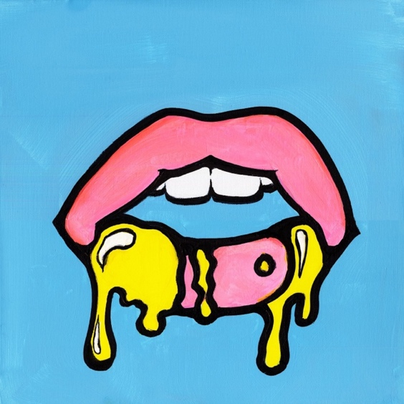
Credit: Benson Boone | Hi-res download HERE

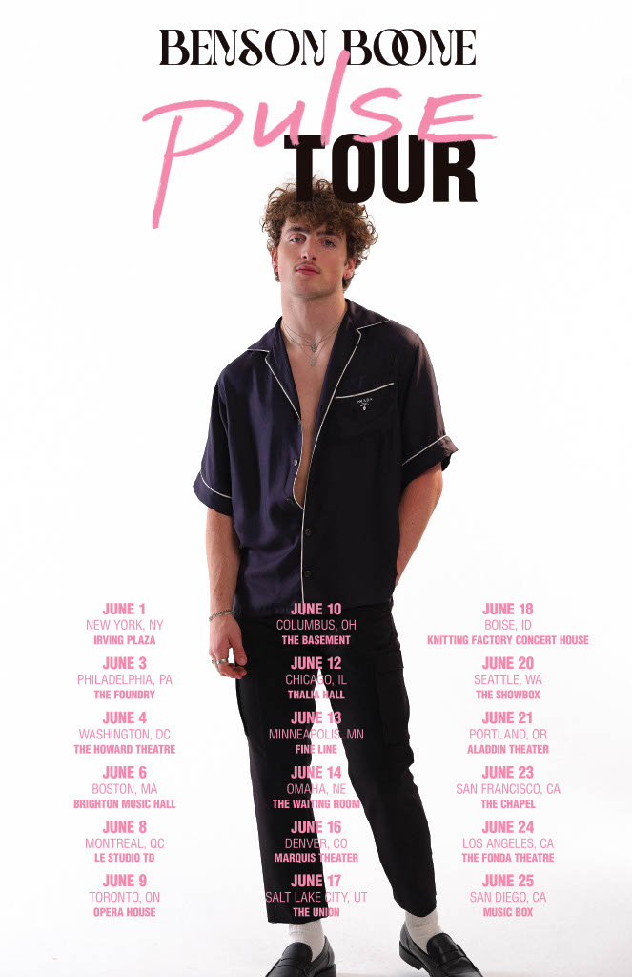

###

FOLLOW BENSON BOONE:
TikTok | Instagram | Twitter | Facebook | YouTube

For more information, please contact:
Darren Baber | Warner Records
Darren.Baber@warnerrecords.com

