BUZZING LOS ANGELES DUO SKYECHRISTY REVEAL NEW SINGLE “BEACH ZOMBIES” TODAY

ANNOUNCE SIGNING TO WARNER RECORDS

LISTEN TO “BEACH ZOMBIES” HERE

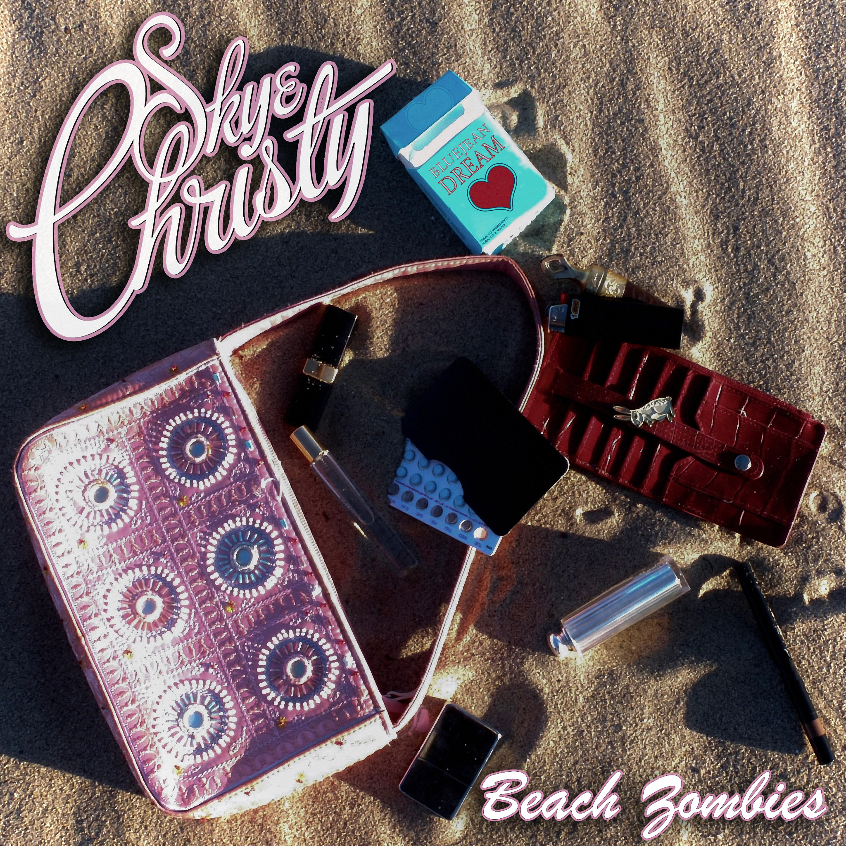
Credit: Emily Vu - High Res HERE

March 3, 2023 (Los Angeles, CA) – Primed for a breakthrough, buzzing Los Angeles duo SkyeChristy share a new single entitled “Beach Zombies” today and announce their signing to Warner Records. Listen to “Beach Zombies” HERE.

“Thanks to our wonderful fans around the world, we got the attention of Warner Records. Getting signed has been such a dream come true for the both of us. We’ve been gifted with such a wonderful team, and feel like we’ve got our Warner Records’ family backing us in everything we do now,” says SkyeChristy. “We couldn’t be more thrilled with the release of ‘Beach Zombies.’ This song means a lot to the both of us, and reflects the experiences we’ve had with people in this crazy city.”

“Beach Zombies” threads dusty acoustic guitar through a glitchy electronic haze punctuated by a sparse beat. Their hypnotic intonation practically hovers over the soundscape as airy harmonies entwine seamlessly. Fittingly, it culminates with a summery apocalyptic chant, “They want me, beach zombie.”

Today’s release arrives on the heels of “I’m Not Like Alice,” “Sending Light (For Lucas)” and “Black Lake.” The sister duo is a sonic union of Georgia Christy Edwards and Sophie Skye Edwards. The Los Angeles natives began writing and recording music together in high school. They honed their voices in choir, even performing at Carnegie Hall as part of their school ensemble choir. Since 2020, they’ve unlocked the power of their familial harmony and have captivated fans around the globe. With their distinct signature sound and forthcoming debut project, the SkyeChristy’s bond will only grow stronger.

Get ready for a whole lot more from SkyeChristy.

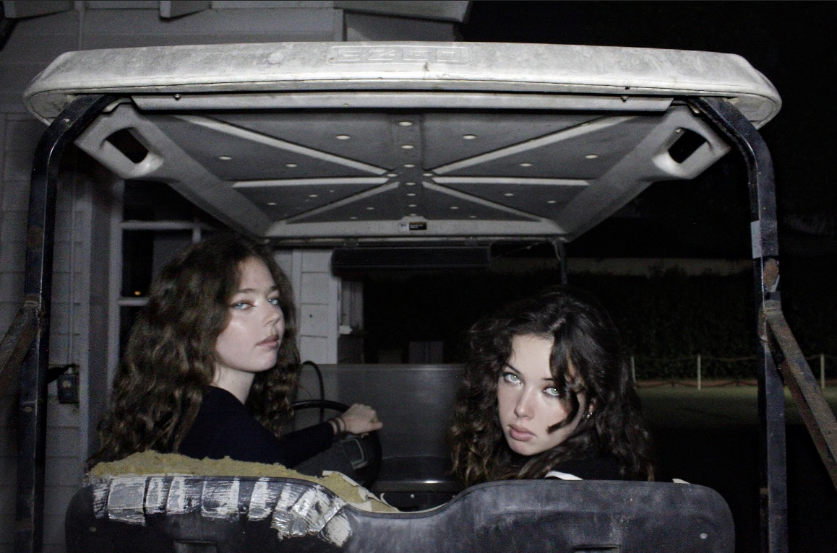
Credit: Hailey Lozano – High Res HERE

Stay Up-To-Date With SkyeChristy

TikTok | Instagram | YouTube

# # #

For More Information:

Connor Hunt // connor.hunt@warnerrecords.com

Patrice Compere // patrice.compere@warnerrecords.com

