BUZZING LOS ANGELES DUO SKYECHRISTY PRESENT NEW SINGLE “I’M NOT LIKE ALICE” OUT NOW

LISTEN HERE

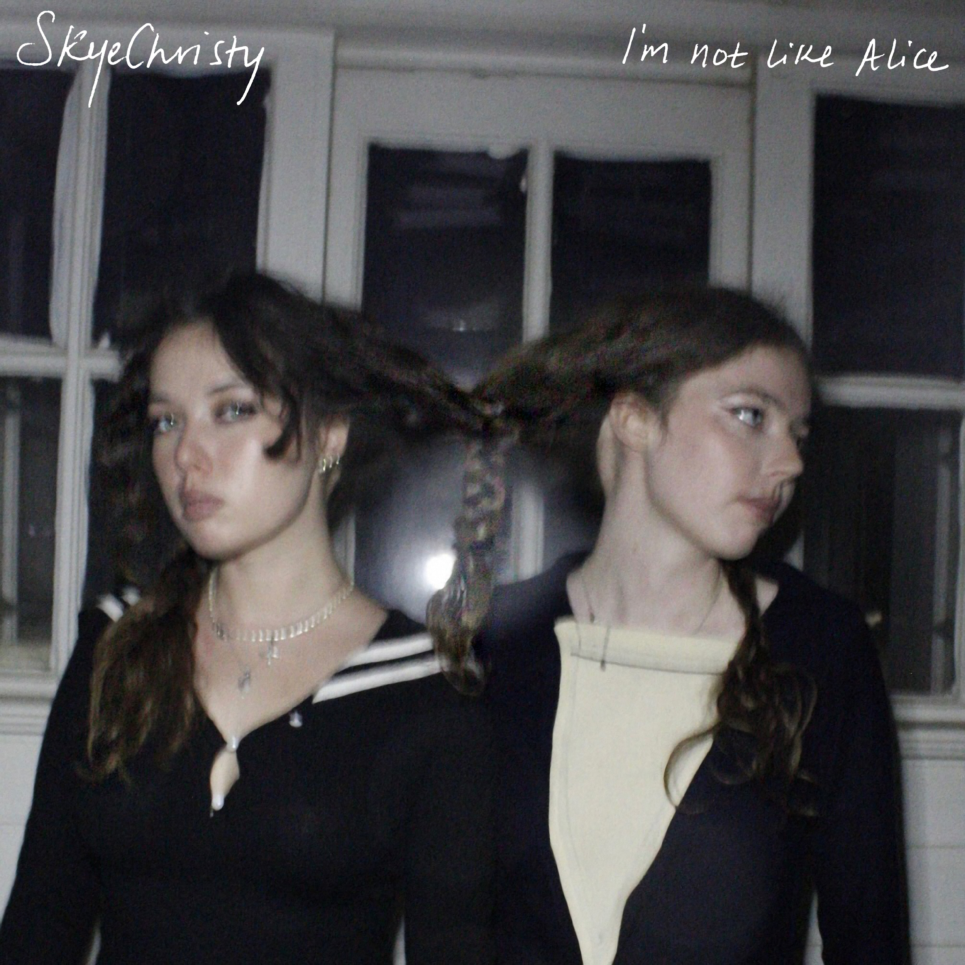
Credit: Hailey Lozano – High Res HERE

November 30, 2022 (Los Angeles, CA) – After lighting up social media with 20 million-plus views on a handful of teasers, buzzing Los Angeles duo SkyeChristy reveal their latest single “I’m Not Like Alice” today. Listen to “I’m Not Like Alice” HERE.

Today’s track cuts deep. Gently plucked acoustic guitar pierces lo-fi production as the chorus rings out, “She’s the kind of girl you like. Why you calling me tonight? I’m not like Alice.” The duo — which consists of sisters Georgia Christy Edwards and Sophie Skye Edwards—initially ignited viral buzz with a series of TikTok posts. The girls penned “I’m Not Like Alice” in the wake of a breakup Sophie went through. The first clip captured her ex’s reaction in real-time and generated 7.5 million views.

Nothing quite matches the power of a sisterly bond. SkyeChristy cements the sonic and spiritual union of sisters Georgia Christy Edwards and Sophie Skye Edwards. The Los Angeles natives began writing and recording music together in high school. They honed their voices in choir, even performing at Carnegie Hall as part of their school ensemble choir. Since 2020, they’ve unlocked the power of their familial harmony on singles such as “Sending Light (For Lucas)” and “Black Lake.” In 2022, SkyeChristy captivated listeners everywhere with “I’m Not Like Alice,” sharpening a distinct signature sound and heralding their forthcoming debut. Their bond will only grow stronger.

Credit: Hailey Lozano – High Res HERE

Stay Up-To-Date With SkyeChristy

TikTok | Instagram | YouTube

# # #

For More Information:

Connor Hunt // connor.hunt@warnerrecords.com

Patrice Compere // patrice.compere@warnerrecords.com

