GENRE-BLURRING ARTIST TEDDY SWIMS ANNOUNCES
SUMMER 2023 INTERNATIONAL TOUR

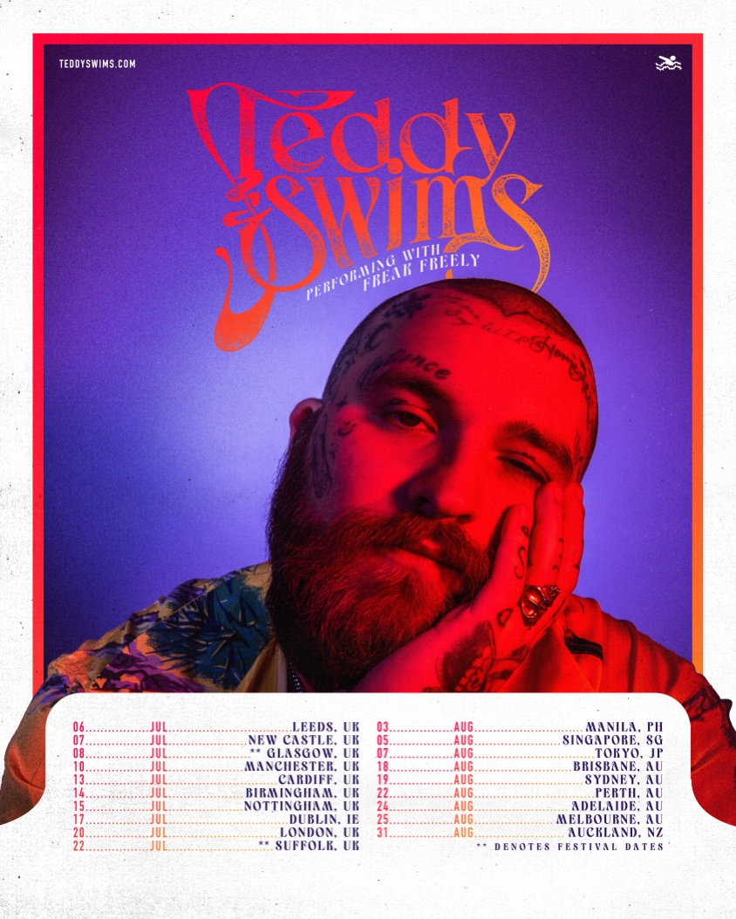

March 13, 2023 (Los Angeles, CA) – Today, Atlanta singer-songwriter Teddy Swims announces his Summer 2023 international tour. Kicking off in the UK on July 6th, the tour includes stops in Ireland, the Philippines, Singapore, Japan and Australia before wrapping up in New Zealand on August 31st. UK and Ireland shows will go on sale this Friday, March 17th at 10am local time. Tickets are available HERE. On-sale details for Asia, Australia and New Zealand will be announced soon.

The announcement arrives after a banner year for Teddy. On the heels of his recent EPs Sleep Is Exhausting and Tough Love, the vocal powerhouse teamed up with Armin van Buuren and Matoma for the soaring dance anthem “Easy to Love” earlier this year. 2022 saw him perform “Don’t Stop Believin’” on America’s Got Talent with season 14 winner Kodi Lee, as well as Journey guitarist Neal Schon. He also lent his powerful pipes to ILLENIUM’s “All That Really Matters,” Meghan Trainor’s “Bad For Me,” and MK & Burns’ “Better.”

It’s a must-see as Swims takes his showstopping live show across the globe in 2023, showcasing his signature eclectic style on stage. More to come soon from Teddy Swims.

ABOUT TEDDY SWIMS:
The Atlanta native, born Jaten Dimsdale, has been tugging at heartstrings since posting a series of covers from his bedroom studio in 2019, which generated hundreds of millions of views and scored him a deal with Warner Records. Teddy changed his focus to introspective originals on 2020’s Unlearning EP, garnering praise from American Songwriter, Billboard, and Rolling Stone, who named him an artist to watch in 2021. Soon thereafter, performances on The Kelly Clarkson Show, Today, and The Late Show With Stephen Colbert and opening for Zac Brown Band’s Summer arena tour cemented his status as a rising star. 2022 marked a banner year for Teddy with the release of his two latest EPs, Tough Love and Sleep is Exhausting, a number of notable collaborations, performances on Ellen, The Late Late Show With James Corden, and Jimmy Kimmel Live!, and his Tough Love headline world tour. With more than 800 million global streams to his credit, as well as a social following that exceeds 10 million, Teddy’s songs of devotion have clearly connected.

TEDDY SWIMS 2023 TOUR DATES:
Jul 6 Leeds, UK Stylus
Jul 7 Newcastle, UK NZ Newcastle
Jul 10 Manchester, UK Albert Hall
Jul 13 Cardiff, UK Cardiff Student Union
Jul 14 Birmingham, UK O2 Academy
Jul 15 Nottingham, UK Rock City
Jul 17 Dublin, IE Olympia Theatre
Jul 20 London, UK The Roundhouse
Jul 22 Suffolk, UK Latitude Festival
Aug 3 Manila, PH TBA
Aug 5 Singapore, SG TBA
Aug 7 Tokyo, JP TBA
Aug 18 Brisbane, AU TBA
Aug 19 Sydney, AU TBA
Aug 22 Perth, AU TBA
Aug 24 Adelaide, AU TBA
Aug 25 Melbourne, AU TBA
Aug 31 Auckland, NZ TBA
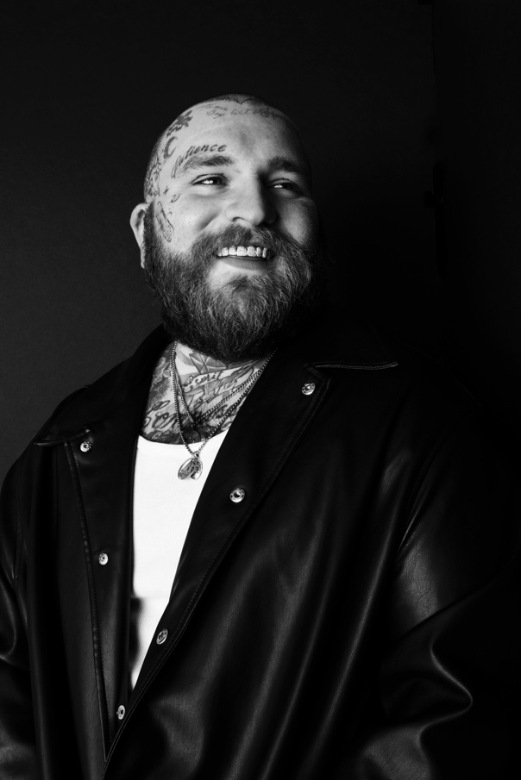
Download hi-res press photo HERE
Photo credit: Lindsey Byrnes

FOLLOW TEDDY SWIMS:
Official | Twitter | Instagram | Facebook | YouTube | Press Materials

For more information, please contact:

Darren Baber | Warner Records
Darren.Baber@warnerrecords.com

