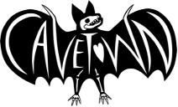
CAVETOWN TEAMS UP WITH FIELD MEDIC ON
NEW TRACK + VIDEO “GLACIER MEADOW”
LISTEN HERE | WATCH HERE

“BITTERSWEET DAZE” U.S. HEADLINE TOUR KICKS OFF JULY 20
FEAT. SPECIAL GUESTS MXMTOON, RICKY MONTGOMERY + GRENTPEREZ

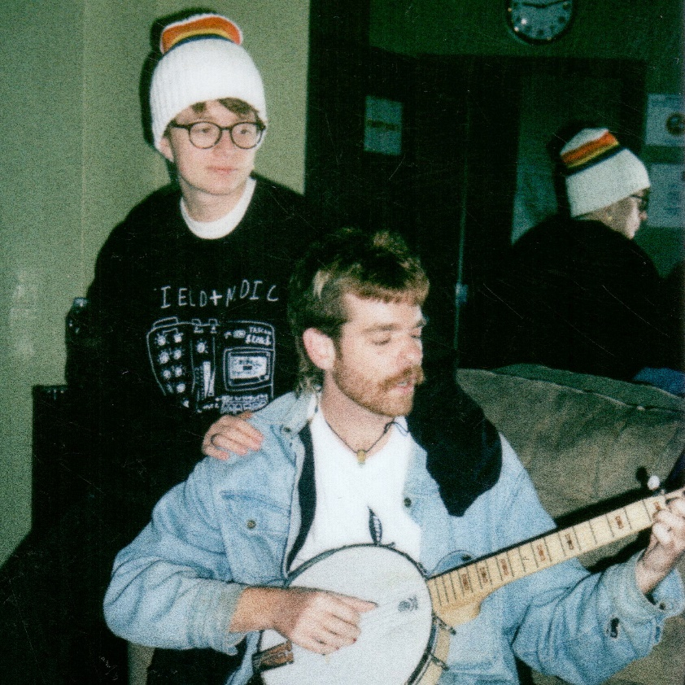

“Cavetown’s heartfelt bedroom pop brings kindness to a cruel world”
– The New York Times

May 19th, 2023 (Los Angeles, CA) – Multi-Platinum singer/songwriter and producer Cavetown, also known as Robin Skinner, unveils a ethereal new single and video “Glacier Meadow” featuring Field Medic today. Originally conceived when the pair hit the road together in 2019, the track’s organic instrumentation melts into an icy backdrop as a magnetic melody resounds, uniting their respective styles into a poetic and poignant tune. Listen to “Glacier Meadow” HERE and watch the music video HERE.

About the collaboration, Cavetown explains, “Kevin is my friend. We wrote this song many years ago on tour together, long before the pandemic. It was lost to time in those tough years, but Kevin recently found it. It’s finally being unveiled at just the right time. The dust is clearing and we can all finally see the ‘Glacier Meadow’ together.”

Cavetown also just announced an intimate underplay show with Field Medic at LA’s Belasco Theater on July 19, just one night ahead of his upcoming “Bittersweet Daze” summer headline tour. Kicking off with a sold-out show at the Greek Theater on July 20, the special 12-date tour will unite Cavetown’s closest collaborators and friends – mxmtoon, Ricky Montgomery, and grentperez – with $1 from every ticket sold benefiting his This Is Home Project. At each show, a This Is Home tent will welcome local LGBTQ+ youth organizations to connect with fans.

The upcoming tour marks Cavetown’s first stateside run since Spring 2022 and is in support of his globally acclaimed album, worm food, which widespread praise from the likes of The New York Times, The FADER, NME, V Magazine, and more. As the follow up to 2020’s Sleepyhead, Cavetown delivers his most elaborately realized body of work to date on worm food, shaping his idiosyncratic storytelling into songs that ultimately give voice to our own most intimate emotions. As with all his output, he produced the album on his own at his home studio, holing up in his garage and infusing his understated alt-pop with a powerful new vitality.

Most recently, Cavetown served up his City Sessions (Amazon Music Live) EP, recorded live in Brooklyn as part of Amazon’s City Sessions livestream on Twitch. During the set, he delivered striking and emotionally charged performances of fan favorites off worm food, including “fall in love with a girl,” “frog,” “1994,” and “Idea of Her.” Listen here, and stay tuned for more music from Cavetown soon.

UPCOMING CAVETOWN TOUR DATES
7/19 – Belasco Theater – Los Angeles, CA^
7/20 - Greek Theatre - Los Angeles, CA*
7/21 - Cal Coast Credit Union Open - San Diego, CA*
7/23 - Frost Amphitheater - Stanford, CA*
7/25 - Saltair - Magna, UT*
7/26 - Levitt Pavilion - Denver, CO*
7/28 - St. Louis Music Park - Maryland Heights, MO*
7/29 - The Salt Shed - Chicago, IL*
7/30 - Rock The Ruins - Indianapolis, IN*
8/1 - Jacobs Pavilion - Cleveland, OH*
8/3 - SummerStage - New York, NY*
8/4 - Skyline Stage at the Mann - Philadelphia, PA*
8/5 - The Palladium Outdoors - Worcester, MA*
^ = w/ Field Medic
* = Bittersweet Daze Tour

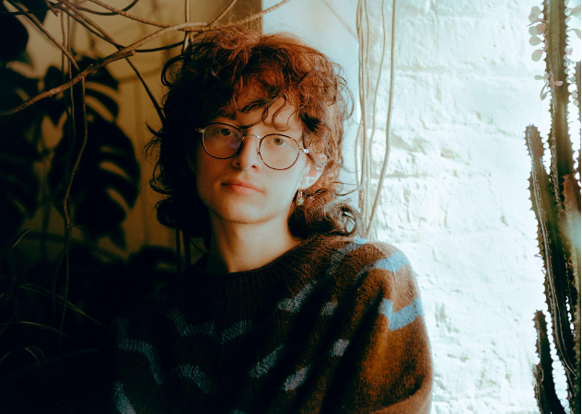
Download Press Photo HERE | Credit: Kane Layland

FOLLOW CAVETOWN:
Press Assets | Website | Facebook | Twitter | Instagram | YouTube

For more information, please contact:
Patrice Compere | Warner Records
Patrice.Compere@warnerrecords.com

