RISING ALT-POP ARTIST RICKY MONTGOMERY DROPS MELODIC NEW SINGLE “DON’T SAY THAT”

LISTEN HERE

Download hi-res image here

May 19, 2023 (Los Angeles, CA) – Breakout alt-pop artist Ricky Montgomery returns with the buoyant new single “Don’t Say That,” out now via Warner Records. Playful yet multi-layered and emotional, the new track is an instant earworm – listen to it HERE.

Continuing the beginning of his exciting new chapter, "Don't Say That" is the latest release from Ricky since dropping the dreamy pop track “Eraser.” Upon its release last month, Billboard praised, “the listener can’t help but pay attention to Montgomery” while V Magazine agreed, “‘Eraser’ is a vibey bedroom pop-esque vulnerable single… with the musician stepping into a more comfortable and mature sound.” That track is gentle rumination on finding success in music—and the pressure that comes with it. And the singer-songwriter knows what he's talking about. Since attaining virality with "Line Without a Hook" and "Mr Loverman," Ricky has amassed more than one billion cumulative streams and more than five billion TikTok views.

Last year, the hitmaker rolled out It’s 2016 Somewhere EP (a nod to the belated success of self-titled album released that year), which included “Talk To You,” “Sorry For Me,” “Settle Down,” and an acoustic rendition of his platinum hit “Mr. Loverman.” Now with “Don’t Say That,” Ricky embraces old scars and forges ahead with a disarming pop sensibility that is bound to sweep listeners everywhere off their feet.

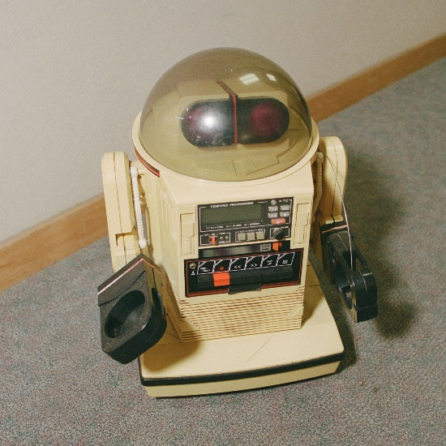
Download hi-res art here

ABOUT RICKY MONTGOMERY:
Music always lures Ricky Montgomery back. He blames the internet. First a devotee of the Vine underground, and now—nearly a decade and several jobs later—an unexpected hitmaker, the Los Angeles native's spent the last few years trying to reconcile with his artist self. He recently surpassed 1 billion global streams thanks to Platinum indie-pop hits “Mr. Loverman” and “Line Without a Hook.” But those songs, written when he was a teen, have come to feel like they were by a whole other person—at least to Ricky. In 2023, we get to meet Rick, a sophomore set that comes seven years later, rich with electro-laced, emo-tinged alt-pop that spins stories about life in all its messy and mundane glory. Ricky's journey fits the bill: a childhood in L.A. interrupted by divorce, an adolescence playing in the basement bands of suburban Missouri, a viral explosion on a soon-to-implode platform, and a brief music career back on the West Coast that sent his songs up the Rock and Alternative charts. That was in 2014, before life intervened and he quit music for good… until the world discovered his sunny, sardonic songs. With millions of socials followers and a string of sold-out tours under his belt, Ricky now sets out to document "my long, awkward path toward remembering myself as an artist," he says. "It’s been embarrassing and difficult, but also thrilling. It’s everything I’ve ever wanted to do but was too scared to try.”

###

For more information, contact:
Ceri Roberts, Ceri.Roberts@warnerrecords.com
Patrice Compere, Patrice.Compere@warnerrecords.com

Press Materials:
press.warnerrecords.com/rickymontgomery

Follow Ricky Montgomery:
INSTAGRAM | TWITTER | YOUTUBE | TIKTOK

