MOTHER MOTHER “NORMALIZE” THE ABNORMAL WITH NEW SINGLE
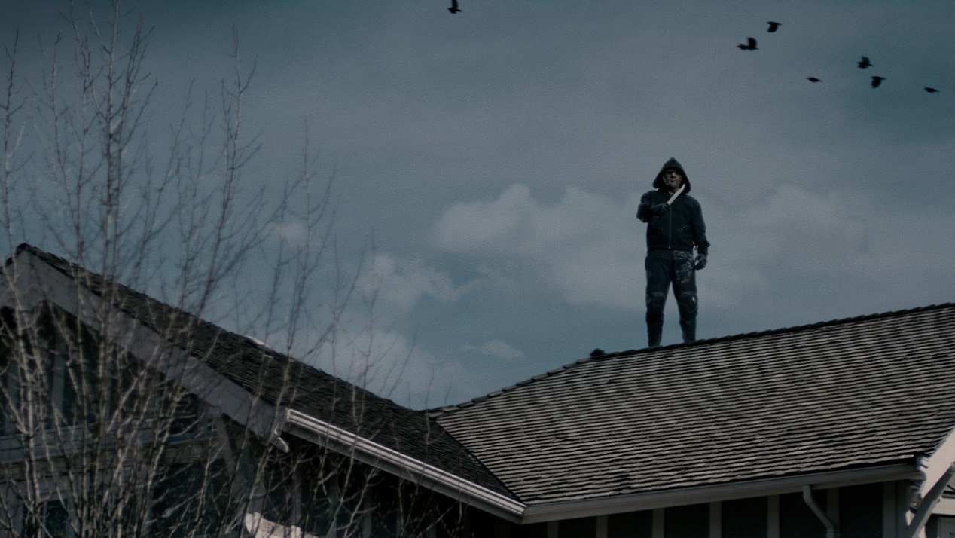
(Video Still)
LISTEN HERE / WATCH HERE
June 30, 2023 – (Los Angeles, CA.) -- Platinum certified alt-pop band Mother Mother announce the release of their first new music of 2023 with the inclusive and progressively propulsive mantra “Normalize.” Produced by frontman Ryan Guldemond and co-produced by Jason “JVP” Van Poederooyen at the famed Warehouse Studios in Vancouver, BC, this alt-pop gem follows the 2022 release of their US Certified Gold global breakout single “Hayloft II.” “Normalize” arrives with an intense video directed by acclaimed horror director Colin Minihan (Grave Encounters, What Keeps You Alive), who previously worked with the band on videos for “Body of Years” and “O My Heart.” Click HERE to watch Ryan Guldemond briefly explain the concept behind “Nomalize.”
“Normalize” is available at all DSPs now. Click HERE to stream. Click HERE to watch the video.
Of the new single, Guldemond says “’Normalize’ is about the metaphorical death which occurs when we’re not being ourselves; the deadening of the spirit when trying to appease some external framework of so-called normalcy. Ideally, it’s an anthem for the outcast. We’re very fortunate to look out at our audience to see such a wealth of uniqueness. This song is our way of telling our people to keep being themselves, whatever that means to them. What is normal? We don’t know, and I’m not sure we care.”
2022 catapulted Mother Mother into a new stratosphere of universal success following the release of their critically acclaimed studio album INSIDE. Their explosive follow-up to “Hayloft,” “Hayloft II” connected with fans around the world. The song debuted inside the Top 10 on Spotify’s Global Top Songs chart, is now certified Gold in the US and approaching Platinum in Canada and has garnered over 630 million global streams including 470 million views across YouTube to date. In addition to their Stateside RIAA Gold & Platinum tracks, the band have earned multi-Platinum certifications in their home country of Canada for the album O My Heart as well as several of their other hit songs.
The quintet spent most of the last year touring the world playing to sold-out audiences in theaters to stadiums, including a hugely successful direct support slot with Imagine Dragons across Europe where they performed to millions of new fans. As a result, their fanbase grew exponentially, evidenced by multiple sold-out headline tours in Europe, UK, Canada, Australia and the U.S. as well as key festival plays in South America and Mexico. The band also made their American late-night television premiere with a performance of their single “Sick of the Silence” on the Late Late Show with James Corden.
Their prolific recent and upcoming touring schedule will see them play festivals such as Reading and Leeds; Lollapalooza Berlin, Chile, Argentina, and Brazil; Corona Capital in Mexico; Pukkelpop Belgium; Frequency Festival in Austria; Lowlands in The Netherlands; as well as countless headline dates. The band are known for their dynamic live show, and their ability to connect deeply with their fans both on stage and on social media.

Comprised of Ryan Guldemond (vocals, guitar), Molly Guldemond (vocals, keys), Jasmin Parkin (vocals, keys), Ali Siadat (drums) and Mike Young (bass), Mother Mother have seen truly remarkable growth over the past three years, with enormous global success since 2021: Over 6 billion global streams, more than 57.5 million monthly listeners on digital platforms, 6 million Shazam searches and nearly 3 million TikTok followers. More to come from Mother Mother soon.
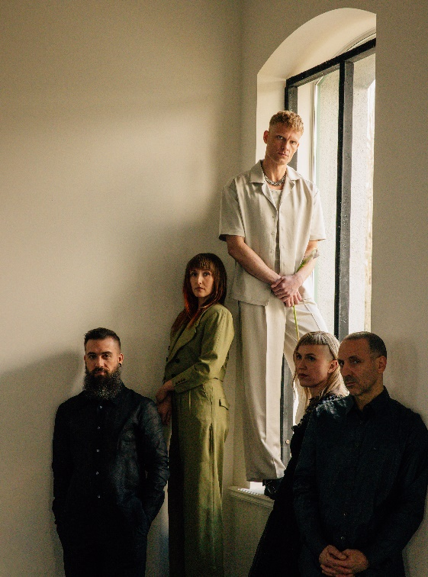
(Mother Mother by Mackenzie Walker – Click HERE for Hi-res)
# # #

For further information, contact Warner Records:
National: Rick.Gershon@warnerrecords.com
Regional: Delanee.Wilson@warnerrecords.com

Follow MOTHER MOTHER:
Official Site | Facebook | Twitter | Instagram | YouTube | Spotify | Press Materials

