VOCAL POWERHOUSE TEDDY SWIMS RELEASES SOULFUL NEW SINGLE “LOSE CONTROL”
LISTEN HERE | WATCH HERE

HIGHLY ANTICIPATED DEBUT ALBUM I'VE TRIED EVERYTHING BUT THERAPY (PART 1) OUT SEPTEMBER 15

NORTH AMERICAN HEADLINE TOUR KICKS OFF SEPTEMBER 22

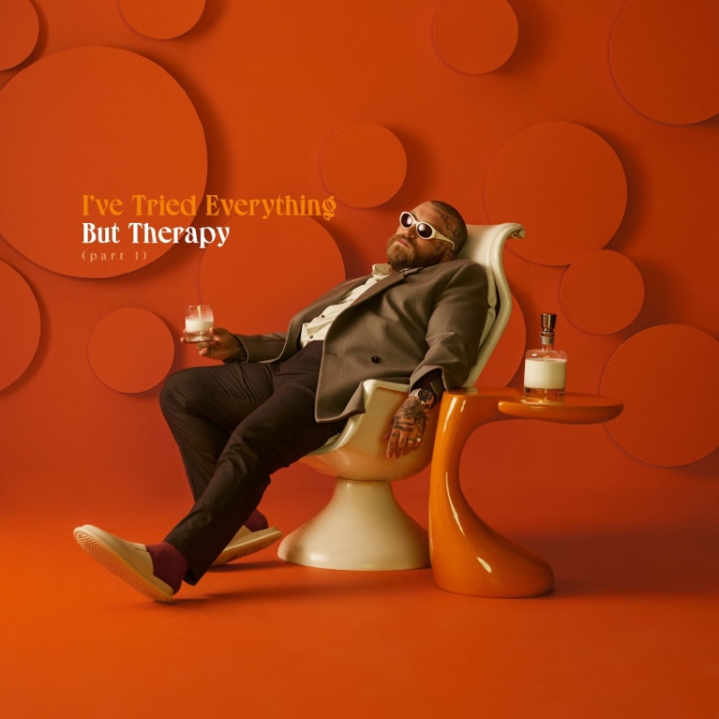
Download Hi-Res artwork HERE

June 23, 2023 (Los Angeles, CA) – Today, genre-blurring artist Teddy Swims returns with the soulful new single “Lose Control.” Listen HERE via Warner Records and watch the video HERE. Boasting a soaring chorus that showcases the Atlanta, GA singer-songwriter’s extraordinary range, the emotional anthem is the latest taste of Swims' highly anticipated debut album I've Tried Everything But Therapy (Part 1) due September 15. Pre-order HERE.

“Being in love can be like an addiction sometimes — always chasing the highs from the lows," Swims says of the track. "It’s about losing yourself and losing control when it all starts to cave in and thinking that the only way out is through being with that person, chasing that feeling over and over again."

"Lose Control" arrives on the heels of “What More Can I Say” and "FACE MYSELF" featuring Elley Duhé. Prior to that, Swims dropped the Sleep is Exhausting EP in late 2022, which capped a busy year that included a viral cover of Journey’s classic “Don’t Stop Believin’” that was reposted by celebrities like Jennifer Garner and Timbaland. He also performed the song on America’s Got Talent with season 14 winner Kodi Lee and Journey founder and guitarist Neal Schon.

Other highlights from last year include playing sold-out shows around the globe and lending his powerful pipes to ILLENIUM’s “All That Really Matters,” Meghan Trainor’s “Bad For Me,” and MK & Burns’ “Better.” Given his prolific output, Swims is sure to have a stellar setlist for his upcoming I've Tried Everything But Therapy Tour of North America, which kicks off on September 22 in Minneapolis, MN. See all the dates below and get tickets HERE.

Teddy Swims 2023 Tour Dates:

Sep 22 Minneapolis, MN First Avenue
Sep 24 Chicago, IL Riviera Theatre
Sep 26 Richmond, VA The National
Sep 27 Norfolk, VA The NorVa
Sep 29 Raleigh, NC The Ritz
Sep 30 Greenville, SC Voyage Music Festival
Oct 1 Charlotte, NC The Fillmore Charlotte
Oct 3 Fort Lauderdale, FL Revolution Live
Oct 4 St. Petersburg, FL Jannus Live
Oct 5 Orlando, FL House of Blues Orlando
Oct 7 New Orleans, LA The Fillmore New Orleans
Oct 8 Houston, TX House of Blues Houston
Oct 10 Dallas, TX The Factory in Deep Ellum
Oct 11 San Antonio, TX Aztec Theatre
Oct 13 Wichita, KS TempleLive
Oct 14 Tulsa, OK Cain’s Ballroom
Oct 15 Oklahoma City, OK The Criterion
Oct 17 Phoenix, AZ The Van Buren
Oct 18 San Diego, CA SOMA – Mainstage
Oct 20 Los Angeles, CA The Wiltern
Oct 21 Las Vegas, NV Freemont Street Experience
Oct 22 Oakland, CA Fox Theater
Oct 24 Portland, OR Roseland Theater
Oct 25 Vancouver, BC Orpheum Theatre
Oct 26 Seattle, WA Showbox SoDo
Oct 28 Salt Lake City, UT Rockwell @ The Complex
Oct 29 Denver, CO Mission Ballroom
Oct 31 Omaha, NE The Admiral Theater
Nov 1 Kansas City, MO The Midland Theatre
Nov 3 Indianapolis, IN Egyptian Room at Old National Centre
Nov 4 Cincinnati, OH Bogart’s
Nov 5 Cleveland, OH Agora Theatre
Nov 7 Pittsburgh, PA Stage AE
Nov 8 Detroit, MI The Fillmore Detroit
Nov 10 Toronto, ON HISTORY
Nov 11 Montreal, QC Beanfield Theatre
Nov 12 Boston, MA Roadrunner
Nov 14 New York, NY Terminal 5
Nov 15 Philadelphia, PA The Fillmore Philadelphia
Nov 16 Washington, DC The Anthem
Nov 18 Nashville, TN Ryman Auditorium
Nov 21 Atlanta, GA Tabernacle

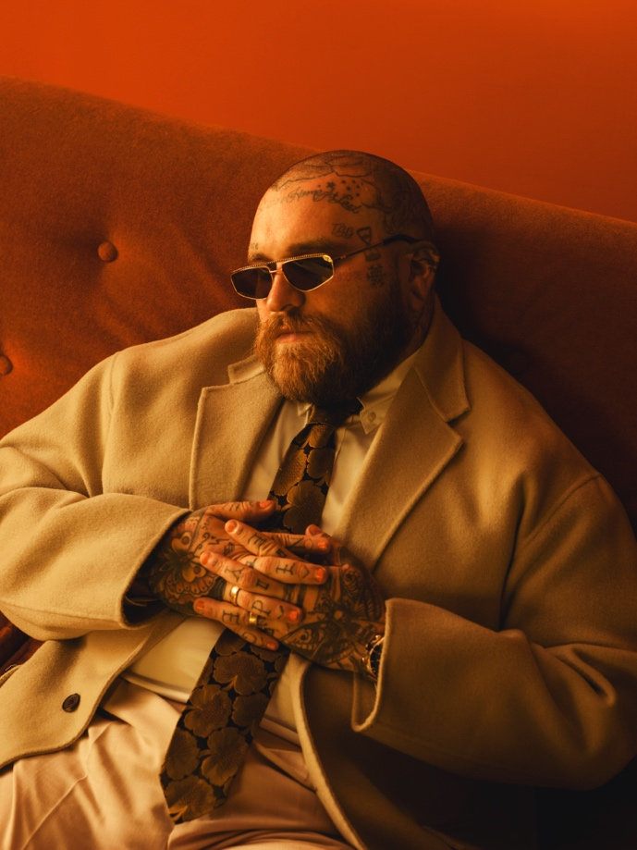
Download Hi-Res press photo HERE
Photo credit: Joseph Cultice

FOLLOW TEDDY SWIMS:
Official | Twitter | Instagram | Facebook | YouTube | Press Materials

For more information, please contact:

Darren Baber | Warner Records
Darren.Baber@warnerrecords.com

