THE BLESSED MADONNA TEAMS UP WITH GABRIELS’ JACOB LUSK
ON NEW SINGLE “MERCY”

LISTEN HERE

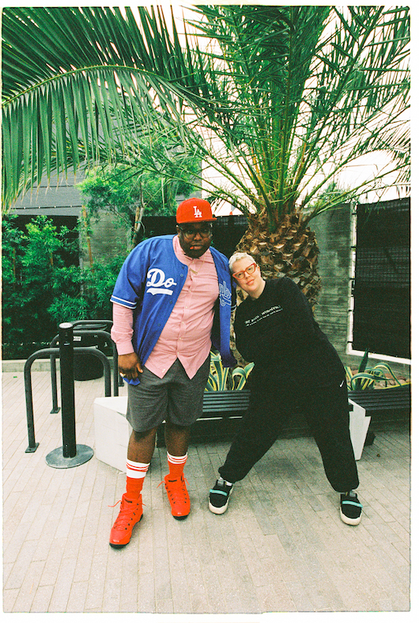
(Jacob Lusk and The Blessed Madonna. Credit Natalie Goldstein / @artbygoldie. High res HERE)

June 23, 2023 (Los Angeles, CA) — Today, The Blessed Madonna releases her new single, “Mercy” — listen HERE. A collaboration with Jacob Lusk of Gabriels, it’s another incredible piece of cathartic house music from the Kentucky-born, London-based DJ, producer and club culture iconoclast. London clubbers first heard the track last month when Lusk made a surprise live appearance at The Blessed Madonna’s roadblocked We Still Believe party to bless the dancefloor with his inimitable vocal. Co-produced with Totally Enormous Extinct Dinosaurs and featuring additional vocals from the House Gospel Choir, “Mercy” is The Blessed Madonna’s first release under Warner Records flagship dance label Major Recordings.

Speaking about “Mercy,” The Blessed Madonna says:

“I’m interested in the dichotomy of the sacred and the ordinary in songwriting. Agony and ecstasy. A song about love and heartbreak can still be a deeply spiritual piece of work. I began by thinking about what love is for me in my life and arrived at the simple idea that it was at its core a promise not just to live but to forgive. Love is Mercy. Over many revisions and with the developments that came from working with Jacob and the rest of the many people who came together to make this record a reality, the idea deepened and we found exactly the sweet spot between the church and the dance floor that I was looking for. The gospel influence in intentional and undeniable. I thought in particular about the sculpture The ecstasy of St Theresa which is an incredibly rich image that feels as carnal as it does holy. This is my conception of god: those moments where we are humbled by a love so big that we can’t imagine being worthy of it or worthy of the kind of acceptance and mercy we feel.”

“Mercy” is the latest in a prolific run of recent releases from The Blessed Madonna. Following 2022’s Uffie-vocaled “Serotonin Moonbeams”—The Blessed Madonna’s first single in over 5 years—she quickly followed up with collaborations with Chicago house legend Jamie Principle (on “We Still Believe”), Durban’s The Joy on the electrifying “Shades Of Love” and garage legend Todd Edwards on “Fuck what u heard.”

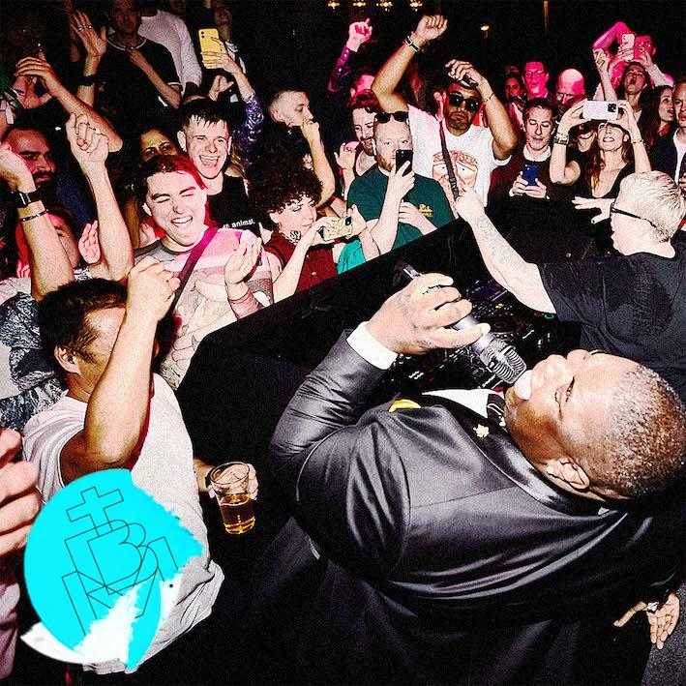
(“Mercy” cover art. High res HERE)

About The Blessed Madonna:
An overnight sensation two decades in the making, Marea Stamper aka The Blessed Madonna is an artist whose career is woven into the fabric of dance music past, present and future. Whether promoting illegal raves to 50 people in sweaty Kentucky basements as a teenager, headlining the biggest stages and festivals around the world, working alongside house legends like Frankie Knuckles or fearlessly taking on one of the most improbable, ambitious remix projects in recent times with Club Future Nostalgia (her collaborative album with pop icon Dua Lipa), The Blessed Madonna is synonymous with inclusive, unifying, cathartic dance music.

In recent years, The Blessed Madonna has channeled the emotions of millions as the vocalist on Fred again..’s lockdown anthem, “Marea (We Lost Dancing)”, become the voice of Saturday night radio, been immortalised as a GTA5 character and provided remixes for the likes of The Chemical Brothers, Florence & The Machine and, improbably, Elton John. With her recent run of singles, she’s set to usher in a whole new era—the results from a year’s worth of blood, sweat, tears and joy in the studio for 50 hours a week with some of her best friends. There are even rumors of a debut album. Watch this space.

About Major Recordings:
Major Recordings is the first-ever flagship electronic dance music label under Warner Records. Taking a music-first approach, the new label will discover, sign, and develop top talent across the ever-evolving and expanding electronic dance community, with early releases from PARISI, Sam Gellaitry, LUUDE, BLOND:ISH, HUGEL, and many more.

FOLLOW THE BLESSED MADONNA:
Official | Instagram | Facebook | Twitter

For more information, please contact:

Darren Baber | Warner Records
Darren.Baber@warnerrecords.com

Judy Miller Silverman | Motormouth Media
Judy@motormouthmedia.com

