PATRICK DRONEY SHARES SOARING NEW SINGLE “GO GETTER”

LISTEN HERE / WATCH HERE

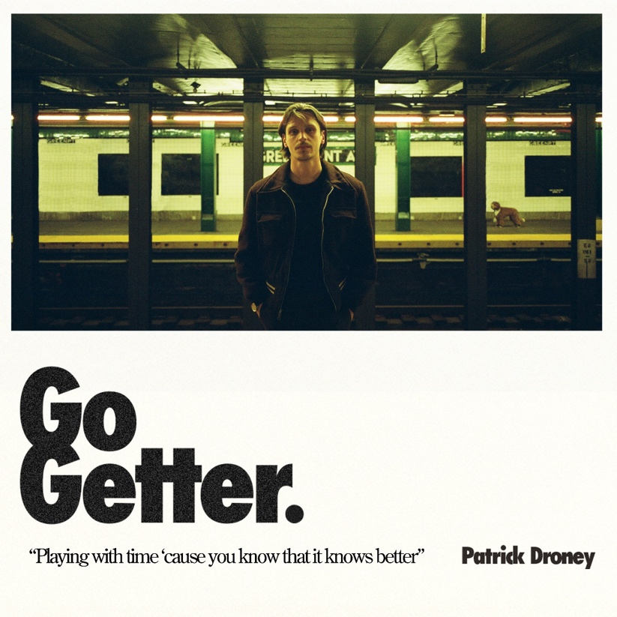
(Download hi-res artwork HERE)

May 26, 2023 (Los Angeles, CA) — Kicking off another chapter, powerhouse singer, songwriter, producer, and guitarist extraordinaire Patrick Droney returns with a dynamic, self-penned new single entitled “Go Getter,” available now via Warner Records. The concept of time threads the narrative of the song, underscored by the lyric, “Playing with time ‘cause you know that it knows better,” which sets the tone for the accompanying video directed by Gus Black. The visual creates the conceptual connective tissue that will link what’s to come. Click HERE to stream “Go Getter” and HERE to watch the music video.

The track highlights his constant progression as an artist, reaching new creative heights with each release. Sparse piano rings out between his stirring line, “I want to reach through a tear in the sky.” Soon, an electronic beat kicks into gear, and his soulful refrain takes flight with an affirmation, “There’s more down the road ‘cause you know you’re a go getter.”

Droney builds the track into a skyscraping guitar solo, boosted even higher by choral harmonies. Sonically, it integrates rock, blues and classic soul all at once. About the track, Droney adds: “Imagine watching the trailer for the movie of your life—a reel tethered across the timeline. Some scenes are instantly recognizable and others strangely familiar—like you’re remembering ahead. I wrote “Go Getter” asking Time the question, ‘What does it mean to remember?’ When you connect two frames, I believe there to be a correspondence. This song is the spark of that journey down the rabbit hole. It was important to me to make sure the visual reflected real backdrops in my movie. Making this video, my close collaborator Gus Black and I adventured through personal landmarks in New York City and hometown of Lancaster, PA. In the process, I had some true revelations. For me, it’s proof that if you go and meet the moment, you’re reminded it’s been waiting for you all along.”

“Go Getter” follows in the wake of the recently released “I’ll Be By Your Side.” The track paired with a feature in the CBS series “Fire Country” this past February and has amassed over 1.6 million global streams.

In between writing new music, Patrick Droney captivated audiences with performances at a Super Bowl LVII pre-game event, in the UK with The Eagles at Hyde Park and The Vamps at the O2 Arena, plus a string of sold-out headline dates. This summer, Droney will grace the stage of Hinterland Music Festival in Saint Charles, IA on August 5 and Pilgrimage Music & Cultural Festival in Franklin, TN on September 24. Click here for more information. More dates to be announced soon.

About Patrick Droney:
Growing up in South Jersey, via Lancaster, PA, Droney became enamored with New York City at an early age, gigging frequently in esteemed Manhattan clubs and eventually attending the Clive Davis Institute of Recorded Music at NYU. By age 13, he won a Robert Johnson New Generation Award as “Best Young Blues Guitarist” and began sharing stages with the likes of B.B. King, James Brown, The Roots, Taj Mahal, Macy Gray, and Elvis Costello. He moved to LA and signed a publishing deal, and in 2018 relocated to Nashville to craft a self-titled EP, also making his TV debut on Late Night with Seth Meyers, performing at Barclays Center for Tidal X, and seeing his song “High Hope” featured in the ABC TV hit series Grey’s Anatomy. After signing to Warner Records in 2019, he collaborated with Kygo, performed live on The Late Show with Stephen Colbert, and the Kelly Clarkson Show and made headlines at his Bonnaroo and ACL festival appearances. Droney released his acclaimed debut album STATE OF THE HEART in May 2021 and hit the road. Droney pulls inspiration from his life experiences living in multiple places around the country with nods to both his musical heroes and current musical interests such as The National and Bon Iver. Droney spent much of 2022 touring the US and UK which included hi-profile performances at this year’s Super Bowl 57 pre-show and supporting The Eagles at London’s Hyde Park. In February of 2023, he released his first new music of the year with the track “I’ll Be By Your Side,” featured in the CBS TV drama “Fire Country” and has surpassed 219 million global streams to date. Coming full circle, Droney has returned to NYC Droney where he is currently putting the finishing touches on his next full-length studio album.
# # #
Contact Rick Gershon at Warner Records Publicity:
Rick.Gershon@warnerrecords.com

Follow Patrick Droney:
Official | Instagram | Twitter | Facebook | YouTube | Spotify | Press Materials

