ANNOUNCE EXTENSIVE US TOUR IN SUPPORT OF NEW ALBUM
BACK TO THE WATER BELOW OUT SEPTEMBER 8
VIA WARNER RECORDS

GENERAL PUBLIC TICKETS ON-SALE FRIDAY, JUNE 2

FIRST SINGLE “MOUNTAINS AT MIDNIGHT” AVAILABLE NOW
LISTEN HERE / WATCH THE OFFICIAL VIDEO HERE

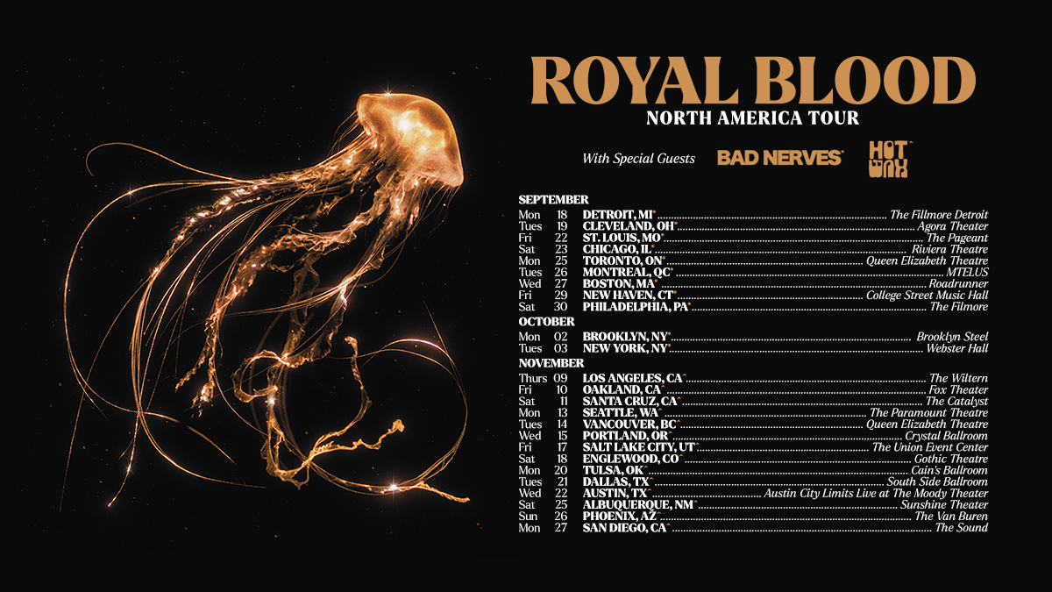

May 30, 2023 (Los Angeles, CA) — In the wake of last week’s new album and single announcement, the mighty Royal Blood reveal an extensive US tour in support of their forthcoming album Back To The Water Below. The general on-sale is on Friday, June 2 at 10:00AM local time.

As previously announced, Royal Blood’s fourth full-length studio album Back To The Water Below is set for release on September 8 via Warner Records and is their strongest, hardest-rockin’ body of work to date. The album’s lead single “Mountains At Midnight” is available now. Listen HERE and watch the official video HERE.

Back To The Water Below is now available to pre-order HERE. In addition to its digital release, physical formats include deluxe vinyl (packaged with a bonus 7” featuring two additional tracks) and two cassettes, all of which are available exclusively from Royal Blood’s official store. Amazon will stock an exclusive gold vinyl, while HMV (UK only) and select indie stores offer an exclusive clear vinyl. The range is completed by a CD and a regular black vinyl.

The single “Mountains At Midnight” provides a fresh take on the old school Royal Blood prototype – albeit with a supercharged rush. Mike Kerr inventively layers a heavyweight wall-of-sound solely with his bass, while Ben Thatcher’s rhythms simultaneously swing with a spacious groove while pummelling us into submission. Mike’s lyrics complement the song’s ominous, foreboding ambiance with vehement menace: “I’m a ticking timebomb hooligan come to light your fuse / 24-carat thug in a velvet glove.”

Royal Blood present plenty of surprises without ever compromising the essence of their identity. “Shiner In The Dark” sets a rock ‘n roll swagger to the tight, danceable rhythms that defined the 2021 album Typhoons. Devoid of distortion, “The Firing Line” represents a bigger departure, its ‘90s alt-rock tone and an underbelly of psychedelia later elevated by a chiming piano melody. “Pull Me Through” goes further still, uniting the plaintive piano that fans loved in the live favourite “All We Have Is Now” with a full-blooded denouement. They’re also songs which will not only provide a broader spectrum of moods for live shows, but that will offer the dynamic contrast to amplify the power of their most fiery moments.

Back To The Water Below tracklist:

- Mountains At Midnight
- Shiner In The Dark
- Pull Me Through
- The Firing Line
- Tell Me When It’s Too Late
- Triggers
- How Many More Times
- High Waters
- There Goes My Cool
- Waves

Deluxe Edition 7” single bonus tracks:
- Supermodel Avalanches
- Everything’s Fine

US Festival Dates – on sale now:
Sep 16 Asbury Park, NJ Sea. Hear. Now Festival (on sale now)
Sep 18: Detroit, MI The Fillmore Detroit
Sep 19: Cleveland, OH Agora Theater
Sep 21 Louisville, KY Louder Than Life Festival (on sale now)
Sep 22: Saint Louis, MO The Pageant
Sep 23: Chicago, IL Riviera Theatre
Sep 25: Toronto, ON Queen Elizabeth Theatre
Sep 26: Montreal, QC MTELUS
Sep 27: Boston, MA Roadrunner
Sep 29: New Haven, CT College St. Music Hall
Sep 30: Philadelphia, PA The Fillmore

Oct 02: Brooklyn, NY Brooklyn Steel
Oct 03: New York, NY Webster Hall

Nov 09: Los Angeles, CA The Wiltern
Nov 10: Oakland, CA Fox Theater
Nov 11: Santa Cruz, CA The Catalyst
Nov 13: Seattle, WA Paramount Theatre
Nov 14: Vancouver, BC Queen Elizabeth Theatre
Nov 15: Portland, OR Crystal Ballroom
Nov 17: Salt Lake City, UT Union Event Center
Nov 18: Englewood, CO Gothic Theatre
Nov 20: Tulsa, OK Cain’s Ballroom
Nov 21: Dallas, TX South Side Ballroom
Nov 22: Austin, TX ACL Live at The Moody Theater
Nov 25: Albuquerque, NM Sunshine Theater
Nov 26: Phoenix, AZ The Van Buren
Nov 27: San Diego, CA The Sound

Click HERE for ticket information and a full list of all international shows.

# # #

For more information, please contact:
National: Rick Gershon Rick.Gershon@warnerrecords.com
Regional: Delanee Wilson Delanee.wilson@warnerrecords.com

Follow Royal Blood:
Website | Spotify | Apple Music | YouTube | Facebook | Instagram | Twitter | TikTok | Press Materials

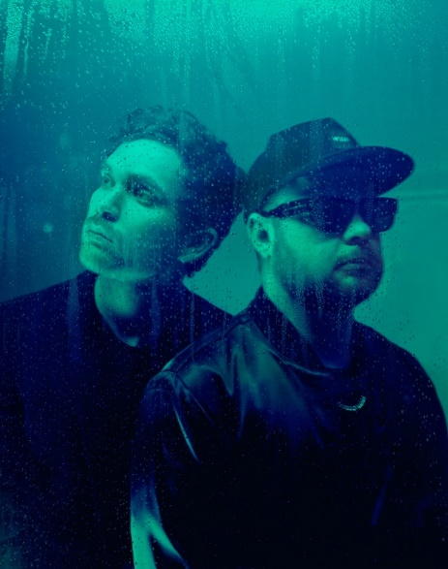
(Download high-res Royal Blood photo by Tom Beard HERE)

