ZACH BRYAN CELEBRATES ONE-YEAR ANNIVERSARY OF CHART-TOPPING ALBUM AMERICAN HEARTBREAK

52 CONSECUTIVE WEEKS ON BILLBOARD 200 CHART

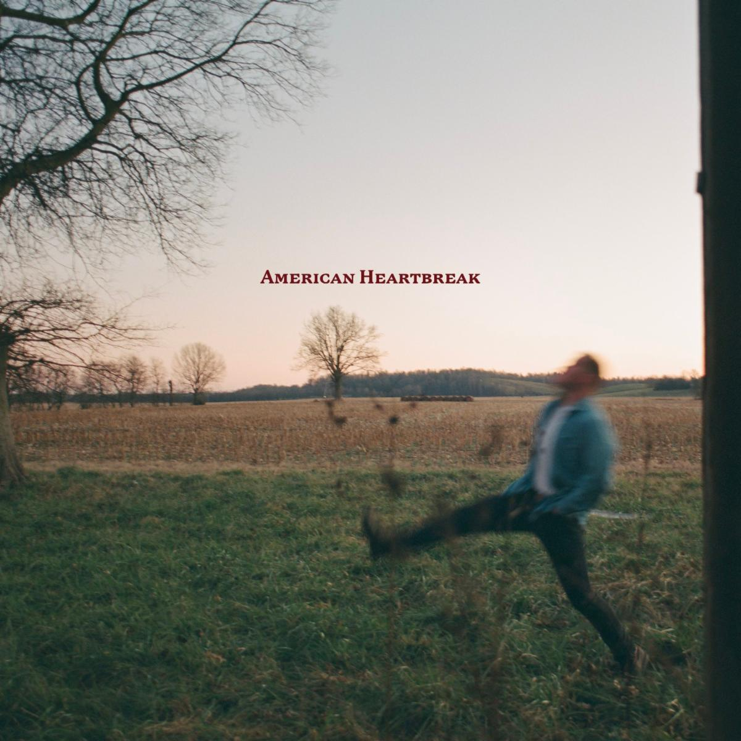
(Hi-res download HERE)

May 25, 2023 (Los Angeles, CA) — This week, GRAMMY® Award-nominated, multi-Platinum certified singer-songwriter Zach Bryan celebrates the one-year anniversary of his critically acclaimed, chart-topping album American Heartbreak. The album has yet to leave the Billboard 200 Chart since its release, topping the Billboard Country Albums Chart at #1 and emerging as the Most Streamed Country Album on Spotify in 2022. Listen to American Heartbreak HERE via Warner Records.

Recently, Bryan received the award for New Male Artist of the Year at the 58th Annual Academy of Country Music Awards. To date, the Oklahoma native has accrued over 5.3 billion streams and earned 3 Gold-certified singles in addition to the now 4x Platinum “Something in the Orange.” The latter also secured him a 2023 GRAMMY® Award nomination for Best Country Solo Performance.

The first half of 2023 saw Bryan touring Europe for the first time with dates in Ireland, England, Scotland, Germany, The Netherlands and Denmark. All shows sold out instantly. His biggest US headline tour to date is currently underway, after selling out months in advance. The Burn Burn Burn North American Tour — which also includes headlining all major country festivals — picks up this week in Albany, NY at MVP Arena.

Earlier this month, Bryan released the cinematic music video for “Oklahoma Smokeshow” — watch it HERE. Bryan is currently hard at work on the follow-up to American Heartbreak.

Zach Bryan Burn Burn Burn 2023 Tour:
* Indicates Festival Date
May 26 Albany, NY MVP Arena
May 28 London, ON Budweiser Gardens
May 30 Philadelphia, PA Wells Fargo Center
May 31 Philadelphia, PA Wells Fargo Center
June 02 Cleveland, OH Rocket Mortgage Fieldhouse
June 03 Lexington, KY Railbird Festival
June 23 New York, NY Forest Hills Stadium
June 24 New York, NY Forest Hills Stadium
June 26 Denver, CO Red Rocks Amphitheatre
June 27 Denver, CO Red Rocks Amphitheatre
July 07 Milwaukee, WI Summerfest
*July 13 Chicago, IL Windy City Smokeout
*July 14-16 Whitefish, MT Under The Big Sky Festival
*July 20-July 22 Cullman, AL Rock The South
*July 23 Cheyenne, WY Cheyenne Frontier Days
*Aug 05 St. Charles, IA Hinterland Music Festival
Aug 07 Grand Rapids, MI Van Andel Arena
Aug 09 Minneapolis, MN Target Center
Aug 11 Tulsa, OK BOK Center
Aug 12 Tulsa, OK BOK Center
Aug 14 Sioux Falls, SD Denny Sanford Premier Center
Aug 17 Nampa, ID Ford Idaho Center
Aug 19 Las Vegas, NV T-Mobile Arena
Aug 20 Bakersfield, CA Mechanics Bank Arena
Aug 21 Oakland, CA Oakland Arena
Aug 23 Los Angeles, CA Crypto.com Arena
Aug 25 Glendale, AZ Desert Diamond Arena
Aug 27 Wichita, KS INTRUST Bank Arena
Aug 29 Lincoln, NE Pinnacle Bank Arena
Aug 30 Kansas City, MO T-Mobile Center
Oct 07 Opelika, AL Auburn Rodeo

# # #

For further information, contact:
Rick Gershon | Warner Records
Rick.Gershon@warnerrecords.com

FOLLOW ZACH BRYAN:
Website | Instagram | TikTok | Twitter | YouTube

