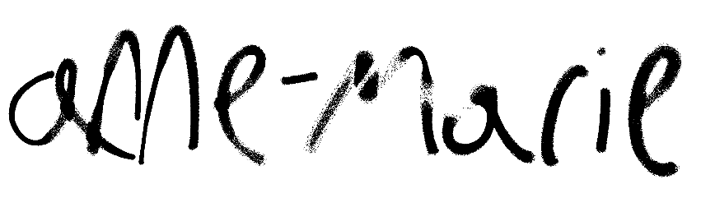
BRITISH POP SUPERSTAR ANNE-MARIE DROPS
NEW TRACK “TRAINWRECK”
LISTEN HERE

THIRD STUDIO ALBUM UNHEALTHY OUT JULY 28
PRE-ORDER HERE

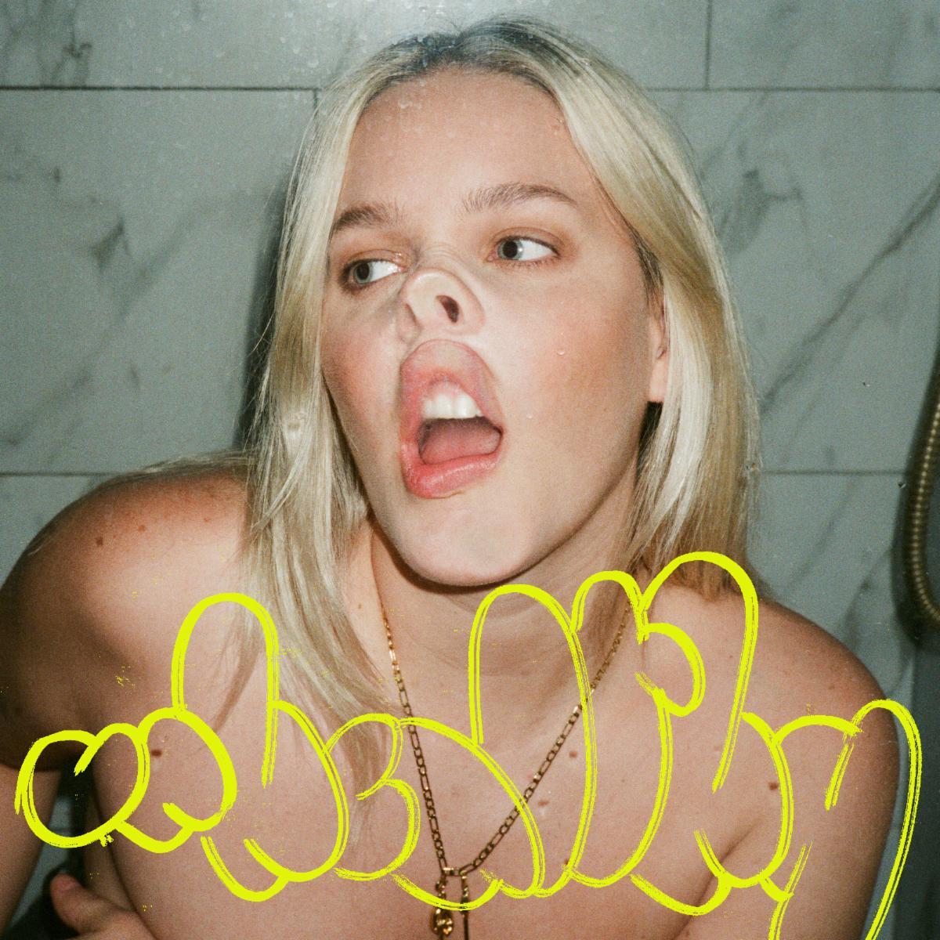
Download hi-res artwork HERE

July 5, 2023 (Los Angeles, CA) — Ahead of her upcoming third studio album UNHEALTHY out July 28, British pop star Anne-Marie has dropped her new single, “Trainwreck.” Listen HERE and pre-order the album HERE.

Produced by Billen Ted (Raye, Becky Hill) and written by Anne-Marie, Kamille (Dua Lipa) and Plested (Lewis Capaldi), the song captures the sweet relief of breaking free from a bad relationship. “The song is about being with someone who’s not good for you, but you stay with them because you’re scared of what will be afterwards,” says Anne-Marie. “You think that you’re going to be down and lost and lonely, but then you dump them and realize how much happier you are without them in your life.”

Leading up to UNHEALTHY, Anne-Marie released her single of the same name. The country-influenced anthem features pop/country legend Shania Twain, and the official video, directed by Olivia Rose (Skepta, Jorja Smith), channels the classic Western movies with Anne-Marie and Shania involved in a mighty standoff. Watch it HERE.

Pulling from all parts of her life, Anne-Marie’s new album UNHEALTHY offers us a sneak peek into her perfectly imperfect world. Penned over a period when she felt ready to revisit and try and make sense of a host of raw past relationships—whilst also learning to process positive new ones—the new album takes us on a journey from chaos to contentment. UNHEALTHY is Anne-Marie standing tall, embracing an all-new version of herself that’s fiercer, bolder, more chaotic and blissfully happier than ever before.

UNHEALTHY TRACKLISITNG:
- SUCKS TO BE YOU
- SAD B!TCH
- PSYCHO (FT. AITCH)
- HAUNT YOU
- TRAINWRECK
- GRUDGE
- OBSESSED
- KILLS ME TO LOVE YOU
- UNHEALTHY WITH SHANIA TWAIN
- IRISH GOODBYE
- CUCKOO
- YOU & I (FT. KHALID)
- NEVER LOVED ANYONE BEFORE

Follow Anne-Marie
Official | Instagram | Twitter | Facebook | YouTube | TikTok | Press Materials

For more information on Anne-Marie, please contact:
Darren Baber | Warner Records
Darren.Baber@warnerrecords.com

